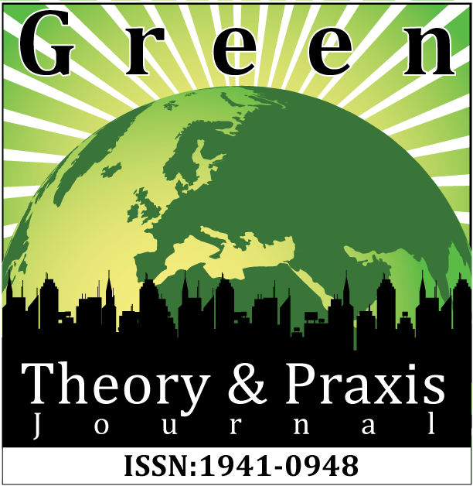

Vol. 8, Issue 1
January, 2015

Movement of Oppressors: An Eco-ability Perspective on Narcissism and the Savior Mentality in Animal Advocacy
Name: Anthony J. Nocella II, Ph.D.
Title: Senior Fellow
Affiliation: Dispute Resolution Institute, Hamline Law School, Hamline University
Location: Saint Paul, MN, USA
Email: nocellat@yahoo.com
Keywords: Ecoability, Racial Justice, Disability Justice, Environmental Justice
______________________________________________________________________________
MOVEMENT OF OPPRESSORS: AN ECO-ABILTIY PERSPECTIVE ON NARCISSISM AND THE SAVIOR MENTALITY IN ANIMAL ADVOCACY

Hello and thank you so much for allowing me to present at the 2nd Annual Eco-ability conference, and thank you so much Mike and Joe for organizing it and all the presenters, as well as the attendees; it is wonderful and the medium for presenting allows people from all over the world to present which is very, very exciting.

I am going to be presenting on “Movement of Oppressors: An Eco-ability Perspective on Narcissism and the Savior Mentality in Animal Advocacy,” and I am really excited about the presentations that have already gone on. There is so much to contemplate and new ideas are always arising in environmental studies, environmental ethics, Critical Animal Studies, and disability studies. They are all new fields that are growing and putting them together will result in rich information and perspectives developing for years to come.
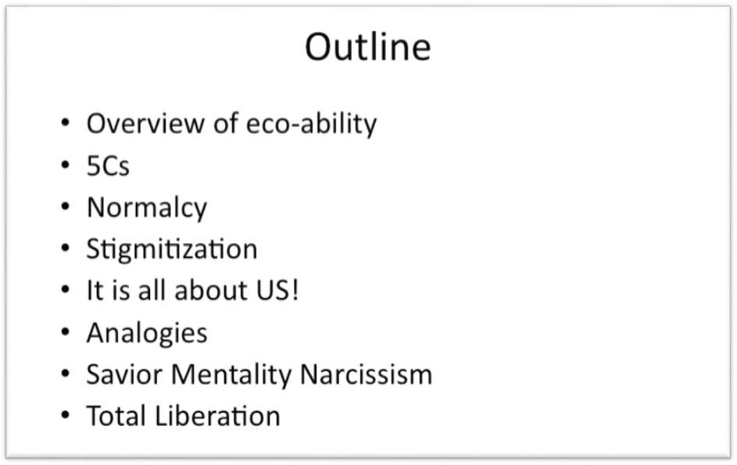
Image 1. Designed by Anthony J. Nocella II

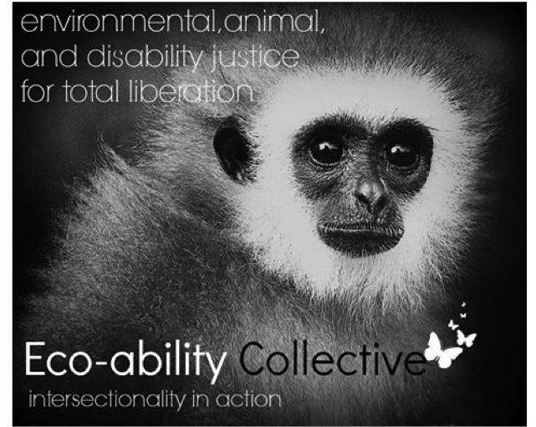

Above is an outline of my presentation, and I am going to be speaking about Eco-ability from my perspective. Eco-ability brings environmental, animal and disability justice and liberation together. Justice is addressing a wrong in our society while liberation is addressing the confinement of a group or individual. An individual who liberates a monkey from a zoo is liberating that animal, but they may not be addressing the systematic issues and exotification of the zoo or trying to close it down; they might just be interested in liberation of that particular monkey.

I want to speak about justice and liberation under the umbrella of peace studies.

Image 2. Designed by Anthony J. Nocella II
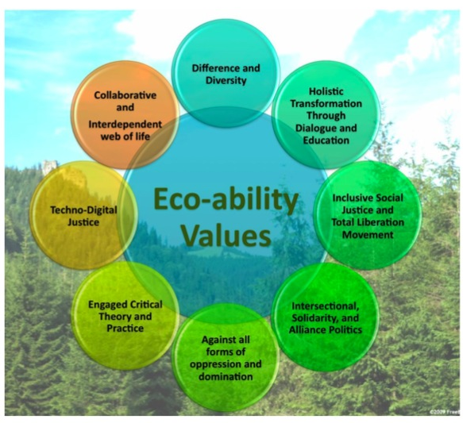
Here are some ideas that you may have seen before in a different presentation I’ve done. Eco-ability values difference and diversity, not equality; equality means “same” and same and equal are socially constructed measurements to perpetuate normalcy. Normal is seen as once side of a coin and abnormal is the other. The “normal” are typically in elite positions of domination and the oppression while the “abnormal” are typically marginalized, oppressed and dominated. So the concept we are trying to develop is very inclusive for total liberation, focusing on intersectionality. A lot of men in our movement praise total liberation but are very opposed to intersectionality. The term “intersectionality” comes from Kim Crenshaw and other women of color and queer women of color looking at the experiences of racism and sexism. So total liberation is the theory, but to experience that theory is intersectionality. We need total liberation as well as intersectionality to inform one another.
I am interested in techno-digital justice and how technology is all around us—from the stick that we use for baseball, to the stick we use as a cane, to a wheelchair. There’s a very fine line when we use technology and when we don’t use technology and how can we challenge the exploitation of nature and the destruction of nature and animals when technology is developed through the medical or military-industrial complexes.
Image 3. Designed by Anthony J. Nocella II

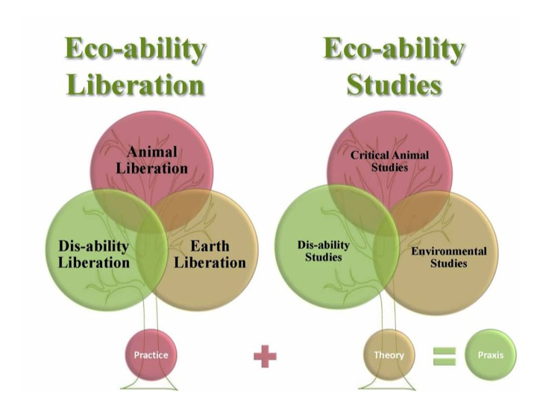
Eco-ability is against ableism, speciesism, and ecocide (the destruction of the environment).

Image 4. Designed by Anthony J. Nocella II

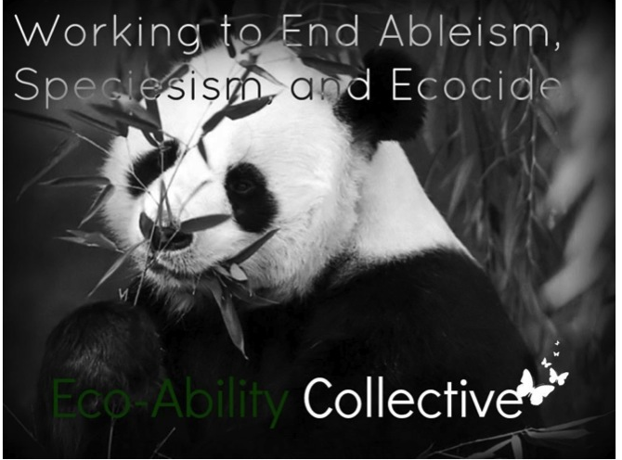
When addressing speciesism, ableism and civilization, we need to really start talking about normalcy, which is the theory behind civilization, and I’ll be talking about civilization. While primitivists have a good analysis of civilization, environmentalists and animal advocates have never really addressed the complexities and importance of why we should critically examine and dismantle the concept of normalcy, which disability studies has done repetitively.

Image 5. Designed by Anthony J. Nocella II
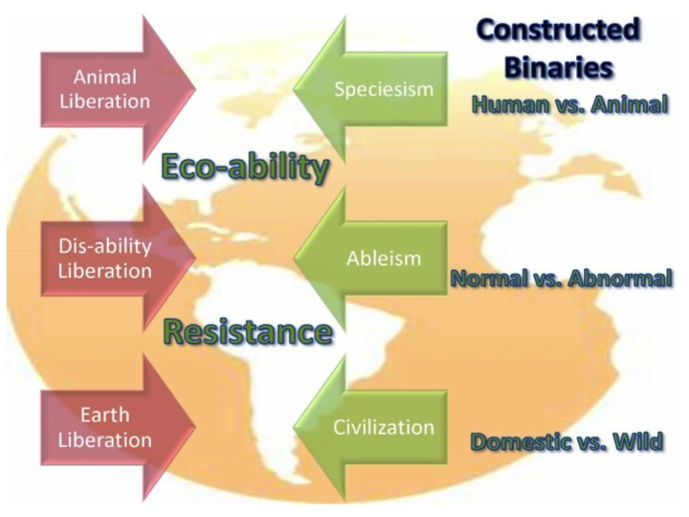
Disability has a kid of invisible hand. Whatever one wants to oppress, one must first stigmatize, and the stigmatized typically have a disability label from not being intelligent, to being crazy, to the other disability labels. This is oppression: the invisible hand that is placed by the oppressor first to stigmatize, then to marginalize, then to incarcerate, then to experiment on, then to kill.

Image 6. Designed by Anthony J. Nocella II
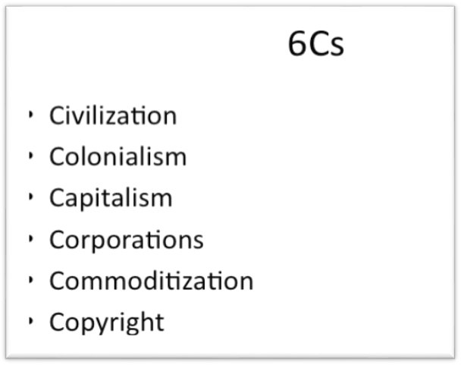
With the six Cs, I look at normalcy in/as civilization. First we have to divide ourselves from nature, and then we divide ourselves from people, which is colonialism. Europe is different than Africa, Asia, and South America. Once we have separated ourselves, capitalism takes over and assigns value to everything that exists. Thus, those who are normal, civilized, and Christian have a higher innate value than the non-colonial, non-white, savage, and disabled.
We now have a reason to exploit people, which requires people and groups to do the exploiting. So we create corporations that are within one’s nation-state or transnational corporations that are in multiple nation-states. From that, we take items, traditions, cultures, and norms and we seize them as our own for profit. This called commodification. And then what we do, like Monsanto, is copyright everything from seeds, to culture, to music, sounds and beats, to language and food so that people cannot steal those things. So those are the six Cs of normalcy that we have to address.

Image 7. Designed by Anthony J. Nocella II
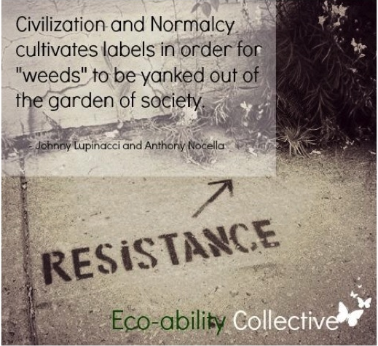
Johnny Lupinacci and I tried to address disability studies and the radical environmental discourse and look at the conflicts within them to see how we could resolve those conflicts. Civilization and normalcy cultivate the labels in order for weeds to be yanked out of the garden of society. In sum, weeds are the abnormal.

Image 8. Designed by Anthony J. Nocella II

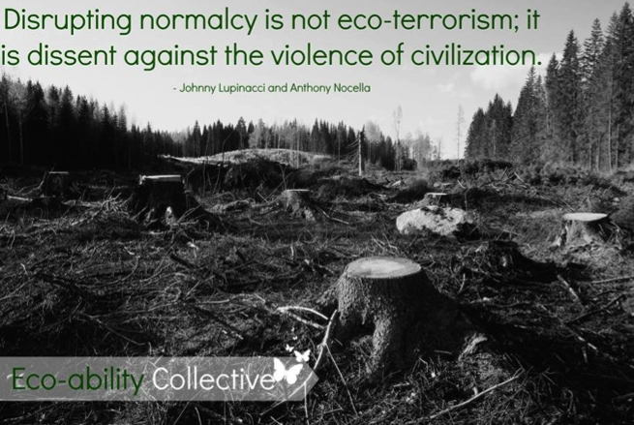
Here is another slide we created—“Disrupting normalcy is not eco-terrorism”—so those who resist, who protest etc.— “dissent against the violence of civilization.” So civilization is the reality, while normalcy is the theory.

Image 9. Designed by Anthony J. Nocella II used image from www.reddisability.org.uk
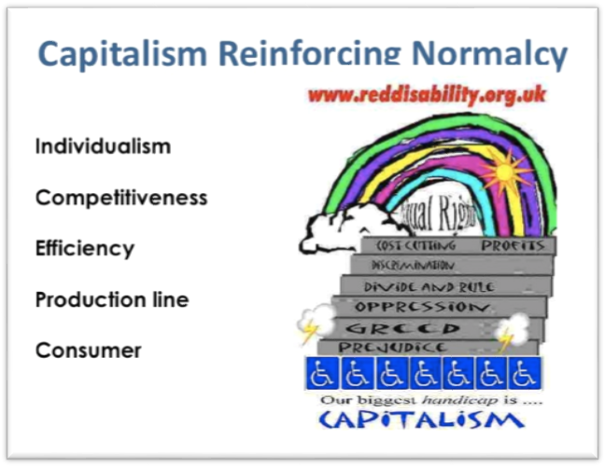
Capitalism reinforces normalcy; it is very individualistic and competitive; it’s about efficiency.

Image 10. Designed by Anthony J. Nocella II with cover of Green Anarchy Issue #22

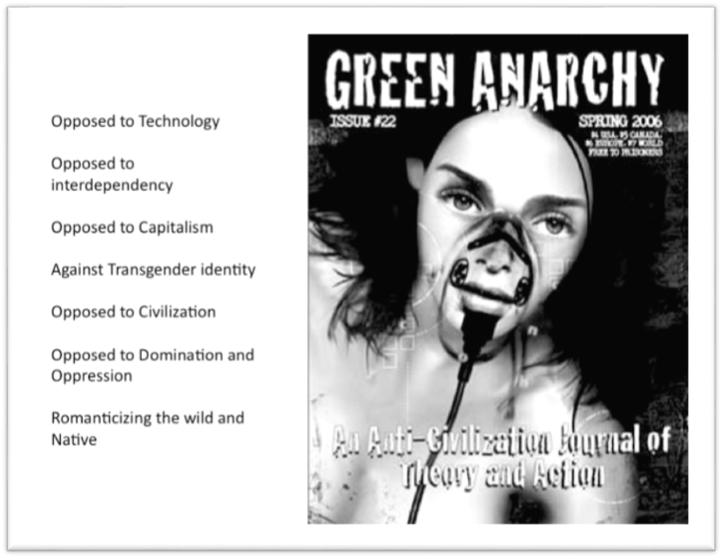
There are some really good things about the anti-CIV, or the green-Prim, primitivist perspective which oppose technology. A lot of technology is not useful, like the military and medical industrial complexes, but the technology that assists those with disabilities are fairly small and we aren’t going to be closing down civilization anytime soon, so why burn the bridge if we don’t need to? I don’t want to get into the Oppression Olympics, but individuals with disabilities comprise the largest group of oppressed people in the world because they span all different identities: race, class, age, gender, sexuality. So people with disabilities need to be in this conversation and you can’t say well ‘just pull the plug’ like John Zerzan said in Toronto. I think what he should have said in Toronto when somebody asked him what do we do with people on technological devices to keep them alive, “That’s a hard question. I think we should sit down with people with disabilities and really have a deep conversation about that.”
Some who oppose civilization also oppose transgendered identities because many who are transgendered want to undergo surgical body modifications. Then, of course, we have Lierre Keith and Deep Green Resistance (DGR), which notes that they do not support transgendered identities and sees it as comparable to a poor person saying he is poor person’s body with a rich man’s mind. This is a simplistic and ineffective analogy and also offensive to the transgender community.

Image 11. Designed by Anthony J. Nocella II
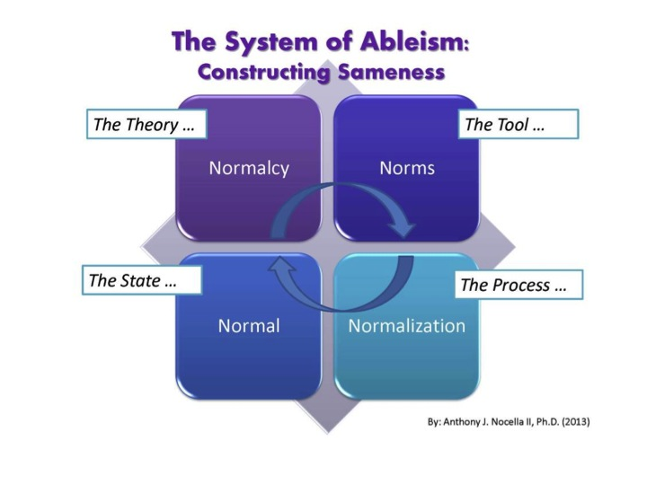
Here is the theory of normalcy. Norms which exist in society are as seemingly simple as going to work, getting on a bus, taking a shower, brushing your teeth, etc. All of these activities are perpetuated as being normal, so we forget that not everyone can easily do them.

A prime example of “normalcy” implemented in Western society is the Holocaust. Those first targeted, tested on, and killed were those with mental and physical disabilities.

Image 12. Designed by Anthony J. Nocella II

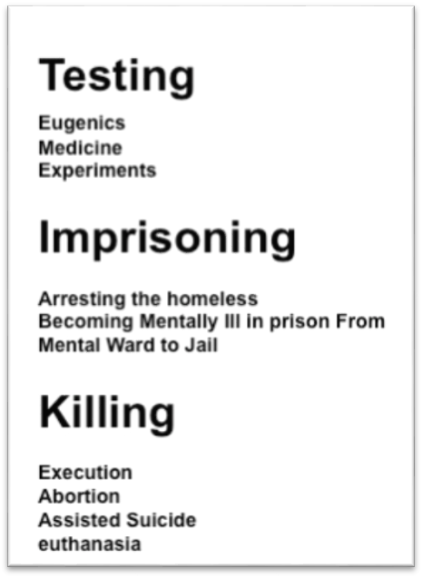

This slide above considers the prison system, including the death penalty, which has historically reinforced eugenics and medical experimentation.

Further, the medical industrial complex has developed procedures so individuals can abort fetuses that will likely grow into children with disabilities or birth defects. The medical and commercial industries state that an unhealthy baby is the abnormal baby; healthy babies have desirable “normal” bodies without defect or disability.

Image 13. Designed by Anthony J. Nocella II

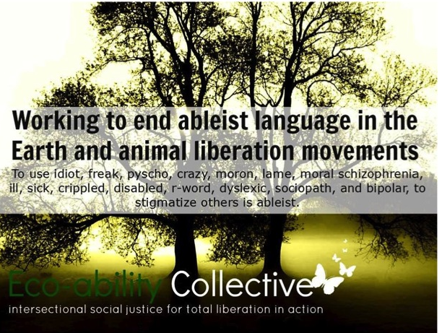

The animal advocacy movement must start challenging the ableist language and images that it often uses to make its points. Lauren O’Laughlin and Marie Houser, feminists and queer theorists, have started examining the exploitation of nonhumans with disabilities whose images are posted all over Facebook to evoke both pity and smiles amongst viewers. Such images also arise on blogs and in videos, resulting in a sort of nonhuman disability pornography.
This imaging and objectification is not coincidental, and it is notable that mainly women, not men, have most ardently begun to articulate the problems with such images. Why women? Why feminists? Because they’ve experienced objectification firsthand on a more regular basis than men.

Image 14. Designed by Anthony J. Nocella II and cover of Vegan Freaks (2010)
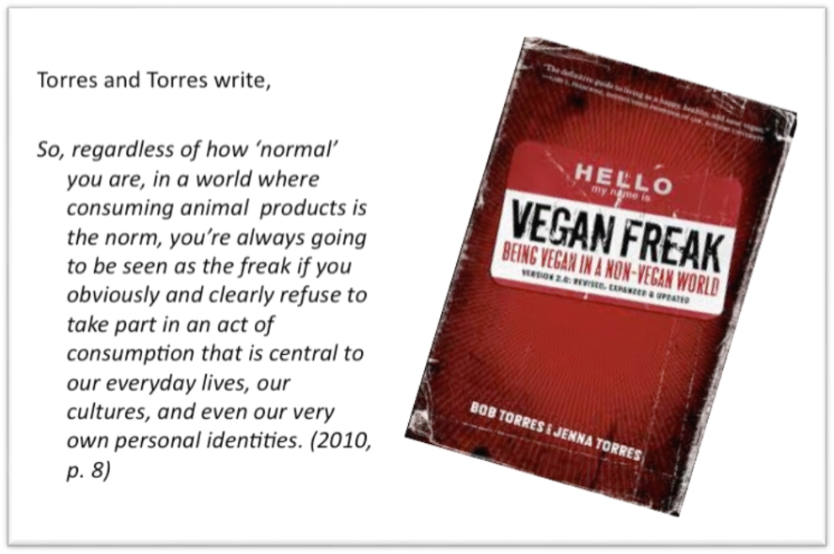

Here is an example of ableism in an otherwise decent book. The problem is the title itself: Vegan Freak. Torres and Torres write that regardless of “how ‘normal’ you are in a world where consuming animal products is the norm, you are always going to be seen as the freak if you obviously and clearly refuse to take in apart in an act of consumption that is central to our everyday lives, our culture and even our very own personal identity". And this is very true, but we also have to challenge their word choice from a disability and lens.

Image 15. Designed by Anthony J. Nocella II and cover of Freak Show (1988)
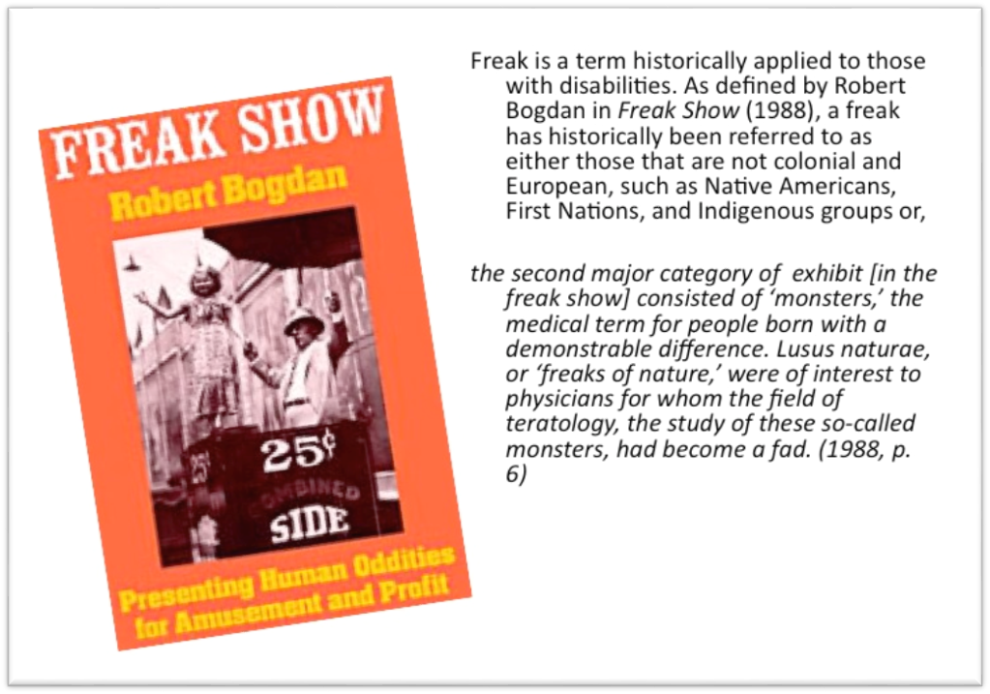

So, you may ask, what is wrong with the word “freak”? As Robert Bogdan explains in Freak Show, there are two types of freaks: Native American, First Nation, and indigenous groups, and those that are “the monster in freak shows and circuses”. In other words, freaks are any who have bodies that differ from the Euro-centric ideal of normal.

Image 16. Designed by Anthony J. Nocella II

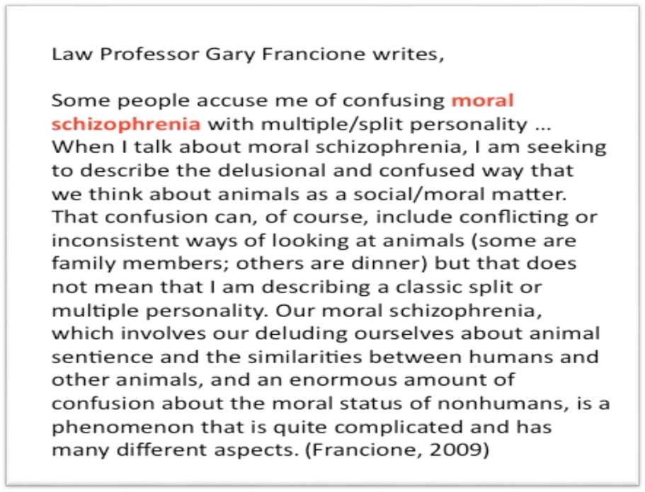

And then there is Gary Francione, whose work is important in many ways. However, he has become well known for this concept of ‘moral schizophrenia’, based on the idea that if one claims to love animals but also eats them, they have a split personality (which is also known as dissociative identity disorder, not schizophrenia). Regardless of Francione’s misunderstanding of basic psychology, ‘moral schizophrenia’ is a negative rather than uplifting term, and, of course, he opposes those who eat meat and test on animals. Therefore, he is stigmatizing those who have certain mental disabilities as less than and immoral. When called out on his use of the term, Francione did not apologize as much as he justified (see below). He is not the only one to do this. I am using Francione as a prominent example of many who use ableist terminology without critical thought.

Image 17. Designed by Anthony J. Nocella II
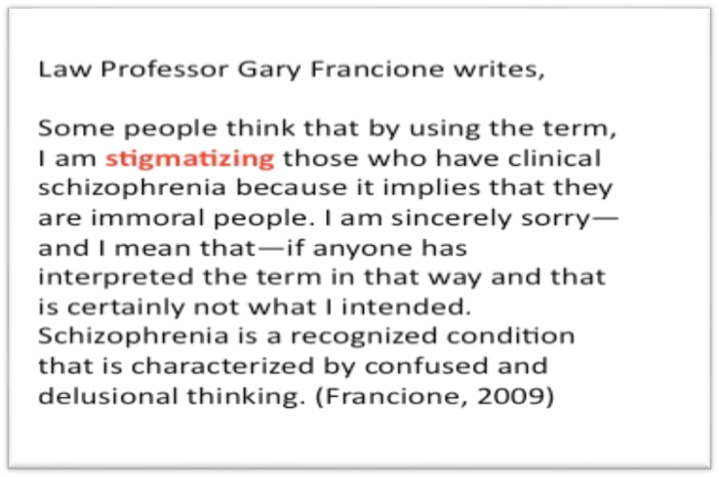
Above is Francione’s response to accusations of ableism. There is a well know Irish Proverb: The road to Hell is paved with good intentions. But rather than justify our misguided good intentions, we must listen to and be an ally of those who are oppressed, Joe Leeson-Schatz ably notes. We have to begin to listen, rather than assume we understand the needs of the oppressed. And this is what the title of this paper is about, about the oppressors leading the movement.
We must ask ourselves what will lead to real animal liberation. Are we really doing what the animals want? We can certainly suppose. I think they would probably not want us to go to the government and ask for larger cages. I think they would want to do more radical and extreme actions so they can be free more quickly, but most are not going to jeopardize their freedom for them, so we have to own the reality that we are not going to do everything in our power to liberate the animals. Rather, most of us do what we can until it jeopardizes our freedom and comfort.

Animal rights activists have the ability to act for or leave the movement at any time because we are not being oppressed in the same way as those for whom we fight. And when oppression and repression of activists do occur, many people leave the movement. We saw that in 1990’s when activists were being repressed, arrested and incarcerated. While many are still involved despite that repression, others just left and are now meat eaters, milk drinkers, and disengaged from any social movements. A person with disabilities does not have such leeway to leave a movement that fights for their rights.

Image 18. Designed by Anthony J. Nocella II
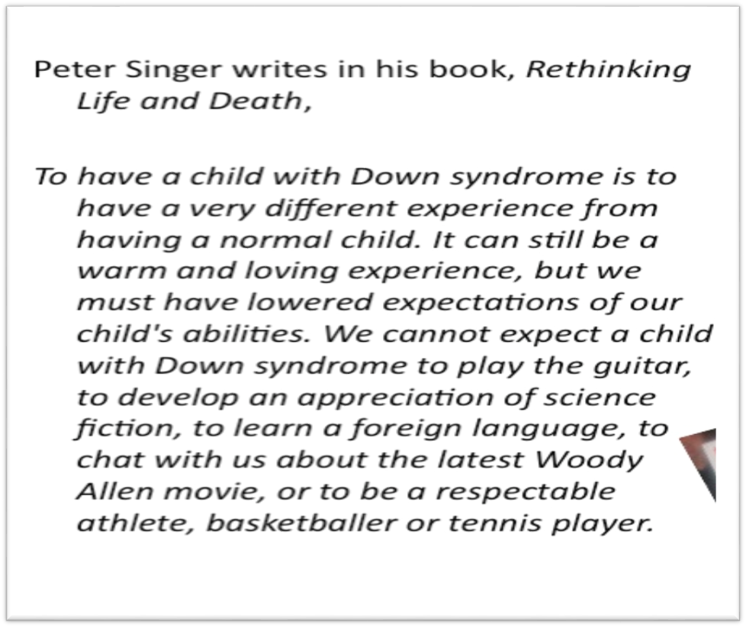
We have another person who has done a lot for the animal liberation movements, but he’s made himself an enemy of the disability movement. Consequently, if you say “animal rights” to people with disabilities who know anything about animal rights, they will be suspicious because of Peter Singer. Singer supports often deny that he has said anything against those with disabilities.
The book excerpt above puts that argument to rest for reasons that clearly do not need to be explained.
Singer is perpetuating the concept of normalcy, and for him, Down syndrome isn’t normal. See the quote above, one with which I take umbrage. I was in a school for youth with physical and mental disabilities, and I observed, firsthand, children who had Down syndrome playing the piano, drums, and violin. So, Peter Singer is wrong about that, as he is also wrong about their athletic ability, for I have seen students with Down syndrome engaging in sporting activities.

Singer is a philosopher who based his specious conclusions on supposition; he’s not a psychologist, medical doctor, or teacher, and he believes that those with Down syndrome are viable medical testing subjects for the betterment of society—that is a utilitarian perspective.

Image 20. Designed by People for the Ethical Treatment of the Animals (PETA)
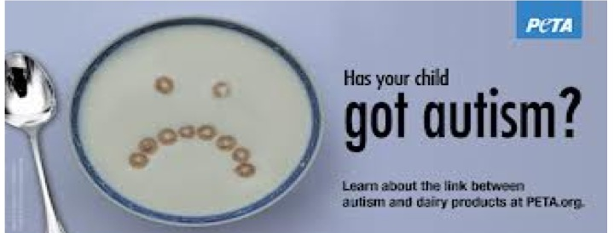

As another example, PETA perpetuates normalcy and tries to challenge what is normal by making veganism fit that criteria. In contrast, they say that drinking cow milk could lead to autism, which is not normal and something to be avoided from their perspective. First, that statement is false. Second, autism is nothing to be ashamed of and should be embraced rather than treated as a vile epidemic to conquer.

Why do we have to be normal? Why can’t everyone be different; that is beautiful and representative of an ecological society that is in balance when everyone is independent and different. A very weak society is where everything is “normal” and the same.
So, don’t drink milk, as PETA would say, so that you don’t have disabilities. Further, if you don’t drink milk or eat meat, then you will be skinny and sexy, which is another attempt to define normalcy and desirability.

Image 21. Designed by Anthony J. Nocella II and cover of Skinny Bitch (2005)

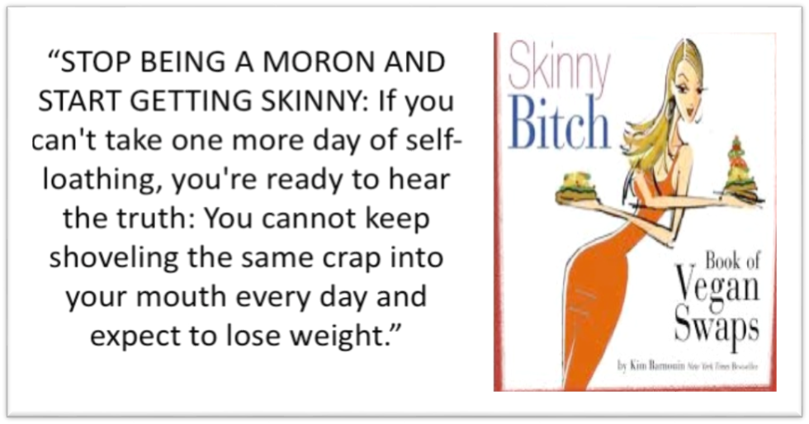

We can now move to targeting based on gender, which also includes ableism (re ‘moron’). Women are to be skinny and men to be bulky (in the muscular sense) to be masculine.

Again, we need to really understand that eating a vegan diet is not about being healthy, looking good, or being sexy. It is an ethical and moral decision and we need to step back and complicate the discourse rather than just giving out literature that says, “Be Sexy. Don’t eat meat.” The literature should say, “Be Ethical. Don’t eat meat.” That’s what we need to start emphasizing.

Image 22. Cover of The Sexy Vegan Cookbook (2012)

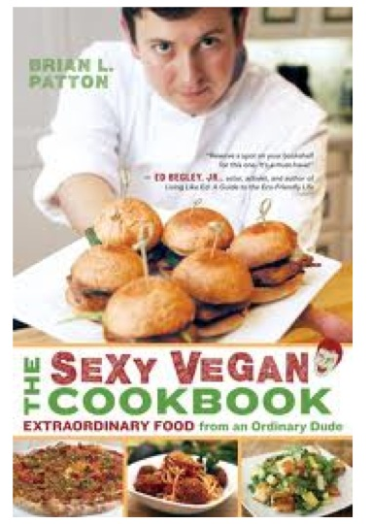
The sexy symbol of going vegan/vegetarian is played out. Look at PETA’s use of Pamela Anderson, which is an airbrushed image of a woman who has ad plastic surgery. That image does not depict the outcome of going vegan. Consequently, Anderson is not normal or natural. In contrast, PETA offers whale analogies to demonize people who don’t meet consumer culture’s weight standards.

Image 23. Designed by People for the Treatment of Animals (PETA)

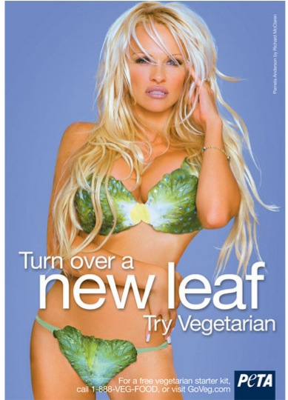

Image 24. Designed by People for the Treatment of Animals (PETA)

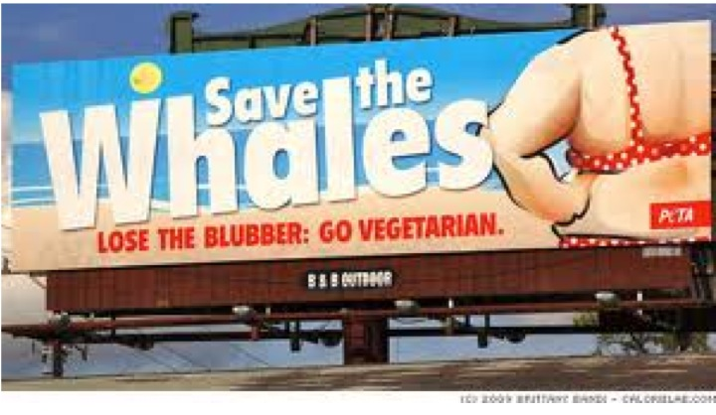

Image 25. Designed by V Girls / V Guys

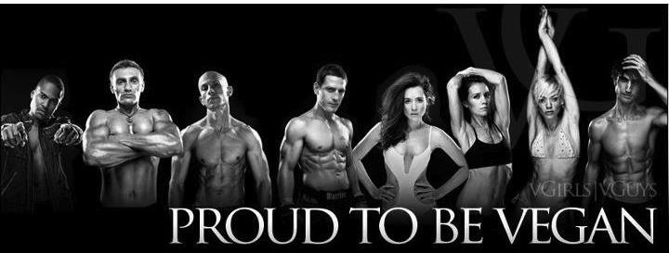

Here is another image of muscular men and women who are also vegan. I have met some of them, and they are nice people, but their bodies should not be the point of veganism. Veganism is about not harming animals.

Image 26. Designed by thinkvegan.net

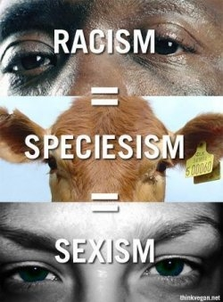

Holocaust analogies are also common in the movement, but the Holocaust is different than the slaughter of animals. The American slave trade is different than elephants exploited in a circus. We can never fully understand another’s oppression. Therefore, we should try to sympathize, and value, engage, and learn about that experience, but we cannot understand what it means to hold an identity different than our own. We cannot have experiences we have not had.

Racism doesn’t equal speciesism; speciesism doesn’t equal sexism. As noted, “equal” is a socially constructed measurement. Racism entails specific experiences, as does speciesism and sexism. Therefore, we shouldn’t make these broad statements even though they are very easy and may sway people to our side. What’s missing here is articulation of a moral/ethical philosophical theory. Analogies such as those mentioned also offend a great amount of people, such as those from the Jewish community, people of color and women.

The savior mentality also arises when we take pictures of ourselves with goats, chickens, pigs, etc. Are those images really about the animals, or are they saying, “Look at what I did today. I am better than you.” I am like Brad Pitt, Madonna, etc. saving youth from Africa.
The disability community does not want pity. The concept of pity is a very philosophical term where you belittle an individual and reinforce ideas about their inferiority while believing yourself superior and of the dominant group.

I also think there is a problem with the term “special,” as in the Special Olympics. What makes them so special? Isn’t everyone special? The concept of “special” is very much like “pity” because we see others as having disabilities, which make them less than. Pitying someone means they aren’t up to your level and don’t deserve to live in a normal society. Normalcy is the framework of pity.
Image 27. Designed by Anthony J. Nocella II
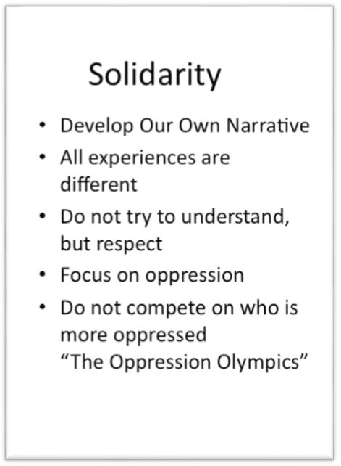

Solidarity is about respect. It is not about focusing solely on another’s oppression. We also shouldn’t compete when it comes to oppression; otherwise, we engage in the futile Oppression Olympics. We need each other, and every experience is very valuable. As Black Panther Fred Hampton would say: “Yellow power for yellow people; Brown power for black people; and White power for white people.” I believe in power for all people.

Image 28. Designed by Anthony J. Nocella II with Igniting a Revolution (2006) book cover
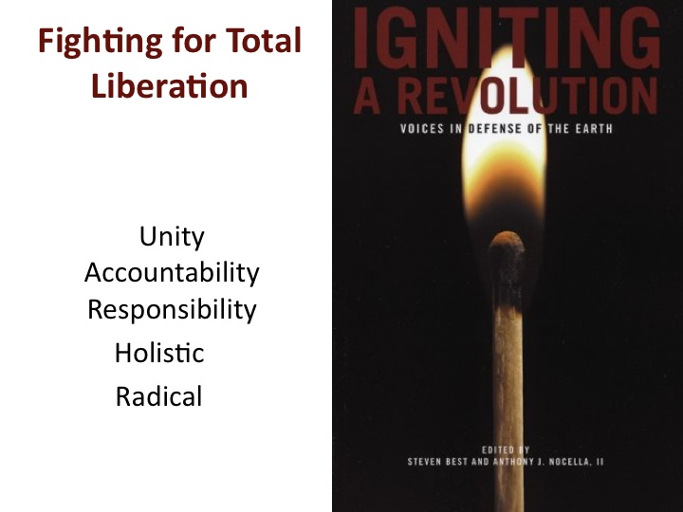
We must start fighting for total liberation, unity, accountability, responsibility, and a holistic and radical approach to these things. For example, I co-edited a book collection called Igniting a Revolution that brought different movements together through concepts of total liberation and intersectionality. Thank you so much. I really enjoyed presenting.

Image 29. Designed by Anthony J. Nocella II

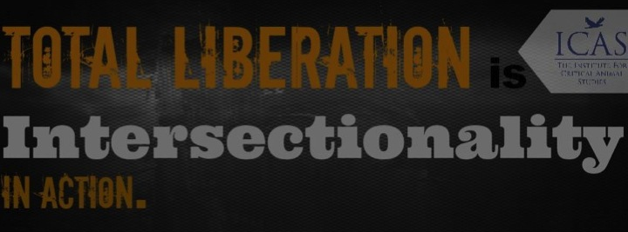

References
Best, S., & Nocella II, A. J. (2006). Igniting a revolution: Voices in defense of the earth. Oakland, CA: AK Press.
Bogdan, R. (1988). Freak show: Presenting human oddities for amusement and profit. Chicago, IL: University of Chicago Press.
Francione, G. (2009, August 12). A note on moral schizophrenia. Animal Rights: The Abolitionist Approach. Retrieved on July 17, 2011, from http://www.abolitionistapproach.com/a-note-on-moral-schizophrenia/.
Freedman, R. (2005). Skinny bitch. Philadelphia, PA: Running Press.

Patton, B. (2012). The sexy vegan cookbook: Extraordinary food from an ordinary dude. Novato,

CA: New World Library.

Singer, P. (1996).Rethinking life and death: The collapse of our traditional ethics. New York,

NY: St. Martin's Griffin.
Torres, B., & Torres, J. (2010). Vegan freak: Being vegan in a non-vegan world: Version 2.0 (Rev. ed.). Oakland, CA: Tofu Hound Press.

