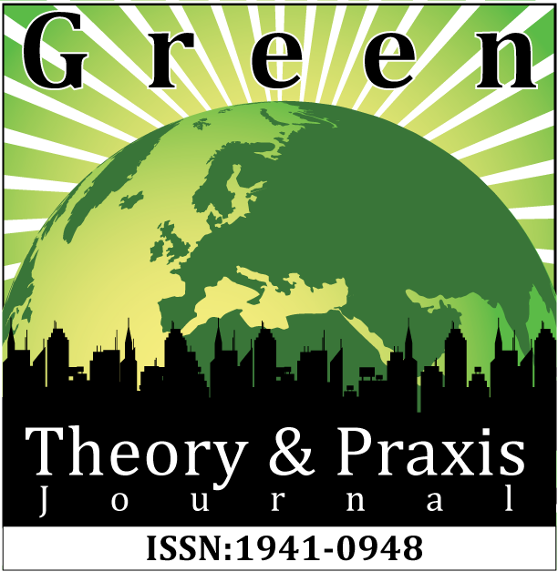
GREEN THEORY & PRAXIS JOURNAL: REVIEW FORM

Please complete the review report form which will be used to directly inform the decision as to the suitability of the article for the Green Theory & Praxis Journal, and to suggest guidelines for any future revisions identified.

Please ensure that you detail your required revisions clearly, and provide an overall evaluation of the paper that is explicit, courteous and respectful to the author(s), and indicative of the standards expected for publication in a journal concerned with environmental justice and radical environmentalism. We especially encourage and promote authors engaged in activism.

In your evaluation (see page 2), please pay particular attention to the following:

• The originality of the subject matter, and whether the manuscript would be of interest to the international, academic and activist readership of the Green Theory & Praxis Journal.

• The theoretical contribution made by the manuscript.

• Whether the article draws on an appropriate range and depth of literature. (If not please indicate which sources of literature should be included by the author in future)

• Whether methods employed are rigorous, ethical, and suitable for the topic under investigation.

• Whether the findings presented are subjected to suitable analysis and sound conclusions drawn.

• Does the paper clearly identify any implications for future activism and/or developing theories or activism for peace and social justice? Are these implications consistent with the findings and conclusions of the paper?

• Is the piece well presented and organized? Does the paper clearly express its case, measured against the technical language of the field and the expected knowledge of the journal's readership? Has attention been paid to the clarity of expression and readability, such as sentence structure, jargon use, acronyms, etc. Is the paper written in a manner, which is non-ableist, non- speciesist, non-sexist, non-homophobic, non-classist, non-racist, non-colonialist, unlikely otherwise to cause offence, and appropriate for an international academic journal?

The Green Theory and Praxis Journal holds to the utmost respect, love, and care when reviewing manuscripts. While we do take off the names of the submitter, we do ask the reviewers to keep their name and e-mail contact on the Reviewer’s Comment Sheet in-order for the author to contact the reviewer directly for assistance and advice. This we feel and argue is the most productive and useful reviewing process for advancing the field of activism and environmentalism.

If there are any comments you would like to make in confidence to the editors and not for onward
transmission to author(s), please complete the ‘confidential comments for editors’ section.

Reviewers’ Name

Reviewer’s Institutional Affiliation _

Reviewer’s E-Mail

Please indicate decision and write your detailed comments to the author either below (using an additional page if necessary). If you choose to use MS comment features, please make your name anonymous—directions can be found here https://support.office.com/en-us/article/Change-the-author-name-for-review-comments-cdd4b8ac-fbca-438d-a5b5-a99fb1c750e3
TITLE OF THE MANUSCRIPT REVIEWED FOR GTPJ

Accept☐ Minor revisions required ☐ Major revisions required☐ Reject☐

One sentence summarizing decision:

Comments for the Author(s) (Please provide your comments for the author(s). Use as many pages as required or feel free to use MS comment features)

Confidential comments for the Editors (if required)

