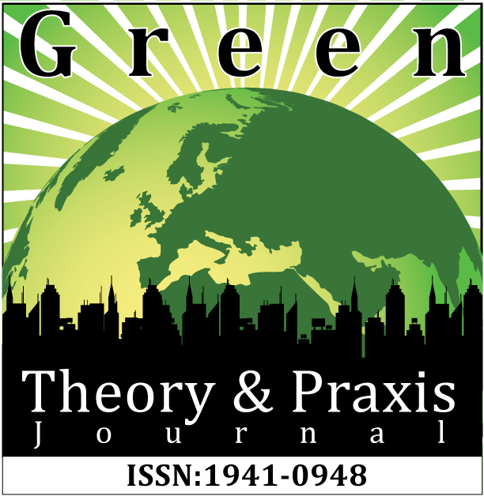

Volume 16, Issue 1, February 2024
Theme:
Labor Ecologies and the Right to Survive

Volume 16, Issue 1, February 2024
___________________________________________________________________________

Issue Editors:

Matthew R. Sparks, William Horne, and Ceire Kealty
Special thanks to Zane McNeill
___________________________________________________________________________

TABLE OF CONTENTS

About Green Theory and Praxis Journal……………..……………………………………………3

Editorial Team…………………………………………..………………………………………...4

Submission Guidelines………………………………………………..…………………...……5-8

LABOR ECOLOGIES AND THE RIGHT TO SURVIVE
(Special issue in collaboration with The Activist History Review)

Introduction: Labor Ecologies and the Right to Survive
William Horne.…………………….……………………………………………………………...9
ARTICLES

Necessary Utopias: Black Agitation and Human Survival
William Horne.…………………….…………………………………………………………….14

To Live: Navigating Survivalism through Ecological Warfare as Colonialism Ravages Onwards
Kathy Nguyen………………….….…………………….……………………………………….34

Reckoning with Survival in the Long-COVID Era
Céire Kealty ………………….….…………………….………………………………………...48

Project Protect Food Systems Workers: The Dance of Legislative and Relational Activism
Michelle Auerbach &
Nicole Civita………………………….….…………………….…………………………...……64

The Animal Apparatus: Taxonomic Stratification as an Anglo-Imperial Technology
Gray Black………………….….…………………….………………………………………......93

BOOK REVIEWS

Review: Vandenbosch, Michael, and Philip Lymberry (eds.). Cultivated Meat to Secure Our Future: Hope for Animals, Food Security, and the Environment. Brooklyn, NY: Lantern Publishing and Media.
Nathan Poirier………………….….…………………….………………………………...........103

ABOUT GREEN THEORY AND PRAXIS JOURNAL

The Green Theory and Praxis Journal (GTPJ; ISSN: 1941-0948), founded in 2005, arose out of two projects: the “Revolutionary Environmentalism: A Dialogue Between Activists and Academics” Conference on February 13-14, 2003, at Fresno State University and Igniting a Revolution: Voices in Defense of the Earth (Best & Nocella, 2006). GTPJ is a carefully peer reviewed, intersectional social justice publication focused on the global ecological community. This scholar-activist journal is dedicated to expanding and challenging classic scholarship on environmental issues, as the field has long been dominated by white, able-bodied, Christian, Western-colonial perspectives on ecology, wilderness, nature, and the environment, with a deficit of criticism against corporate greenwashing and capitalism.

A multi-movement publication, GTPJ is a critical theory journal seeking scholarship in the areas of environmental justice, indigenous people, first nations, aboriginal communities, eco-ability, eco-feminism, eco-transgender studies, global justice, food justice, revolutionary environmentalism, critical race theory, critical environmental education, ecopedagogy, Earth liberation, etc. Further, the journal promotes deconstruction of oppressive binaries (culture/nature, wild/civilized, human/animal), real world application of critical theory, and a jargon-free rhetorical foundation supporting the abolition of all systems of domination. GTPJ is not a reformist publication. Rather, our mission argues for mass global transformation through the critique of systems, not individuals, that promote oppression and/or domination. We believe change emerges from building alliances, as opposed to fueling conflicts. Ultimately, GTPJ a theory-to-action journal open to scholarship that fosters a holistic journey for total liberation and justice.

– Green Theory and Praxis Journal, (December 19, 2014)

EDITORIAL TEAM
Editor

Matthew R. Sparks
Ben Gurion University of the Negev
Managing Editor and Co-Founder

Dr. Anthony J. Nocella II
Salt Lake Community College

Media Reviewers

Gray Black
University of St. Andrews

Reviewers
Dr. Konstantina Tsalapati
National & Kapodistrian University of Athens
Matilda Nuñez del Prado
Universidad Mayor de San Andrés

Dr. Amber E. George
SUNY Cortland and Le Moyne College
Dr. Aristotelis Gkiolmas
University of Athens, Greece

Dr. Richard Loder
Syracuse University
Dr. John Lupinacci
Washington State University
Dr. Les Mitchell
University of Fort Hare

Dr. David Pellow
University of California, Santa Barbara
Dr. Kostas Skordoulis
National & Kapodistrian University of Athens
Brian Trautman
Berkshire Community College
Dr. Richard White
Sheffield Hallam University
Dr. Roger Yates
University College Dublin and the University of Wales
Nikoleta Zampaki
National & Kapodistrian University of Athens

SUBMISSION GUIDELINES

Please read these guidelines below and then send your article, essay, review, research notes, conference summary, etc. to:
greentheoryandpraxis@gmail.com

Value and Uniqueness of GTPJ
- The Green Theory and Praxis Journal publishes rigorously peer-reviewed academic work of the highest quality.
- The Green Theory and Praxis Journal is a free-to-access electronic journal.
- The Green Theory and Praxis Journal charges no fees for publication.
- The Green Theory and Praxis Journal supports and encourages submissions that are excluded from mainstream journals, including the use of photographic, video and new media work.
- The Green Theory and Praxis Journal, while an academic journal, provides space and place for activist contributions.

We Seek
- research articles and essays – 2,000 to 10,000 words
- student final papers – no more than 10,000 words
- course/class summaries – no more than 2,000 words
- research notes – no more than 2,000 words
- commentary – no more than 2,000 words
- tactic and strategy analysis – no more than 10,000 words
- academic development – no more than 10,000 words
- lecture summaries – no more than 2,000 words
- conference summaries – no more than 2,000 words
- protest summaries – no more than 2,000 words
- action alert summaries – no more than 2,000 words
- film, book, art, and media reviews – no more than 3,000 words
- interviews and dialogues – between 1,000 to 10,000 words
- poems – no more than 10,000 words

Formatting, Referencing and Submitting your Manuscript
- GTPJ uses the APA format. For details on the APA format see Purdue Owl.
- Please follow these guidelines when preparing your submission. Failure to do so may mean that your submission is not put forward for peer review.
________________________________________________

Review Process and Policy
- All submissions must be grounded in the fields of environmental justice, Earth liberation, revolutionary environmentalism and intersectional total liberation social justice and locate their arguments in existing GTPJ essays/reviews/conversations when possible. All submissions need to be jargon-free and promote activism.
- Every effort will be made to inform authors of the Issue editors’ decision within 60 days of receipt of a manuscript.
- Authors whose manuscripts are accepted for publication will be asked to submit a 50- to 80-word biography that includes their institutional or organizational affiliations if applicable, professional title, e-mail, country, and one to six keywords.
- All submissions must not be under review with any other publication.
- All submissions must be original and not published anywhere else such as wordpress, Facebook, blogs, website, or academia.edu prior or after without proper permission from the original source and from the GTPJ Editors.
- Upon acceptance for review, the editors will send manuscripts, under a double-peer reviewed process, to no less than two, and generally three reviewers. Reviewers provide their recommendations to the Issue editor(s), who makes the final decision to accept the manuscript.
- Everyone who submits text to be reviewed for publication in GTPJ will be assigned an Issue Editor, who will be the only person of contact with GTPJ.
- If a dispute/conflict arises that cannot be resolved with the Issue editor the author(s)/reviewer(s) may contact the Editor of GTPJ, but not anyone affiliated with ICAS. If a legal matter the Editors of GTPJ will if necessary involve the ICAS Board of Directors.
- Once accepted for the GTPJ the author(s)/reviewer(s) will work on a structured timetable with deadlines to edit the text for publication. A final draft of the text will be sent from the Issue editor to the author(s)/reviewer(s) of the text to approve with the ability for minor grammar, spelling and formatting errors with 5 days to reply. Once sent back with approval with edits attached in a Word Doc. and/or just an approval via e-mail, the Issue editor will reply with acknowledgement of the e-mail Cc:ing the GTPJ editors.
- After the issue is formatted by the Issue editor and GTPJ Editors it is uploaded via PDF, Word Doc, and Issuu.com. Once published/uploaded no re-editing is allowed only in the case of a legal situation where the material written by the author(s)/review(s) is under question.
- The final process once the Issue is published online, is for the contributors, Issue editor, GTPJ Editorial Team, and ICAS to promote the Issue through e-mail listerserves, social media, websites, blogs, flyers, media, newsletters, etc.

Submission Review Determination
- accept without revisions
- accept with editorial revisions
- revise and resubmit for peer review
- reject

Copyright, Republishing, and Royalties
- All work published by the Journal is copyrighted by GTPJ.
- Republication of Contributor’s Submitted Work may be assessed a reasonable fee for the administration and facilitation to other presses. Such fee shall be determined at the discretion of GTPJ.
- Royalties: Contributor agrees and acknowledges that no royalty, payment, or other compensation will be provided by GTPJ in exchange for or resulting from the publication of the Submitted Work.
- Review Form available here: GTPJ Review Form
- Author’s Contract Form available here: GTPJ Authors Contract 2016

Publication Dates
GTPJ uses a rolling submission process, allowing authors to submit at any time during the year without time restraints or quota of articles in an issue. Rolling submission, the most current scholarly method of accepting publications, allows for more timely publications and current scholarship to enter the public sphere in a more timely fashion, rather than conforming to traditional academic print journal guidelines.

We are pleased to accept your submissions at any time and will move quickly through the review process to ensure timeliness.

For general submission, please submit to:
greentheoryandpraxis@gmail.com

Volume 16, Issue 1, February 2024
________________________________________________________________________

Introduction: Labor Ecologies and the Right to Survive
Author: William Horne
Titles: Ph.D.
Affiliations: Villanova University, The Activist History Review
Emails: horne.activisthistory@gmail.com
Location: Villanova, Pennsylvania
Keywords: survival, collapse, COVID-19, labor ecologies, race
________________________________________________________________________

Who has the right to survive? This shocking question captures the defining problem of our era. From medical care to mass incarceration, homelessness to mass starvation, the right to survive is hardly guaranteed in the U.S., and the question of survival only grows more urgent as global capitalism seems bent on squeezing out the last drops of petrocarbon profits from the withered husk of our planet. If we are to seize the right to survive for all, we must understand the ways that these issues are intertwined.

The essays in this special issue address this multifaceted question of survival from a variety of perspectives with the urgency required of our time. Together, they reveal the scope of the problems we face as living beings in societies and on a planet made increasingly unlivable. The interrelated crises of inequality, climate collapse, mass deprivation and migration, and resurgent white supremacies and authoritarian nationalisms present a devastating present and doubtful future. Among the defining recent expressions of these crises, the dismal and eugenic response of Western democracies to the COVID-19 pandemic reveals the unwillingness of the powerful to prioritize human life over their own wealth and convenience. In many respects, as Gray Black’s contribution to this collection reminds us, Western democracy has always been impeded by its devotion to the social, racial, and ecological hierarchies of its colonial origins.
My essay contribution to this issue, “Necessary Utopias: Black Agitation and Human Survival,” examines this dynamic of crisis and utopian alternatives through the historical lens of slavery and white supremacies in the U.S. While this landscape of racial oppression presented a genocidal and unlivable present for nonwhite Americans, Black thinkers and organizers imagined and agitated into existence systems designed to support human thriving and equality. Against the backdrop of slavery, Black radicals led the way to expansions of citizenship, education, and suffrage that benefitted millions while authoring the nation’s first anti-discrimination laws. Black workers demanded, enacted, and nearly cemented an astonishing system of land reform that would have redistributed the land of former enslavers to the Black workers who had tilled the soil and made it profitable. After waves of unprosecuted white supremacist violence and insurrections toppled their effort, Black radicals of the civil rights era applied these lessons of agitation to the apartheid state of Jim Crow, making systems of oppression inoperable as they demanded and created new structures and institutions. “From the survival programs of the Black Panther Party to the Freedom Farm work of Fannie Lou Hamer,” I explain, “Black radicals worked to implement precisely this vision—one designed to sever the relationship between property and power.” These tactics of resistance—of utopian revolt and creation—provide a blueprint for a life based on living, what Aimé Césaire calls “a society rich with all the productive power of modern times, warm with all the fraternity of olden days.”

The racialization of the right to survive not only shaped the experience of subjects within the U.S., as Kathy Nguyen shows, but also of those in the clutches of its sprawling empire in Vietnam. Her article, “To Live: Navigating Survivalism through Ecological Warfare as Colonialism Ravages Onwards,” examines the impact of indiscriminate U.S. bombings and occupation on Vietnamese women, with special attention paid to the experience of her mother. For Nguyen, the care work expected of Vietnamese women forced them to navigate a war in which they had very little say while having to maintain families and communities in the absence of men put them in impossible situations. In some respects, these worsened in the wake of the conflict. “Amid the residual rubble of war,” she writes, “women’s stories are buried underneath, producing an internal displacement within their own country of origin.” This experience only exacerbated the trauma of war and deprivation in an impoverished society.

Against this gendered and nationalist silence, Nguyen’s essay is especially poignant in her inclusion of her mother’s testimony:

I don’t think any of us wanted to be born during thời chiến loạn // wartime. If you were born as a Vietnamese during that time, it was fate. As long as I didn’t inflict harm on others to ensure my own survival, I could sleep a bit at night, knowing that I survived. It was like that every day, wishing to survive even if there wasn’t a guarantee. Survival can be a fragile promise, just like human lives.

Nguyen’s story gives a powerful statement of solidarity and survival during a period of extreme ecological and social devastation—her mother even risks her life to save her family’s two cows—as well as a pressing case for reordering society around care and community. “This surrealistic bleak dystopian society where survivalism remains a tenuous civilian right, afforded and offered to only a specific few,” she argues, represents a collective choice we cannot afford to make.
Building upon this foundation of social hierarchy and racialized expropriation that continues to impact those both within and beyond the boundaries of the state, America’s ruling class weaponized its response to the COVID-19 pandemic to increase the vulnerability and exploitability of underpaid “essential workers” without whom it cannot function. In “Reckoning with Survival in the Long-COVID Era,” Céire Kealty, who co-edited this issue with me, argues that this response demonstrates the need for a complete reassessment of our collective priorities around an ethic of care and human survival. Kealty does not mince words—the disregard for the wellbeing of others by the powerful who “cannot bear to be inconvenienced for the sake of the vulnerable and sources reassurance from the death of these groups is more than broken and pathetic—it is eugenicist.” Under such a system, there can be no right to survive because survival itself becomes a commodity, prepared and packaged by the most vulnerable among us, pushed to the margins, their unseemly suffering kept safely out of view.

While most aspects of our society are highly partisan, Kealty observes that the eugenic response of those in power to COVID transcends party lines. She writes:

Long haulers also face another roadblock: that of a stunted political imaginary. This imaginary subsists on neoliberal logics, exposing how Trump and Biden are cut from the same bootstrap-addled, corporatized, rest-averse cloth. Our political imaginary cannot envision a body reclining, a person away from work, a form not laboring.

Here, Kealty identifies the fetishization of work as the bedrock of the American psyche, one riddled with racist, ableist, and gendered logics. Even those in power are defined by and assigned value based on their perceived ability to work. It is the central organizing feature of our society. This workist culture has produced a surge in Long COVID as workers are forced back into submission before their bodies fully recover from infection while risking reinfection, creating what may well be a generation-defining mass disabling of the American worker. Kealty illustrates powerfully that our underlying sickness comes not from the disease itself, but from our withered political imaginary. Seizing a livable future requires not only reordering our systems of food, housing, and health to prioritize human survival over corporate profits, but also reimagining the role and value of work itself in our society.

Those most vulnerable to the predations of the ruling class are, in a terrible dystopian twist, also most essential to the survival of everyone else. Michelle Auerbach and Nicole Civita examine this historical dynamic among agricultural workers, who have long faced suppressed wages and coercive working conditions through racist policy and practice. In every respect, they are the actual “job creators” whose underwaged work translates into lower food costs and facilitates other forms of labor and leisure across the economy. These conditions were only amplified by the pandemic, during which food workers were forced back to the line with very little protection or access to healthcare. Auerbach and Civita chart the legal battle and organizing in Colorado to force growers—landowners, farm managers, and corporations—to provide safe working conditions and decent living conditions to those keeping food on our tables. Their successful campaign culminated in the passage SB 21-087 in 2021, designed to protect and empower agricultural workers in the state.

Auerbach and Civita ground their analysis in the testimony of working people themselves, who regularly faced racism, sexism, intimidation, poor treatment and living conditions, hostile work environments, and a constant threat of job loss and deportation. As one worker testified:

I worked for 5 to 6 years as a farm worker in Colorado and Arizona. I have worked with all kinds of vegetables and greenhouses with roses and in all places. The conditions are horrible and they took hours away from us. Saturday and Sunday there is no rest. I experienced exploitation in each of the places - wage theft, sexual harassment, they fired me from work when I asked permission to go to the clinic, they didn't give us water, there were no bathrooms, we had to go to the river and the cornfields, and there was no water to wash or remove the insecticide from the hands before eating.

Auerbach and Civita partnered with farmworkers, activists, and grassroots organizations as part of a coalition under the banner of Project Protect Food Systems Workers, which sought to transform the state of food work in Colorado. Together, they “distributed 45,492 food boxes, 909,840 pounds of food” to workers and their households along with “16,540 articles of clothing, 8,554 hygiene kits, 10,544 articles of outerwear, 5,510 pairs of work gloves, 2,694 duffel bags, 2,490 containers of sunscreen, and 891 sleeping bags” and worked to guarantee culturally-informed healthcare access through their promotora network. It is hard to label this effort alone as anything short of transformative, yet their organizing, testimony, and persistence also led to the passage of SB 21-087 to protect the rights of agricultural workers over stiff grower opposition. This story of triumph illustrates once more that working people are not just euphemistically but actually essential and powerful and are able to topple systems of exploitation and injustice.

Whether in fields, factories, cubicles, or COVID wards, colonial ideologies and practices of extraction, commodification, and hierarchy shape the political imaginaries, built environment, and systems that govern our lives. In “The Animal Apparatus: Taxonomic Stratification as an Anglo-Imperial Technology,” Gray Black analyzes the terminologies of commodification that created and spread British imperialism. Their essay examines the ideological labor of The Great Exhibition of 1851 where, “alongside the Royal Society’s panoply of technological inventions, Victorian journeymen had foregrounded the crown jewels of conquest within the exhibit: non-human animals.” In the wildly successful exhibition that launched the phenomenon of world fairs, nonhuman animals and even our shared environment were transformed into illustrations of colonial power presented for popular consumption. “Even fully-grown trees were engulfed by the hungry mouth of the cage,” Black writes, “as if to placate these ‘once-animals’ by showcasing their original habitats.” British elites refashioned these once-living beings as the centerpieces of their own ingenuity and power, suggesting a mastery over nature itself.

Black’s work illustrates not only the makings of the consumer capitalism that now threatens us all with the prospect of omnicide, but also the terminological innovations that facilitated this world of destruction. The explain:

It is critical to evoke the etymological origins of the word “animal,” which the Victorian ruling class seemingly sought to neutralize as the lexical successor of the once-common “beast.” …. Un animal, in French, or “an animal” descends from the Proto-Italic word anamos; a word not only meaning “breath,” but which also served as a metonym for “soul” or “spirit” (Cresswell, 2021). Therefore, once again, it is implied that an animal is a breathing, locomotive entity with the inclusion of a particular lifeforce which plants and rocks alike could never possess.

These ideas, in Black’s estimation, transformed both racialized subjects and nonhuman animals into subordinate beings through whom colonial elites and their successors “engineer[ed] and maintain power.” While some readers might be skeptical of the premise, I cannot help but recall Aph Ko’s Racism as Zoological Witchcraft: A Guide to Getting Out, which supports this central assertion that the ideological transformation of nonhuman animals into commodities lies at the heart of the alienation and exploitation of “postcolonial” racial capitalism. While I believe that we rightly prioritize human over nonhuman struggles, Black’s work reminds me that the two cannot actually be disentangled and that struggles for liberation must promote ecological justice and, with it, a vibrant and robust world of nonhuman life if they are to succeed.

From experiences of war and oppression to pressing food and health justice work, the essays in this issue reach to the core of what ails us. While we experience these crises differently based on the contexts in which we live, the machine they animate threatens survival itself. Those targeted and exploited by the ruling class and its enforcement army of consumers confront the resurgent dangers of colonialism—nativism, religious extremism, white supremacy, patriarchy, and ecological devastation—even as the larger network of predation could not function without their labor. It is at this point that we can see not only the horrors of this system but also its greatest weakness: the poorest participants in global capitalism are responsible for producing the bulk of the goods and services upon which we depend for survival. As we look to prior movements to inspire our own struggles against the forces of mass death, their successes reveal solutions in world building—in language, community and the commons, the destruction of commodifying systems and the creation of new ones—which are not only possible but absolutely imperative. While this realm of solutions might seem daunting, the history is clear: we have only to begin building these new structures in networks of community and care, support and solidarity, to make the utopian possible and bring a new and livable world into being.

Volume 16, Issue 1, February 2024
________________________________________________________________________
Necessary Utopias: Black Agitation and Human Survival
Author: William Horne
Titles: Ph.D.
Affiliations: Villanova University, The Activist History Review
Emails: horne.activisthistory@gmail.com
Location: Villanova, Pennsylvania
Keywords: utopianism, black radical activism, survival, revolt

________________________________________________________________________

Abstract

Why would we accept dystopias—futures of unmitigated human suffering—as “realistic” while denouncing the prerequisites for human survival as mere fantasy? While the question might seem at first glance to exaggerate our failures to address the interrelated crises of inequality, white supremacy, and ecological collapse, it is undeniably the case that our public discourse reflects a set of deeply dystopian assumptions about the future. Such an approach is not only defeatist, but nonsensical. If we can accept the potential transformation of reality into a macabre horror of human torment and deprivation, we must likewise concede that its transformation into the transcendent, the egalitarian, and the sublime is no mere possibility but an urgent necessity.

In this essay, I examine two moments of utopian revolt in the Black radical tradition situated against the functional dystopias of slavery and Jim Crow. The Black radicals of the nineteenth and twentieth centuries show the potential of a militant and unapologetic utopianism as well as the urgency of understanding the dystopian systems created by the vampire class to drain the life out of everyone else. From Frederick Douglass, Sojourner Truth, and Charlotte Forten to Rosa Parks, James Boggs, and Malcolm X, Black radicals articulated and developed a utopian praxis that brought new worlds into being, providing a model for overcoming the social and ecological crises wrought by centuries of unfettered racial capitalism. As we confront what may well be the last gasps of life in a habitable atmosphere, this utopian imperative is greater than ever: there is no other future—no alternate potential existence—than a utopian one.

*****************

“The Black revolution must create a kind of society which goes far beyond any that have been achieved by the revolutions of the past.”
—James Boggs, “Democracy: Capitalism’s Last Battle Cry,” 1968

A little girl picks petals from a daisy before an ominous countdown begins, culminating in a nuclear apocalypse. “These are the stakes!,” Lyndon Johnson warned in the iconic 1964 “Daisy” ad, “to make a world in which all of God's children can live, or to go into the dark. We must either love each other, or we must die” (Schwartz, 1964). Perhaps no single text or image better captures the relationship between utopia and dystopia than the Johnson campaign’s “Daisy” ad—as a byproduct of a clear choice between two stark alternatives, two potential futures in sharp relief. While the ad has long been denounced as the inauguration of a dirty sort of politics, the truth is that then, as now, public policy really is a matter of life and death—of choices between private gain and public good. Johnson’s opponent Barry Goldwater celebrated his ability to manufacture mass death in defense of global capitalism abroad and white supremacy at home (Mann, 2011). Those really were the stakes. A Goldwater administration promised nothing less.

Today, we stand on the outskirts of a very real dystopia, one built by generations of public policy, but as we might imagine in the idyllic opening of Daisy ad, I would like to suggest that we are likewise on the cusp of a utopian revolt. The vestiges of imperialism—from the resurgent global authoritarian movement targeting racialized and marginalized groups to the devastated ecology wrought by global capitalism—present a vast and deteriorating wasteland in our midst. Rather than fund healthcare, childcare, a meaningful safety net, or a Green New Deal, the U.S. chooses to cower and grovel and tout the wonders of the gig economy and the genius of the latest billionaire. Ours is a world of diminishing opportunities for the many to sustain the few, of a common sense dystopia populated by preppers, bunkers, and escape capsules to nowhere. As Black radicals and revolutionaries have long argued, white supremacy itself—the very cornerstone of the state in the U.S.—represents a functional dystopianism, a “pragmatic” and profiteering embrace of mass death and human suffering (Gardiner, 1992, pp. 22-28; Bookchin, 1986, pp. 16-19). If we are to survive, we must abandon these collapsing structures, literal and socio-political, and embrace ways of living founded on de-escalation, restitution, and public welfare. We must embrace a utopian revolt.

While some readers may object that the premise of a utopian revolt is unrealistic, the dystopian nature of the present, and indeed of white supremacy itself, makes it a survivalist imperative. Why would we accept dystopias—futures of unmitigated human suffering—as “realistic” while denouncing the prerequisites for human survival as mere fantasy? Such an approach is not only defeatist, but nonsensical. If we can accept the transformation of reality into a macabre horror of human torment and deprivation, we must likewise concede that its transformation into the transcendent, the egalitarian, and the sublime is no mere possibility but an urgent necessity.
Photo: This image from the opening segment of the Daisy ad remains among the most iconic in American history and illustrates well the relationship between utopias of human thriving and the dystopian omnicide of capitalism, looming now in the mass death of climatic collapse. (Schwartz, 1964).

In fact, utopian and futurist thinking is nothing new in the U.S. and, as the quote at the beginning of this essay suggests, Black radicals have long been at the forefront of these movements for a better world. From the egalitarianism of abolition democracy—which sought to upend systems of property and power—through the experiments in communal living, mutual aid, and militant nonviolence, civil rights activists have long worked to transform the world constrained by the dystopian forces of racial capitalism into one based on human flourishing. When renowned Black abolitionist Frederick Douglass argued in an 1857 speech before an abolitionist convention in New York, for example, that “nations … should provide for all wants—mental, moral and religious—and against all evils to which they are liable as nations,” this was no mere egalitarian fantasy but an urgent material project. “Power,” he famously told listeners, “concedes nothing without a demand. It never did and it never will” (Douglass, 1857).

In the pages that follow, I examine two moments of utopian revolt in the Black radical tradition situated against the functional dystopias of slavery and Jim Crow. The Black radicals of the nineteenth and twentieth centuries show the potential of a militant and unapologetic utopianism as well as the urgency of understanding the dystopian systems created by the vampire class—those who draw their wealth and power from the bodies of working people—to drain the life out of everyone else (Horne, 2022, pp. 21-22). As we confront what may well be the last gasps of life in a habitable atmosphere, the utopian imperative is greater than ever: there is no other future—no alternate potential existence—than a utopian one.

Destroying Property, Dissolving Power: The Work of Emancipation

When Douglass thundered that “power concedes nothing without a demand,” he had a particular group in mind—the white abolitionists “who profess to favor freedom and yet deprecate agitation” (Douglass, 1857). Their unwillingness to take even the smallest risks on behalf of enslaved Black Americans made slavery, Douglass argued in his 1857 speech, more powerful and entrenched than at any moment in American history.

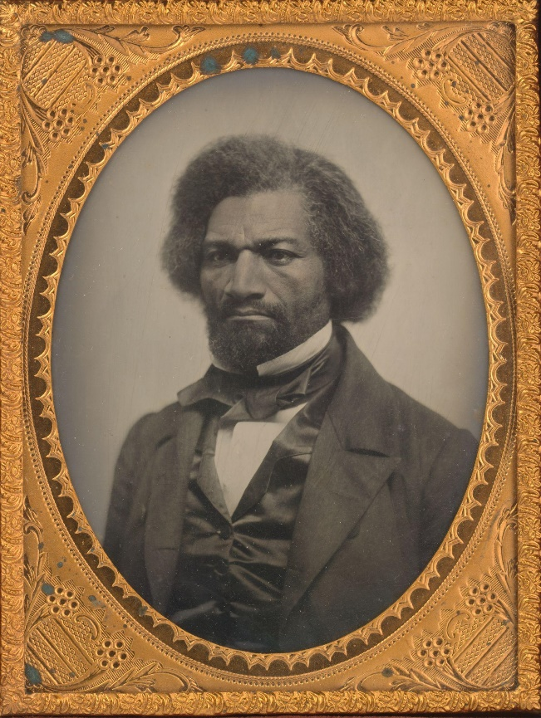
Although today we tend to think of the abolition of chattel slavery—the legal practice of treating African-descended people like transferable property—as inevitable, nothing could have been further from the truth. Whether from the perspective of enslavers, who consistently held the presidency and had effectively captured the Supreme Court and Senate, or from that of enslaved people who worked from dawn till dusk on plantations, docks, and the factory floor, overturning slavery would have seemed an impossible task. Slavery formed the cornerstone of global capitalism in 1860, with slave-produced raw materials like sugar, cotton, tobacco, and rice facilitating industrialization and the factory jobs that went along with it. Even the most “advanced,” “developed,” and “free” economies relied heavily on goods produced by enslaved people. It was an institution wedded to “civilization” itself (Ransom and Sutch, 2001; Sell, 2021).

Photo: A portrait of Frederick Douglass made in 1856, a year before his famous “power concedes nothing without a demand” speech. Douglass was among the most outspoken advocates of openly fighting to end slavery and his analysis of power remains crucial to understanding the relationship between revolution and reform. (Douglass, 1856).

When Douglass spoke in 1857, slavery would have seemed nearly unassailable, the bedrock of so many existing systems of wealth and power. This is why Douglass spelled out in no uncertain language what forms agitation must take for Black Americans to achieve liberation. “The answer,” he argued, “is that abolition followed close on the heels of insurrection in the West Indies, and Virginia was never nearer emancipation than when General [Nat] Turner kindled the fires of insurrection at Southampton” (Douglass, 1857). The U.S., he worried, had moved further from emancipation in its restrictive laws supporting slavery. While freedom might be won by other means, it could never be achieved without directly challenging those in power, without asserting at least the possibility of Black self-defense and liberation.

Sojourner Truth made much the same argument as Douglass in her famous speech to the Ohio Women’s Rights Convention in 1851. Remembered today as “Arn’t I a Woman,” a phrase she likely never used, Truth’s oration rejected the limits of patriarchy as an adjacent form of bondage—articulating what the Combahee River Collective would later conclude—that “major systems of oppression are interlocking” (Combahee River Collective, 1977). She told listeners that “I have heard much about the sexes being equal; I can carry as much as any man, and can eat as much too, if I can get it” (Truth, 1851). In tying gender to labor and consumption, Truth made a sophisticated critique of production under racial capitalism. While the existing system required her to work just as hard as a man, it deprived her of equal compensation for her work. While she could “eat as much” as a man, laboring under a racist and patriarchal system made it unlikely that she would. Justice, she argued, required destroying this system (Painter, 1996).

A logic of total transformation defined the demands not only of famed Black abolitionists and intellectuals, but Black agricultural workers too. Formerly enslaved people themselves were at the forefront of movements to redistribute land, expand voting rights, and create public resources to benefit all regardless of race. From Louisiana to South Carolina, Washington D.C. to Philadelphia, working class Black organizers and visionaries petitioned officials and pooled resources in a bold attempt to create a truly egalitarian democracy (Roediger, 2014; Foreman et al., 2021). While these movements failed to transform society, sabotaged by white Americans at every turn, Black thinkers saw them as nothing less than a survivalist imperative in the wake of emancipation. As formerly enslaved Black South Carolinians from Edisto Island demanded of President Johnson, how could a legitimate emancipation process bind them once more to their former enslavers?

While we’ve been trained to dismiss these demands for redistributions of land, wealth, education, and power as fanciful, they offer a realistic appraisal of the material consequences of slavery and the limits of social mobility imposed by the vampire class. As the Edisto Islanders explained:

And we who have been abused and oppressed For many long years not to be allowed the Privilige of purchasing land But be subject To the will of these large Land owners? God fobid, Land monopoly is injurious to the advancement of the course of freedom, and if government Does not make some provision by which we as Freedmen can obtain A Homestead, we have Not bettered our condition.

Theirs was a remarkable claim coming out of chattel slavery, but one that anticipated the malleability of racial oppression in the U.S. from sharecropping and debt peonage to white flight and mass incarceration. They were acutely aware that “our Situation is dangerous” and that freedom itself would be stripped of all meaning unless “some provisions be made by which Every colored man can purchase land. and Hold it as his own” (Edisto Islanders, 1865). Having served as property themselves, the Black revolutionaries on Edisto Island understood on a personal level the ways that systems of property and power were designed explicitly at their expense, one that could only be addressed by radically upending existing networks of oppression.

The careful social analysis of the Edisto Islanders coincided with a growing Black revolutionary movement across the old enslaving South. During the war, enslaved people rejected the demands of overseers and enslavers, abandoning plantation spaces by the hundred thousand. Nearly a quarter of a million joined the U.S. military to help defeat the enslaver regime of the Confederacy, hoping in the process to create a new world that would destroy once and for all the systems of torment and deprivation that defined racial capitalism. After it became clear that his former enslavers would not pay him, for example, Black farmworker Lucius Green took matters into his own hands in rural Louisiana and “drove [the overseer] out of the field remarking at the time that it did not belong to him and they, the freedmen had the first claim to it and could do just as they pleased.” When the planter and overseer returned after the harvest to take the crop, “Lucius refused and forcibly hauled off sixty (60) barrels of corn and twelve (12) bushels of potatoes” (DeGrey, 1867). Green’s actions sent local and Army officials into a frenzy to reinforce the old plantation order, one that Green and his comrades understood all too well.

The postemancipation social analysis of Black radicals and militant utopians grew, not only from the dystopian experiences of slavery, but also drew lessons from a transnational movement for liberation (Clavin, 2008). Black abolitionists had long looked to the militant abolitionism of the Haitian Revolution and its leader, Toussaint Louverture, as an example of how slavery could be destroyed in the U.S. In Haiti, as historian C.L.R. James explained:

Each slave gang murdered its masters and burnt the plantation to the ground. The slaves destroyed tirelessly. They knew that as long as those plantations stood, their lot would be to labor on them until they dropped (James, 2012, p. 40).

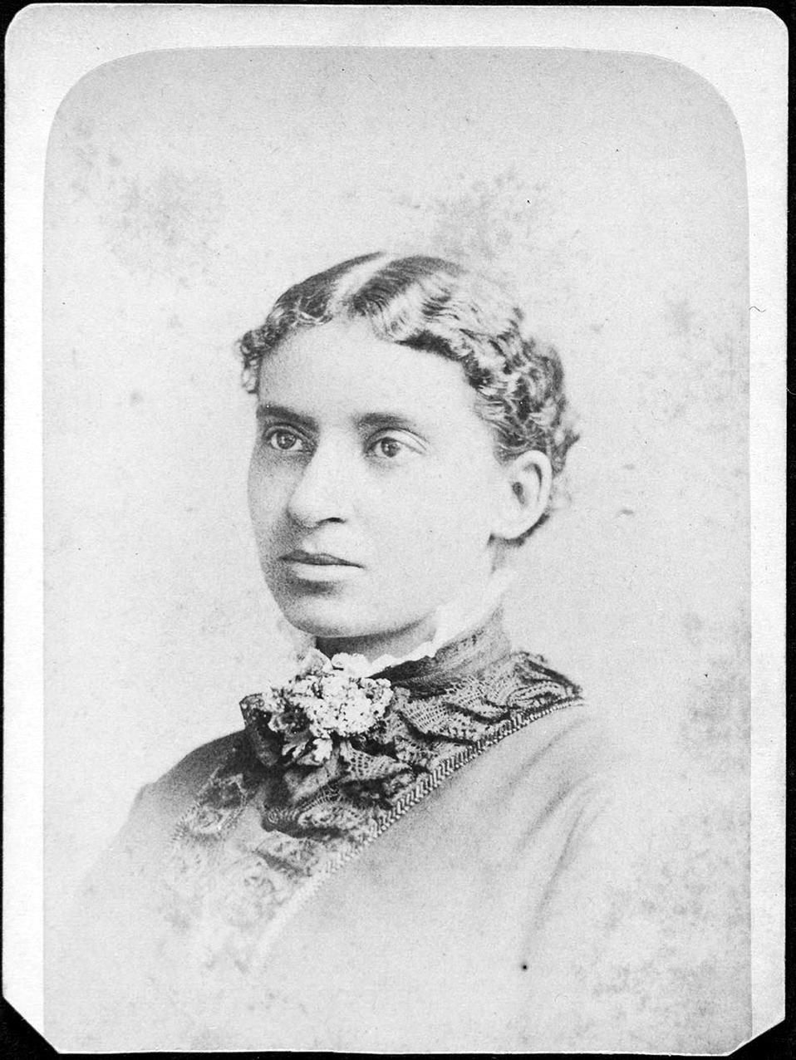
For James, enslaved people could only achieve liberation through agitation—by rendering plantations inoperable and creating alternate systems. James echoed Douglass on this point, who thundered “all that I contend for is this: that the slaves of the West Indies did fight for their freedom, and that the fact of their discontent was known in England, and that it assisted in bringing about that state of public opinion which finally resulted in their emancipation” (Douglass, 1857). The threat of a utopian revolt, one which refused to concede the dystopian reality of the plantation regime, weighed constantly on the minds of enslavers and elites, inspiring a gradual white abolition movement in hopes of buying time and maintaining power.
Photo: A portrait of Charlotte Forten Grimké, in the 1870s following her work helping to create the first schools accessible to formerly-enslaved people in South Carolina. She married Francis Grimké, a pastor and renowned supporter of Black rights and equality, in 1878. (Schomburg Center, 1870s).
The utopian revolutionaries of the emancipation era tied the destruction of the old regime to the creation of a new world ripe with egalitarian potential. For famed Black abolitionist and educator Charlotte Forten, this meant traveling to the coastal islands of South Carolina to create schools for formerly enslaved South Carolinians. Forten wrote about teaching in deeply precarious circumstances—about making space for children far too young to learn, about creating opportunities for elders deprived of the chance to learn by enslavers, and about Black parents’ “sacrifices that their children may attend school” (Forten, 1864, 379). Among the first lessons she taught was “about Toussaint [Louverture], thinking it well that they should know what one of their own color had done for his race” (Forten, 1864, 371). For Forten, as her own work illustrated, Black revolutionaries and visionaries themselves showed the utopian potential of emancipation, one that might no longer be bound by the limits imposed by white supremacy. “It was,” she explained, “a sight not to be soon forgotten—that crowd of eager, happy Black faces, from which the shadow of Slavery had forever passed” (Forten, 1864, 375).

While we read today with the knowledge that slavery ended and women’s suffrage prevailed, this was hardly inevitable from the vantage point of Douglass, Truth, or Forten. And in fact, Black liberation seemed so tenuous that Forten slept with a loaded pistol next to her bed, ready to defend herself quite literally from the ravages of white supremacy. Her example and her embrace of Toussaint reveal the fragile nature of Black liberation and the urgency of a robust utopianism, one that embraced redistributions of property and power as the cornerstone of a better world. It is a lesson Black utopian revolutionaries embraced and applied as they mobilized to overturn slavery, seized plantations and other nodes of enslaver power, and demanded just wages, meaningful opportunities, and stable living conditions. Formerly enslaved people understood clearly how racial capitalism worked and positioned themselves as the foremost radical theorists of their era. Their work during the 1860s and 1870s in collectivism, education, self-determination, and self-defense remains among the most advanced in American history (Robinson, 1983; Marable, 1983).

Although we tend to remember the movement that Black radicals of the emancipation era created as successful and to place responsibility for those successes at the feet of white officials, this version of emancipation would have been unrecognizable to Lucius Green or the Edisto Islanders whose demand for land, wages, and justice were overwhelmingly ignored by white officeholders. Their intimate knowledge of racial capitalism inspired Black abolitionists and revolutionaries to write and organize with an incredible urgency and stamina against a dystopian system, one under which enslaved people had little reason to hope for abolition. Looking from Douglass and Truth to Forten, Green, and the Edisto Islanders for inspiration, we might approach our own system in much the same way—the dystopias that define our present are hardly necessary or inevitable, but the product of choices made by those in power at the expense of everyone else. We need not accept the most aggressive carceral state in the world, devastating inequality, climatic collapse, or a death-inducing healthcare system as natural or unavoidable because neither equality nor inequality are inevitable. Rather, the Black utopians of the emancipation era time and again illustrate the importance of agitation—of making existing systems of profit and power too costly and difficult to operate. If their utopian vision of a livable world remains incomplete—hijacked, sabotaged, and suppressed by those in power—it also offers a model for transforming society and seizing a livable future.

“By Any Means Necessary”: Sabotaging Jim Crow and Seizing Survival

Rosa Parks opened her 1985 interview for the Eyes on the Prize documentary series with an analysis of the dystopian landscape she and other organizers confronted under Jim Crow. “Everything was segregated and by law,” she explained, “transportation, occupation, and just, it was just one of those Southern traditions that was enforced in schools.” Looming at the back of this grotesque landscape of racial oppression, for Black Americans, was the very real prospect of spectacle violence—public attacks by city employees like bus drivers and police alongside white vigilante violence from bankers, grocery store clerks, and random passers-by—designed to instill racial terror and subordination and to promote white power. The famed Montgomery Bus Boycott, Parks remembered, drew support from the visceral and inescapable nature of this racist violence personified in the lynching of Emmett Till. As Parks put it, she and other organizers were “devastated by the fact that in the United States of America that a child could be just taken out and killed” without consequence (Parks, 1985).

Yet the bus boycott drew inspiration not only from the dystopian, impossible world of racial oppression in the U.S., but also from a utopian praxis that brought into being a world of human thriving and potential. Parks had in fact been a longtime organizer, recalling that she had been “working with NAACP since 1943” helping to register Black voters beyond the “very few selected by the white community” (Parks, 1985). She met activists and attended workshops, including one organized by the Highlander Folk School, an explicitly utopian and egalitarian community with whom she would later share her assessment that Montgomery was “a different place altogether since we demonstrated” (Parks, 1956, p. 1). For Parks and her fellow visionaries, equality meant working to put ideas into practice regardless or whether or not they were accepted by the white establishment, an approach crucial to the success of the boycott (Wolcott, 2022; Gore et al., 2009).

Her early work and the connections she forged prepared Parks not only for speaking and fundraising events, but also for the mutual aid work of helping to organize and operate a parallel people’s bus service. Understanding the “great sacrifices” made by drivers, Parks asked potential riders to be patient when waiting for a donated ride and to walk if they were within easy walking distance of their destination (Parks, 1955). The boycott represented a coordinated effort, one that identified and leveraged a weakness in Montgomery’s public transit system as it relied on Black riders for fares even as it regularly denied them services. This collaborative and targeted effort facilitated the movement’s success, as Parks remembered that “there were so many other people involved, I did not feel any discouragement, I just felt that with the number, the masses of people being involved and taking a part that it was not as discouraging as it had been before the incident and before others joined in.” The mass mobilization not only allowed Parks and other organizers to sabotage the racist dystopianism of Jim Crow public transit, but also suggested that utopian and egalitarian futures were within reach. “The atmosphere was, was very, I would say practically jubilant,” Parks explained, “because people were singing, clapping their hands, and shouting, and doing all that kind of a thing” (Parks, 1985). By analyzing and undermining the structures of Jim Crow governance, organizers created parallel systems, at once anticipating a better world and celebrating it into existence.

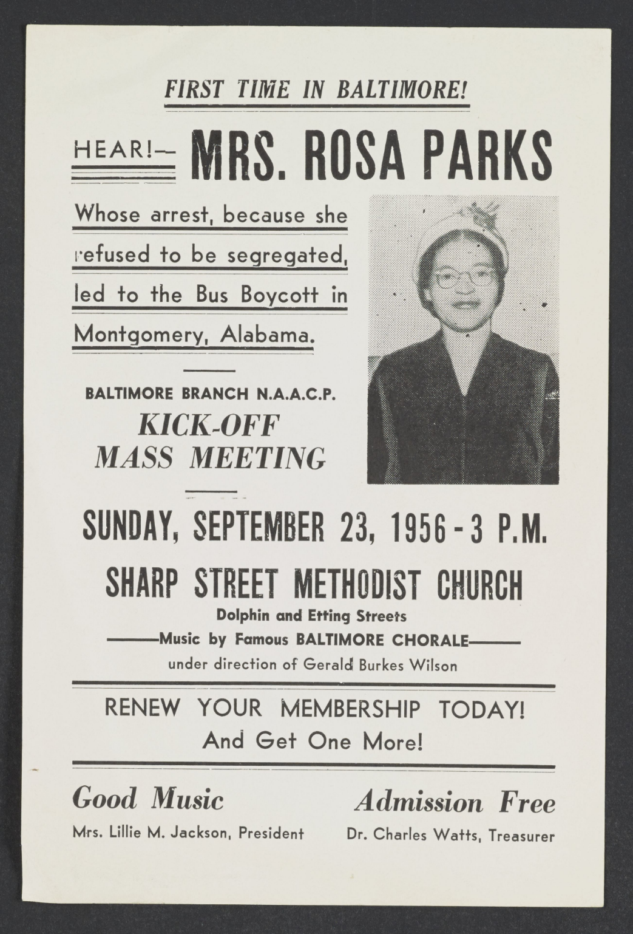
Photo: A poster for a 1956 NAACP event in Baltimore featuring Rosa Parks. As the “Good Music” advertisement at the bottom left indicates, organizers understood that liberation goes hand-in-hand with celebration. (NAACP, 1956).

Photo: A note from Rosa Parks to riders reminding them of the “great sacrifices” made by drivers to create a parallel public transit system, one designed to meet the needs and respect the dignity of Black residents. (Parks, 1955).

Although we do not usually think of her as a radical or utopian thinker alongside famed revolutionaries and egalitarians like Stokeley Carmichael (Kwame Ture) or Fannie Lou Hamer, Parks’ work suggests that we should and illustrates two important features of civil rights era organizing. First, organizers built upon previous gains, organizations, and coalitions, creating a dynamic scholars now refer to as the long civil rights movement (Hall, 2005). We see this clearly, for example, in the way that Bobby Seale recalled adopting the Black radical mantle in the wake of the assassination of Malcolm X in the opening lines of his 1970 memoir Seize the Time. In Seale’s telling, in fact, the “Ten-Point Program” of the Black Panther Party simply articulated “what Black people have been voicing all along for over 100 years” (Seale, 1970, p. 62). On a macro scale, the work of civil rights organizing in the 1950s and 1960s was made possible by the anti-lynching advocacy of the Congress of Racial Equality and the NAACP as well as the urbanizing rebellion of Black migrations beginning in the first quarter of the twentieth century. Second, Black radicals grounded their revolutionary work in a careful assessment of the failures of the state to meet the basic needs of marginalized and exploited communities (Gilmore, 2009). As Carmichael and Charles Hamilton argued in their book Black Power: The Politics of Liberation, for example, white lawmakers had designed the government to impede human survival for their own benefit and those of the vampire class more broadly. “Black people in this country form a colony,” they wrote, “and it is not in the interest of the colonial power to liberate them” (Carmichael and Hamilton, 1967, p. 5). Thus, Black radicals of the civil rights era set out to both meet the needs of Black communities and, in so doing, to undermine the racial state as illegitimate.

When Malcolm X first uttered the words “by any means necessary,” he pointed not only to the steadfast refusal of the U.S. to support Black rights but also to the transformative potential of Black mobilization. If white officials would not act to preserve life and the well-being of Black communities, Black organizers must do this themselves. For Malcolm, creating “a society in which the 22 million Afro-Americans are recognized and respected as human beings” meant embracing an explicitly anti-imperialist and anti-capitalist approach to power (Malcolm X, 1965, p. 2). If the U.S. used colonial systems abroad and at home to accumulate wealth and power for the ruling class, he reasoned, then overturning that network of oppression required a sabotage of those systems and an inversion of the priorities that animated them.

Destroying the apartheid state of Jim Crow was precisely the agitating aim of the Black Panther Party’s (BPP) mutual aid programs, which at once fed, clothed, healed, and housed Black Americans while pressuring the state to actually meet the needs of Black communities. In a system designed to prevent it, the Panthers reasoned, survival was an explicitly revolutionary act. As Deputy Chairman Fred Hampton explained, “first you have free breakfasts, then you have free medical care, then you have free bus rides, and soon you have FREEDOM!” (Bloom and Martin, 2013, p. 177). While the Panthers’ free breakfast programs were raided and destroyed by the FBI, which also orchestrated Hampton’s assassination, they impacted thousands of families per week all across the country and demonstrated the utopian potential of radical organizing (Bloom and Martin, 2013). This was precisely the concern of FBI Director J. Edgar Hoover, who wrote the agent in charge of the Bureau’s San Francisco office that “One of our primary aims in counterintelligence as it concerns the [Black Panther Party] is to keep this group isolated… in their Breakfast for Children Program… they are actively soliciting and receiving support from uninformed whites and moderate blacks” (Bloom and Martin, 2013, p. 177). The Panthers’ ability to disrupt systems of deprivation, in Hoover’s telling, warranted their total annihilation.

Hoover’s approach to the Panthers put words to the often-unspoken rules governing the functional dystopia of American democracy. The FBI director had no qualms about destroying their meager resources, community building efforts, as well as countless lives in defense of existing systems of property and power (Bloom and Martin, 2013). Yet he was right about one thing: the platform of the BPP was genuinely transformative (Potorti, 2014). The Panthers’ famed Ten Point Program aimed to reorient society around human flourishing, summarized beautifully in Point Ten—“We Want Land, Bread, Housing, Education, Clothing, Justice And Peace” (Black Panther Party, 1966). As they argued in Point One, “We believe that Black people will not be free until we are able to determine our destiny,” which might only be accomplished by totally upending the racist systems of profit and power that Hoover fought so desperately to defend (Black Panther Party, 1966; Bloom and Martin, 2013). Yet as so often happened in our history, those in power turned opportunity into tragedy.

The idea that access to the means of sustenance—food, work, shelter, and land—formed the bedrock of political power informed organizing and goals across movements. While Fannie Lou Hamer, for example, is best remembered for her 1964 speech to the Democratic National Convention denouncing the voter suppression and attacks she endured at the hands of the state and white vigilantes in Mississippi, Hamer’s organizing against food insecurity and founding of Freedom Farm Cooperative illustrates a sophisticated analysis of the relationship between wealth and power. As Hamer told supporters in Madison, Wisconsin in 1971, “it’s no way on earth that we can gain any kind of political power unless we have some kind of economic power” (Hamer, 1971). She had observed for too long how “down where we are, food is used as a political weapon” by white conservatives, who fired, harassed, and assaulted Black voters while rewarding Black locals who served white interests during election season (Height, 2005, p. 188). White conservatives had used these tactics throughout the Deep South since emancipation to prevent Black labor and political organizing, forcing activists to create their own foodways to make organizing possible (Kelley, 1990; Blain, 2021).

Hamer saw food sovereignty not only as an issue of political empowerment, but also as the goal of radical politics itself. In her estimation, the radical organizing that had led Lyndon Johnson to declare a “national war on poverty” aimed to create a livable future, one that the administration’s programs had so far failed to do (Johnson, 1964). With this in mind, Hamer reasoned that “if we could get the forty acres of land to grow our own vegetables, and to grow our cabbage, and to grow our pork, we could wipe out hunger in Sunflower County.” She viewed this as a new sort of grassroots politics grounded in mutual aid, “and all of the qualifications that you have to have to become a part of the co-op is you have to be poor. This is the first kind of program that has ever been sponsored in this country in letting local people do their thing theirselves” (Hamer, 1971). As with the Panthers, Hamer analyzed the systems of deprivation that had been designed by those in power to create and sustain Black precarity to the benefit of the vampire class and created new structures grounded instead in liberation (Blain, 2021).

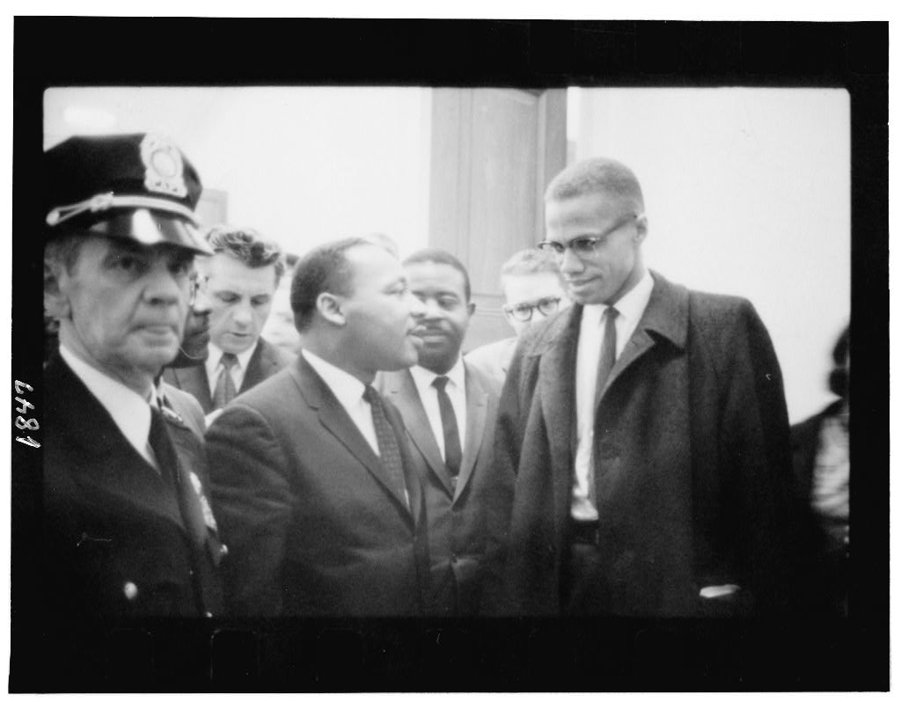
Photo: Malcolm X and Dr. Martin Luther King, Jr. following King’s press conference on the Civil Rights Act of 1964 then working its way through the Senate. (Trikoskl, 1964).

Black radical thinkers like Hamer identified the state itself as a vehicle for white power, an argument that only became clearer amid the violent repression of the urban rebellions of the late 1960s. For Malcolm X, this meant organizing Black voters, transforming America’s racist school system, and providing a means of protection. His sweeping program was grounded in a logic very similar to that put forth by Black autoworker and leftist intellectual James Boggs, that a repeatedly racist and oppressive state was not “worth maintaining.” “After a system has existed for this long,” Boggs argued, “it has to be judged by what it is and what it has been, not by the alleged hopes or faiths of its founders or supporters” (Boggs, 1970, 123). “What it ha[d] been” was a vehicle for racial subordination. Or as Malcolm X phrased it, “concerning anything in this society involved in helping Negroes, the federal government shows an inability to function.” “It can function in South Vietnam,” he observed, “in the Congo, in Berlin and in other places where it has no business. But it can’t function in Mississippi” (Malcolm X, 1965, p. 4). The conclusion was inescapable: the U.S. acted as an explicitly colonial power, bombing revolutionaries fighting for self-determination abroad while ignoring bombings in Tulsa, Birmingham, and Philadelphia. The two strategies worked together towards the same colonial ends.

Boggs identified this fundamental incompatibility of democracy and white supremacy as the basis for action, concluding that “the Black revolution must create a kind of society which goes far beyond any that have been achieved by the revolutions of the past” (Boggs, 1970, p. 128). For Boggs, this meant that the benefits of technological innovation—“automation and cybernation”—must be distributed evenly to improve the lives of everyone in society. Instead, the elites of his day advocated for work as the fundamental organizing feature of society, criminalizing, ostracizing, and starving those excluded from work (Horne, 2022). They created an explicitly carceral capitalism—through which they continue to maintain power in a deeply unequal and unstable society (Davis, 2003; Gilmore, 2007).

While Boggs was reasonably skeptical of American democracy given its abysmal track record for Black Americans, he theorized that a utopian revolt could be successful if it targeted chokepoints in the existing system.

The simultaneous rebellion of the Black masses in major cities would create a mass disruption of production, transportation, communications, and all political and social institutions greater than it created by the strikes of the 1930s and comparable to those created by the recent general strike in France. This would be the effect of spontaneous rebellion. On a planned scale it could result in the complete control of the cities, and therefore of the heart of the nation. (Boggs, 1970, p. 129).

This sort of agitation, one that sabotaged the means of exploitation created by the vampire class, might seem far-fetched, extreme, or even dangerous, but it grew directly from the colonial nature of the American apartheid regime. For Black radicals of the civil rights era, the problem originated in the systems of profit and power created to benefit white Americans and especially white elites at the expense of everyone else. The legacy of those systems is why—from Malcolm X and Boggs to Seale, Carmichael (Ture), and Hamer—Black visionaries considered integration to be totally insufficient, because, as Boggs put it, “it is obvious that integration means class collaboration, pacification, and incorporation into the system” (Boggs, 1970, p. 130). To advance integration without redistribution, which eventually became the highest aspiration of the post-Brown state, was tantamount to creating a colonial puppet state regime for many Black radicals of the 1960s.

Writing at a point of escalating white flight, massive layoffs resulting from automation, and the beginnings of an even more aggressively repressive carceral state, Boggs imagined a livable future in harnessing the productive potential of technologies used to displace workers to their own advantage (Silver, 2003). And in fact his withering attacks and calls to transform the state and embrace redistribution were not all that different from “mainstream” figures like Dr. Martin Luther King, Jr., especially in the aftermath of Malcolm X’s assassination. In his “Other America” speech, which he would make repeatedly during the last year of his life, King distinguished between the “struggle for decency” of the early civil rights integrationist organizing and “struggling now for genuine equality” in transformed and equitable systems of employment, housing, and education (King, 1967). Even the premise of the “Other America”—that there are in fact two parallel Americas—grew from an engagement of the anti-colonial framework of Black Power activists. King envisioned a relationship in which the poverty and powerlessness of the working poor and especially Black America facilitated the wealth, stability, happiness, and power of middle- and upper-class white America. The two Americas also had a spatial component that allowed those in power to more effectively surveil and extract resources from marginalized communities. A colonial regime in all but name.

The transformations necessary to bridge the two Americas of his analysis would require a response that overwhelmed and undercut existing systems. “It is much easier,” he observed, “to integrate a public park than it is to make genuine quality integrated education a reality” (King, 1967). In later versions of the speech, King emphasized the militancy required to bring this utopian America into being. “I've been searching for a long time,” he told listeners just weeks before his assassination, “for an alternative to riots on the one hand and timid supplication for justice on the other and I think that alternative is found in militant massive non-violence” (King, 1968). His embrace of agitation bore a striking resemblance to Douglass’ observation more than a century earlier that “power concedes nothing without a demand.” In King’s telling, the early successes of civil rights organizers had been brought about by boycotts, sit-ins, and marches that undermined the ability of the segregationist state to police the color boundaries. What remained was the ability of the white elites to retain their control of wealth and power as well as the opportunities that came with them. This, too, would have to be broken.

King outlined a vision for how an egalitarian, militant mass movement might transcend the two Americas in his last major work, Where Do We Go From Here: Chaos or Community?. He argued that the organizing successes of the early 1960s illustrated that equality “will not be legislated for us and delivered in neat government packages” (King, 1968, p. 165). “Laws only declare rights,” King explained, “they do not deliver them. The oppressed must take hold of laws and transform them into effective mandates” (King, 1968, p. 167). As with proponents of Black Power like Carmichael (Ture) and Boggs, King reasoned that “we must utilize the community action groups and training centers” in Black neighborhoods to wage a “deliberate campaign to organize” both reformist efforts through state programs and parallel programs under local control (King, 1968, p. 165). Equality could only be reached, King argued, through the “total, direct and immediate abolition of poverty” as the foundation of racial capitalism and the systems of white supremacy associated with it (King, 1968, p. 175). Through a guaranteed basic income and a federal jobs guarantee, a militant mass movement could both address the legacies of inequality and sabotage its reproduction. The two Americas could become one.

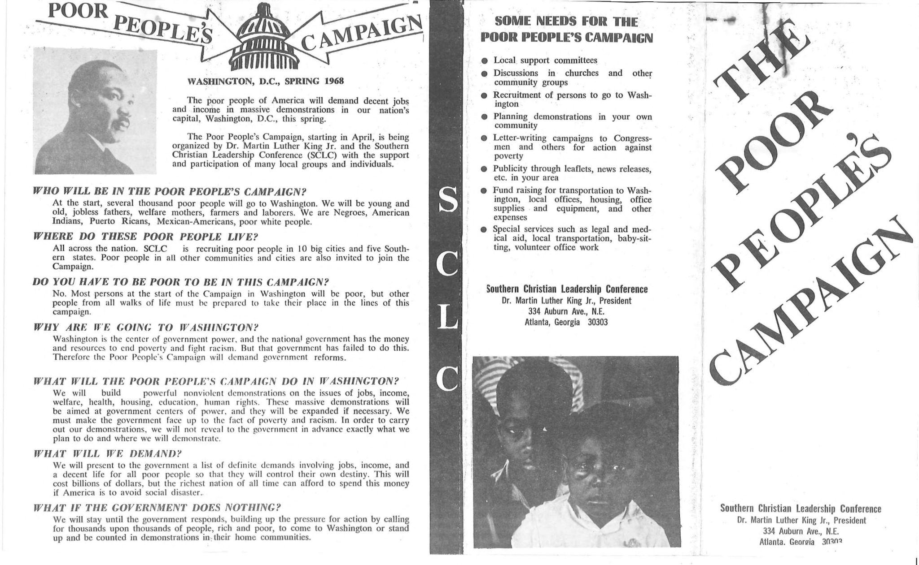
Photo: A pamphlet calling civil rights organizers and activists to action around “The Poor People’s Campaign.” Dr. Martin Luther King, Jr. worked to organize and raise support for the effort, which he hoped would lead to federally guaranteed jobs and income, and was campaigning to that end when he was assassinated in Memphis on April 4, 1868. (King, 1968).

Black visionaries of the 1960s had seen the timid lip service of the state in response to their demands and understood that this was yet another tactic in an intergenerational regime of racial oppression and plunder. They were acutely aware of the ways that those in power used process and politics, as in the aftermath of the 2020 Black Lives Matter protests, to sustain racial capitalism even as they claimed to oppose it. White elites commissioned studies like the Kerner Commission, which concluded that “white society is deeply implicated in the ghetto. White institutions created it, white institutions maintain it, and white society condones it” (Kerner Commission, 1967). They then ignored those findings. And yet, from the survival programs of the Black Panther Party to the Freedom Farm work of Fannie Lou Hamer, Black radicals worked to implement precisely this vision—one designed to sever the relationship between property and power. Although their projects were hampered by limited resources and active state sabotage—both byproducts of racial capitalism—the utopian praxis of these Black visionaries point the way towards a livable society, one that prioritizes survival and happiness over property and power.
Seizing a Utopian Future

The problem is not to make a utopian and sterile attempt to repeat the past, but to go beyond. It is not a dead society that we want to revive… It is a new society that we must create with the help of all our brother slaves, a society rich with all the productive power of modern times, warm with all the fraternity of olden days.

—Aimé Césaire, Discourse on Colonialism, 1950

We live with the legacy of utopian revolt all around us, from emancipation and enfranchisement(s) to the seedlings of true integration and equality. We inhabit and animate a world that would have been unimaginable to previous generations of organizers. Yet as the entwined crises we now face in automation and AI, climate collapse, disenfranchisement, and fascism illustrate, these successes are vulnerable to machinations of the vampire class (Horne, 2022, pp. 21-22). The underlying problem is that we have retained and attempted to repurpose the ideologies and structures of colonialism. As Aimé Césaire notes in the passage from Discourse on Colonialism that opens this section, “it is not a dead society that we want to revive,” but “a new society that we must create” (Cesaire, 2001, p. 52). Implementing such a vision requires an acknowledgment of what has been almost totally lost, from the songs and stories of elders to the faces and spaces of kinship and community in an embodied society. And lives. Millions upon millions of lives snuffed out and cut short by the machinery of mass deprivation that drives capitalist production. While echoes of these may linger, as Césaire reminds us, these were the features of “a dead society,” destroyed by the ravages of state violence and the scarcity-driven regime of capital. Seizing a utopian future, then, means acknowledging this existing regime of theft and violence and moving beyond it.

We have models for just this sort of transformative utopian praxis, not only in the historical examples of solidarity and sabotage that spelled death to slavery and direct colonial and apartheid rule, but also in the realm of radical and imaginative fiction premised upon liberation. N.K. Jemisin, for example, imagines a utopian world that exists alongside but apart from our own in her short story, “The Ones Who Stay and Fight.” In her fictional Um-Helat, the legacies of colonial oppression linger, but are “being actively, intentionally corrected” by residents (Jemisin, 2020). The society they create is defined by possibility and mutuality as conscious civic duties, with farmers and working people “honored alongside the city’s merchants and technologers” (Jemisin, 2020). Each facilitates the labors and successes of one another, in Jemisin’s thinking, and are equally deserving of dignity and survival. She conceives of human thriving as multifaceted and dynamic, enriched and enhanced as new groups are brought into the fullness of human dignity. “Without contrasts,” Jemisin asks, “how does one appreciate the different forms that joy can take?”

While Jemisin envisions liberation as demanding the embrace of the many forms and features of human existence, this commitment to the actually-existing diversity of humanity is not the source of the utopia she describes. Rather, Jemisin counters, “the people of Um-Helat are not naive believers in good intentions as the solution to all ills. No, there are no worshippers of mere tolerance here, nor desperate grovelers for that grudging pittance of respect which is diversity. Um-Helatians are learned enough to understand what must be done to make the world better, and pragmatic enough to actually enact it” (Jemisin, 2020). Tolerance, in her thinking, cannot exist in actuality if it is applied equally to both different ways of living and ideologies premised on the dehumanization of others. Such a vision of society cannot “make the world better” because it is not intended to change the world at all, and in fact represents an attempt to undermine genuine egalitarian analysis and action (Táíwò, 2022). “This is the paradox of tolerance, the treason of free speech,” she explains: “We hesitate to admit that some people are just fucking evil and need to be stopped” (Jemisin, 2020). The logics of mass subordination and plunder are indeed fundamentally incompatible with human flourishing and must be rendered inoperable if we are to make a livable future possible.

What remains an open question for us to answer is how to speak and to act—how to implement a utopian praxis capable of seizing a livable future for one another and our communities. That praxis is in fact a three-fold process, first an assessment and critique of the world as it exists, second a sabotage of those existing systems grounded in an alternate vision of the future, and third the construction of an infrastructure capable of sustaining life. While we might sketch out some of the possibilities in mutual aid, in work stoppages, in self-determination, and in organizing, to do so here might be counterproductive since this new world should be born democratically, from the demands and desires of our communities. As Lorenzo Kom’boa Ervin puts it, the “people themselves must be in command, not leaders” (Ervin, 2021, p. 35). What we can say for certain, however, is that the history of these utopian movements, from emancipation and civil rights through ongoing movements for racial, economic, gender, and climate justice, show that this type of organizing can be successful and illustrate the possibilities for the struggles of today.

We can seek solutions to the problems of mass misery and death or we can succumb to them. Perhaps that’s the power of the “Daisy Ad,” representing not a dirty sort of politics but an “unseemly” refusal to deny the threats we face. Yet if the dystopian and the grotesque illustrate the pressing need for a robust utopianism, they also show that if the fantastically horrific and odious are possible, so too are their negations. It is a message Black radicals emphasized since the era of abolition: a better world is possible.

Acknowledgements

I want to thank my family, friends, and colleagues who have indulged my interest in utopian and radical thinking, especially in the Black radical tradition. Special thanks are due to my colleagues Tim Horner, who expanded my thinking on Jemisin’s work, Vincent Lloyd, whose work on Black dignity contributed to my analysis, as well as Emma Slonina, Betty Patch, Maggie Matthews, J-P Spiro, Greg Hoskins, and Ting Cho Lau, whose collegiality and ideas informed this essay. I am also deeply indebted to the brilliant students at Villanova University, whose questions and interest in race and futurisms helped me reconsider the problems we face and the ideas we embrace with new urgency and joy. Finally, I am grateful for the Patricia and Vincent J. Trosino '62 Fellowship, whose generous funding supported my research.

References

[Baltimore NAACP]. (1956). [Rosa Parks event poster]. Rosa Parks Papers. Library of
Congress. https://www.loc.gov/resource/mss85943.001906/?sp=2.
Black Panther Party. (1966). The Ten-point program. Marxists.org.
https://www.marxists.org/history/usa/workers/black-panthers/1966/10/15.htm.

Blain, K.N. (2021). Until I am free: Fannie Lou Hamer’s enduring message to America.
Beacon Press.
Bloom, J. & Martin, W. (2013). Black against empire: The history and politics of the Black
Panther Party. University of California Press.
Boggs, J. (1970). Racism and the class struggle: Further pages from a black worker’s
notebook. Monthly Review Press.
Bookchin, M. (1986). Post-scarcity anarchism. Black Rose Books.
Carmichael, S. (Kwame Ture) & Hamilton, C. (1967). Black power: The politics of liberation.
Random House.
Césaire, A. (2001) Discourse on colonialism. Monthly Review Press. (Original work published 1950)
Clavin, M. (2008). A second Haitian Revolution: John Brown, Toussaint Louverture, and the making of the American Civil War. Civil War History, 54(2), 117-145.
Combahee Collective. (1977). The Combahee River Collective statement. Blackpast. https://www.blackpast.org/african-american-history/combahee-river-collective-statement-1977/.
Davis, A.Y. (2003). Are prisons obsolete?. Seven Stories Press.
________. (1971). Lectures on liberation. N.Y. Committee to Free Angela Davis. https://archive.org/details/AngelaDavis-LecturesOnLiberation.
DeGrey, Lt. James to J.M. Lee, Nov. 15, 1867, Clinton, Record Group M 1905. Roll 68. Louisiana Bureau of Refugees, Freedmen, and Abandoned Lands. National Archives and Records Administration.
Douglass, F. (1857, August 3). West India emancipation, Blackpast. https://www.blackpast.org/african-american-history/1857-frederick-douglass-if-there-no-struggle-there-no-progress/.
[Douglass, F.]. (1856). [Portrait of Frederick Douglass]. National Portrait Gallery. https://npg.si.edu/object/npg_NPG.74.75.
Edisto Islanders. (1865). Committee of freedmen on Edisto Island, South Carolina, to the president, October 28, 1865. Freedmen and Southern Society Project. http://www.freedmen.umd.edu/Edisto%20petitions.htm.
Ervin, L.K. (2021). Anarchism and the black revolution. Pluto Press.
Foreman, P.G., Casey, J., Patterson, S.L. (2021). The colored conventions movement: Black organizing in the nineteenth century. University of North Carolina Press.
Forten, C. (1864). Life on the Sea Islands. In William L. Andrews (ed.), Classic African American women’s narratives. Oxford University Press.
[Forten, C.]. (1870 - 1879). [Studio portrait of Charlotte L. Forten Grimke]. Schomburg Center for Research in Black Culture, Photographs and Prints Division, The New York Public Library. https://digitalcollections.nypl.org/items/510d47df-796a-a3d9-e040-e00a18064a99.
Foster, J.B. (2024). The dialectics of ecology: An introduction. Monthly Review, 75(8). https://monthlyreview.org/2024/01/01/the-dialectics-of-ecology-an-introduction/.
Gardiner, M. (1992). Bakhtin's carnival: Utopia as critique. Utopian Studies, 3(2), 21-49.
Gilmore, G. (2009). Defying Dixie: The radical roots of civil rights, 1919-1950. W. W. Norton & Company.
Gilmore, R.W. (2007). Golden gulag: prisons, surplus, crisis, and opposition in globalizing California. University of California Press.
Gore, D.F., Theoharis, J.,& Woodard, K. (2009). Want to start a revolution?: Radical women in the black freedom struggle. New York University Press.
Hall, J.D. (2005) The Long Civil Rights Movement and the Political Uses of the Past. The Journal of American History, 91(4), 1233-1263.
Hamer, F.L. (1971). Until I am free, you are not free either [speech transcript]. https://stjamesaustin.org/wp-content/uploads/2021/02/Until-I-Am-Free-You-Are-Not-Free-Either-by-FLH.pdf.
Hartman, S. (2019). Wayward lives, beautiful experiments: Intimate histories of riotous black girls, troublesome women, and queer radicals. Norton Press.
Height, D. Open wide the freedom gates: A memoir. PublicAffairs.
Horne, W.I. (2022). Torchbearers of democracy. In Case of Emergency. https://drwilliamhorne.substack.com/p/torchbearers-of-democracy.
________. (2022). The vampire’s bacon: meat work, empire, and abolition. In Z. Zane McNeill (ed.), Vegan entanglements: Dismantling racial and carceral capitalism (pp. 21-31). Lantern Press.
James, C.L.R. (2012). A history of pan African revolt. PM Press. (Original work published 1938).
Jemisin, N.K. (2020). The ones who stay and fight. Lightspeed: Science fiction and fantasy. Issue 116 (January 2020).
Johnson, L. (1964). Special message to the Congress proposing a nationwide war on the sources of poverty. The American Presidency Project. https://www.presidency.ucsb.edu/documents/special-message-the-congress-proposing-nationwide-war-the-sources-poverty.
Kelley, R.D.G. (1990). Hammer and hoe: Alabama communists during the Great Depression. University of North Carolina Press.
Kerner Commission. (1967). Report of the National Advisory Commission on Civil Disorders. United States Government Publishing Office. https://belonging.berkeley.edu/sites/default/files/kerner_commission_full_report.pdf?file=1&force=1.
King, M.L. (1967, April 14). The other America. [Speech at Stanford University]. rev.com. https://www.rev.com/blog/transcripts/the-other-america-speech-transcript-martin-luther-king-jr.
________. (1968, March 14). The other America. [Speech at Grosse Pointe High School]. Grosse Pointe Historical Society. http://www.gphistorical.org/mlk/mlkspeech/mlk-gp-speech.pdf.
________. (1968). Poor people’s campaign [Flier]. Civil Rights Movement Archive. https://www.crmvet.org/docs/68_sclc_ppc_brochure.pdf.
________. (1968). Where do we go from here: Chaos or community?. Beacon Press.
Mann, R. (2011). Daisy petals and mushroom clouds: LBJ, Barry Goldwater, and the ad that changed American politics. Louisiana State University Press.
Marable, M. (1983). How capitalism underdeveloped black America. South End Press.
Painter, N. (1996). Sojourner Truth: A life, a symbol. W.W. Norton and Company.
Parks, R. (1985). Eyes on the prize. Blackside Inc. https://americanarchive.org/catalog/cpb-aacip_151-610vq2sx12.
Potorti, M. Feeding revolution: The Black Panther Party and the politics of food. Radical Teacher, 98, pp. 43-50.
________. (1956). Mrs. Rosa Parks reports on Montgomery, AL bus protest. Civil Rights Movement Archive. https://www.crmvet.org/disc/5603_parks_mbb.pdf.
________. (1955). Instructions to car-pool drivers and passengers. Library of Congress. https://www.loc.gov/resource/mss85943.001505/?sp=2.
Robinson, C. (1983). Black Marxism: The making of the black radical tradition. UNC Press.
Roediger, D. (2014). Seizing freedom: Slave emancipation and liberty for all. Verso.
Samudzi, Z. & Anderson, W.C. (2018). As black as resistance: Finding the conditions for liberation. A.K. Press
Schwartz, T. (1964, September 7). Peace, little girl [Daisy political spot]. Tony Schwartz Collection. Library of Congress. https://www.loc.gov/item/mbrs01185386/.
Seale, B. (1970). Seize the time: The story of the Black Panther Party and Huey P. Newton. Random House.
Trikosko, M.S. (1964, March 26). [Martin Luther King and Malcolm X after King's press conference at the U.S. Capitol about the Senate debate on the Civil Rights Act of 1964]. Library of Congress. https://www.loc.gov/pictures/item/92522562/.
Truth, S. (1854, June 21). Women’s Rights Convention. Anti-Slavery Bugle, 4. https://chroniclingamerica.loc.gov/lccn/sn83035487/1851-06-21/ed-1/.
Sell, Z. (2021). Trouble of the world: Slavery and empire in the age of capital. University of North Carolina Press.
Silver, B. (2003). Forces of labor: Workers, movements, and globalization since 1870. Cambridge University Press.
Springer, K. (2005). Living for the revolution: Black feminist organizations, 1968-1980. Duke University Press.
Táíwò, O.O. (2022). Elite capture: How the powerful took over identity politics (and everything else). Haymarket Books.
Taylor, K.Y. (2016). From #blacklivesmatter to black liberation. Haymarket Books.
Wolcott, V. (2022). Living in the future: utopianism and the long civil rights movement. University of Chicago Press.
X, M. (1965). Interview with Malcolm X. Young Socialist. https://www.marxists.org/history/etol/newspape/youngsocialist/1964-1965/v08n03-w63-[2nd-w63]-mar-apr-1965-young-socialist-ysa.pdf

Volume 16, Issue 1, February 2024
________________________________________________________________________

To Live: Navigating Survivalism through Ecological Warfare as Colonialism Ravages Onwards
Author: Kathy Nguyen
Titles: Ph.D., MSW.
Affiliations: Metropolitan State University in Saint Paul
Location: Minneapolis–St. Paul, Minnesota
Emails: kathyngoc.nguyen@gmail.com
Keywords: Vietnam war, women, oral history, survival
________________________________________________________________________
Abstract

Surviving any war is a basic human right. While the Việt Nam War devastated every Vietnamese citizen, countries within proximity such as Laos and Cambodia were equally devastated by the war. Vietnamese women, who are also Vietnamese citizens despite being often ignored and relegated to the status of invisible citizens, endured and survived the war. However, their experiences, stories, and the entirety of their lives are rarely prioritized because the Việt Nam War, like all wars, are disproportionately centered on men’s perspectives and their postwar legacies. This article briefly frames my mother’s experiences and memories of being born in the ongoing and long Việt Nam War and her life as she navigated war torn geographies ruined by excessive unrelenting bombings and shootings that she witnessed and survived. As an oral history project, this essay aims to contribute to understanding the continuing intersections between gender disparity, masculine-centered ethos of war, citizenry, and survivalism rooted in the devastating destructions and chaos caused by war. In particular, the article historicizes how women were expected to silently endure the war while waiting for both the fighting to end and for the men to return home. Through the horrors of war and displacement, women were both physically and ideologically left behind.

*****************

These things happened every day: airplanes screamed; bombs exploded. This time, they exploded on the strategic hill about 300 meters from our cave. The ground beneath our feet shook. Even the washcloths we’d hung out to dry shook. Everything became feverish. Smoke rose up and filled the entrance to the cave. We couldn’t see the clouds or the sky any longer.

– Le Minh Khue, “The Distant Stars”

I thought of what my mother knew then. She knew about war, what it felt like to be shot at in the dark, what death looked like up close in your arms, what a bomb could destroy. Those were things I didn’t know about, and it was all right not to know them, living where we did now, in a country where nothing like that happened. There was a lot I did not know.

– Souvankham Thammavongsa, “Edge of the World”

Introduction: Vietnamese Women Navigating Gender Through the Atrocities of the War

The most basic human right for any citizen in the world, whether here, there, or elsewhere, is the right to survive ongoing and any inevitable subsequent wars. During the turbulent yet contentious years of the Việt Nam War, documented between November 1, 1955 to April 30, 1975, Vietnamese women were repressed under their nation’s intrinsic nationalistic and patriarchal structure. Their lives were pushed into the background and then slowly relegated into the margins until their voices and bodies are controlled into absolute subjugation, a dynamic that stretched into Việt Nam’s postwar era. Although discussing women’s “complicity” and “orchestration” of wars in the United States, militarism, and terrorism, Einstein (2008) broadly asserts how nothing is more “undemocratic than war” because no human’s rights – “especially not women’s – can be met in war; or by waging war” (p. 27). Likewise, in a dominant systemic structure where wars were/are waged by men in positions of power, Vietnamese women, too, become the muted voices of the Việt Nam War, a conflict that they were forced to navigate and endure. And as history unfailingly presages, war (rein)forces women to recede from the conflict zones and into obscurity as their existence is both threatened and forgotten in favor the state’s survival as controlled and animated by men.

War is not only defined by the seismic destruction it caused. Amid the residual rubble of war, women’s stories are buried underneath, producing an internal displacement within their own country of origin. The tragedy becomes apparent: their lives, war contributions, and even their survival are eclipsed by the men. It is never my intention to diminish anyone’s experiences and memories of the war because the lingering grief and trauma continue to dwell inside their bodies and bones, exacting permanent physical and mental traumas. Wars affect everyone, that much should be obvious. However, the blatant gender disparities between whose survivalism is prioritized and valued are especially pronounced when women are expected to remain resilient for their families—the men—by quietly surviving, as if their pain is unimportant and necessarily veiled in silence. As such, this article attempts to examine the following question: As war persists—in memory and as colonialism remains prevalent—what does the word survivalism carry in the present when women's experiences during the war remain not only historically suppressed but precluded from even existing and living? What are the unknown stories and experiences of women's survival as war displaces them?

Selective remembering is one of the many unfortunate patterns of war, which is sustained by a dominant, singular ideological perspective. Men position themselves at the frontlines of any war, waging wars against other states, other nations, and among themselves while dismissing and often violating women’s rights. A frequent recurrence of both war and history, regardless of how fragmentary history is formed and retold, is witnessing women being denied human rights. With precise language that becomes a reverberating echo in a geopolitical landscape that en/forces the disappearance of women, Turner-Gottschang and Pham (1998) reiterate that “Any accounting of the American War in Vietnam that leaves out Vietnamese women tells only half the story” (p. 19). And like most inequitable and undemocratic institutional structures and political conflicts, men’s glory and comfort are repeatedly protected in historical retellings and reproductions, frequently prioritized over women’s comfort, security, and contributions, as if women, as both humans and citizens, were never comparable to the male members of their communities. Despite the fact that women did actively fight and contribute to the Việt Nam War, the ethos of war is gendered. This “canard” regarding war, Lawson (1989) reasons, shows “that war is the exclusive province of men, a closed and gendered activity inscribed by myth, informed by ritual, and enacted solely through the power relations of patriarchy” (p. 6). Since this ethos of war remains an unbroken constant part of the world’s militarism, an exclusive institution just for men, all wars are continually attributed to men and glorifies their involvement in countless battles, sacrifices, political strategies and tactics, heroism, valiant acts of saviorism, their impact, and tragically, their deaths.

Blatant dismissals and negations of women’s stories concerning their visible and undocumented contributions to the war are nothing new, but the dominant’s perspective and political disavowals of their voices and experiences never lessen their deleterious impacts. Employing an anthropological framework that examines the sacrifices of both Vietnamese men and women during the war, Rydstrøm (2012) observes the gender roles that were attributed to men and women that “shaped individual war experiences and memories” (p. 276). Men were drafted into the army and “expected to make sacrifices (hy sinh) by investing their lives, while women were asked to provide supportive force at the rear, ready to make self-sacrifices by enduring suffering (chiu dau kho)” (Rydstrøm, 2012, pp. 276-277, emphases in original). In extreme cases that were, and still are, normalized, women were/are expected to disappear from history and from any political conflicts and wars. Plümper and Neumayer (2006), for instance, after specifically analyzing how wars impact life expectancy in connection to the gender gap, assert that women “suffer most from the indirect consequences” such as their “health and survival” during any militarized and armed conflicts because of the prevalent and damaging social roles ingrained in both a culture and society rooted in unchallenged gender expectations (pp. 723-724). What continues in frequency when it comes to repetitive retellings of war are how women are unjustly rendered as a backdrop to the war when their lives were equally affected. Women’s efforts, their many untold and unknown sufferings and sacrifices, and their many active roles in the Việt Nam War were comparable to men’s roles, but society and history never balanced their weights equally. Yet, women are expected to shoulder and carry a weighted burden that’s imbalanced but culturally expected for them to preserve and maintain out of nationalistic obligation as citizens. This cultural weight is intensified by allegiance and further exacerbated by wars and a history that either displaces or misremembers them. Vietnamese women, too, are expected to endure and suffer in silence as men are afforded the multiple privileges rooted in the excessive glorification of war and are extolled for their unquestionable, undying allegiance to a nation facilitates for democratic governance and security for its citizenry. What the men waging and remembering the Việt Nam War and other conflicts fail to acknowledge are the recurring systematic failures in protecting and securing the rights of the nation’s entire citizenry, including women’s rights. In any nation during and after the war, women are still rendered as invisible and unprotected citizens.

Methodological Approach: Remembering and Retelling Unmarked History of War and Survival

The first instinct for anyone living during any onset of wars and constant genocides is the impetus to survive. As humans and citizens, Vietnamese women had the right to survive during the war. But what does survival mean for Vietnamese women who carry on living and survive histories of Việt Nam’s colonialism and decade’s worth of wars? What does survival look like for these women, who migrated within South Việt Nam’s desolated geography terrain to another elsewhere within topographical distance while normalizing the violence committed by their state’s unilateral political system that threatened to disrupt life and security? How do both labor and a nation’s geographical economy transform from everyday occupations to survivalist imperatives for Vietnamese women as war rages on?

To closely examine how South Vietnamese women constantly resituate themselves during the height of the Việt Nam War, I asked my mother to share her own experiences and stories as both a woman and citizen living, enduring, and witnessing the atrocities of war, all of which are grounded in a gender analytical framework. Both my mother’s memories and stories constitute an oral history, which Nguyen (2018) describes as a process or method that “enables the recording of voices that have been marginalized by history” (p. 55). My mother, like several of the women in her family, women she never knew, and women who came before her, endured the wars and their tragic colonial dispossession, destruction, and violence, creating an enduring, intergenerational impact.

Too often do critics dismiss singular accounts of a historical moment. Oral narratives, even a single oral narrative that frames the Việt Nam War as a specific referential point in time, are important. Intimately entwined in embodied memory work, oral narratives dismantle the gendered, canonical renderings and retellings of the war. I seek to specifically ground my mother’s voice to demonstrate how her voice and stories are not only remembered and retold but are essential. Stories like my mother’s enrich and expand the liberatory potential of anticolonial inquiry that has explicitly excluded women on the basis that women, whether their bodies or corporeal memories, do not offer anything of value. These antiquated critiques are rooted in exclusionary and gendered dichotomies that ironically disempower entire populations even as they purport to reject hierarchies and oppression. It’s as if women’s bodies have either no point of origin or historical significance.

The interview was conducted in Vietnamese since it is my mother’s native language, and subsequently translated in English. Translating the words that hold my mother’s stories from her interview shows the complex structural threads in language. Tran and Sachs (1997), who translated Le Minh Khue’s short fiction collection, The Stars, The Earth, The River, believe that while “English is a language that calls for precision,” Vietnamese “offers as many possibilities as certainties and refuses to be pinned down” (p. xix). Because Vietnamese doesn’t intone a specific tense and is tonal language, it conveys tone through the use of phonemes; the conversation and some word additives steer the listener to perceive the intended tense or the intended change in meaning. There are also no plural forms in Vietnamese nouns. These are all challenges when translating because so much meaning, feeling, and experience gets lost in translation.

Enduring Bombastic Cacophony to Survive

A nation’s forced disappearance conceals stories of survival. The body specifically creates multiple fractures and indentations to create autobiographical imprints that create a lingering, traumatic archival documentation of the war. For my mother, the body is perhaps the single moving corpus that can extract the many residual fragments and memories of war. My mother remembers a time when war encompassed this candid war philosophy: “Wars for us meant living to survive and surviving to live even while witnessing the multiple destructions that devastated Việt Nam’s landscape.” This statement feels too obvious and absurd to be a fact, but there’s an immensity to its brevity, revealing the many unspoken realities of war.

As a South Vietnamese woman, citizen, and daughter born in the province of An Giang, Long Xuyên, my mother was born to a war that became an agonizing constant in her life, shaping her. Or, perhaps, she was forced to endure the war because it was an expectation, a mentality that was ingrained like everyone else before her who were also born into conflict. Somewhere fate created an absurdism concerning the intersections of memory, temporality, home/land, and identity: Việt Nam is honored and remembered more for the wars fought on its geographical soil while conveniently disremembering Việt Nam, especially South Việt Nam, as a country. Consistent to how wars are redocumented and retold, disassociating Việt Nam from the Việt Nam War is perhaps inescapable because wars are commemorated more than the living—the many who survived—and the dead—the many who were also killed for war.

After growing up as what my mother considers a “typical Vietnamese child living in the country that’s constantly at war,” she decided to quit school at thirteen or fourteen years old and worked in the rice paddies to support her family after her father was shot in the arm and became paralyzed. She then married her husband, a Navy officer, and then became a mother during the height of the war. But as a woman living in a country governed by wars and political divisions, she felt like an invisible, nameless citizen. Like several women who were born into the war and raised in a country and patriarchal culture where women were seen as replaceable ancillaries, sometimes interchangeable with other adjacent women, my mother could only depend on herself to ensure her own survival. For my mother, being a woman living and surviving the war meant not being given a political and familial prioritizing and devotion because Việt Nam, like so many countries at war, operates on a relentless and undying systemic mantra: “trọng nam khinh nữ” // “to value men above women.”
Since wars are rooted in chaos, survival and any acts that activate all forms of war survivalism hinge on a sequence of instinctual responses that waver between fight or flight re/actions. Not only is survivalism a reactive response, but it’s also deeply entrenched in disruptive disorders. Noting that “To survive is messy, elaborate, layered,” Black, Glasberg, and Bartkowski (2016) reflect on the word survival, which is firmly activated by this innate desire to continue to persevere during devastation and political chaos (p. 14). They continue a long etymological dissection of the word:

The metaphysics of deferral are implied by the world’s Latinate roots: sur (over) vive (life). Sur-vival, “to live beyond,” implies competition among the living, some who go on and some who, perforce, are survived. Live, survive, preserve, and conserve all share the root vivre, which itself is preserved by its prefixal adaptability. Linguistically, life survives. Its animacy is not merely grammatical but neither is it a guarantee of human living; the root vivre’s uptake into multiple frames and fields suggests viral proliferation more than a predictive, grammar-like generation. To survive takes and crease risk, both philologically and materially. (Black et al., 2016, p. 14, emphases in original)

Perhaps like the very act of surviving itself, the tragedy of living and experiencing war is that both survival and wars force humans to be competitive with one another. Certain lives are more valued and privileged than others. Inevitably, this is inherent given the binary view of wars where they demand a violent outcome where the victors and the defeated are identified. Though broadly used in several Asian countries and cultures, the Vietnamese expression, “thắng làm vua, thua làm giặc” // “winner becomes king, loser becomes the rebel,” denotes how men determine the victors and effaced by waging wars on each other. Black et al. (2016) clarify that survival is connected to a form of “political affordance,” meaning that it is “too often the given of the living” (p. 14). Given the singular rationalization of militarized and political violences, survival is an “affective mode” where it activates various modes of responses (Black et al., 2016, p. 14).

Survival is like an inherited hymn that saturated the lives of Vietnamese families. If wars enforce conscription, then it forces survival, making it a primal sustenance. For the most part, survival encompasses everything to ensure bodies and people find resources and security in conflict zones. For my mother, it wasn’t something that was easily afforded, but a reactive response that was taught and ingrained since childhood. Remembering her younger years as a war child, my mother came to realize that South Việt Nam was fighting the Second Indochina War, more commonly known as the Việt Nam War. As a civilian who moved forward to live, she only understood that this war was ideologically complicated:

I don’t think any of us wanted to be born during thời chiến loạn // wartime. If you were born as a Vietnamese during that time, it was fate. As long as I didn’t inflict harm on others to ensure my own survival, I could sleep a bit at night, knowing that I survived. It was like that every day, wishing to survive even if there wasn’t a guarantee. Survival can be a fragile promise, just like human lives. We were always in a state of panic whenever the enemy, or enemies, started shooting, aiming for whomever was within their kill range. Some people didn’t leave their houses during the shootings because the sounds of the gunfire would eventually stop at some point. Most of us felt safe if we had something like a bunker-like shelter to relocate to and hide in. People could deal with a small fire in their houses because they could be immediately extinguished. Bombs, however, were a different story; if we weren’t bombed, then we had a chance. It was up to fate if we encountered any bombs or any bombings nearby. People either got injured or died from the explosions, disappearing with the last remains of their houses. Living during the war for anyone, young and old included, was harsh. Morning and night, if we heard any news of soldiers attacking or sounds of gunfire or bombs, we hid, something that was instilled in us by our parents. But, peaceful or not, we were also expected to carry on as normal. Most of us went to work out in the fields or rice paddies to live. If we don’t work, then what happens to our own livelihoods? Where I lived, it was near a battlefield zone, but the rice paddy where I worked felt peaceful, undisturbed by war.

Navigating between daily life and living through a country regimented by wars, my mother, like many other Vietnamese citizens, internalized the normalcy of living at a time when wars were constant and synonymous with life. Exploring the affective visual art renderings of war, Rebecca A. Adelman and Wendy Kozol (2016) examine the visual representations of survival and its connection to militarized violence. Due to war, survival is designated as a “process of continually navigating phenomena that are essentially incompatible but coexist all the time: the maintenance of life in an environment engineered to immiserate or extinguish it” (Adelman and Kozol, 2016, p. 173, emphasis in original). In this context, survival centralizes the notion on how to react amongst chaotic polarities. Who gets to live during violent political occupations where multiple people are either massacred or spared arbitrarily? Dead or alive, what does surviving a war mean when war redefines the totality of the human experience?

Survival, for my mother, required a state of constant evasion, both individual and familial-based, to outlive the war. Each waking day to sleepless nights were dedicated to ensuring survival. Remembering the vibrations of war, she retells a story that her parents told her, perhaps multiple times because war memories traumatically linger:

Even at a distance, war noises from outside carried a menacing force that disrupted a time when birds and crickets outside were the only sounds we heard at night, lulling us to sleep, but those same noises also triggered sleepless nights. We mostly grew up with guns being fired and bombs exploding and sometimes sound separation couldn’t be distinguished because everything sounded like a threat. There was a night when sounds of guns started blasting off in the middle of the night as my family tried to fall asleep; the noises sounded frighteningly near. Your grandfather and grandmother screamed at everyone in the home, telling them to crawl into the bunker. Everyone then went inside the bunker and crawled underneath the only bed inside and hid for the rest of the night. Every few seconds a booming roar could be heard as people screamed about their injuries. They only came out of hiding once the sounds of gunfire stopped.

While my mother did mention her childhood was filled with a partially peaceful life in the countryside, she also recognized this innate fear that pervaded Vietnamese life. Revealing her own fear of living amongst the fire and smoke, she reveals a moment where she witnessed a violent attack:

I always heard stories about civilians being shot in their own homes with a B40. I remember one afternoon, around this time at 4pm, a B40 rocket was shooting at us from the mountains, somewhere within a distance away from us but still within proximity to kill anyone within its range. I was outside laying in a hammock outside with a relative, the two of us enjoying a peaceful moment without worry. My two cows were tied to a tree and idly grazing on the lush field of grass nearby but immediately panicked after a B40 exploded within their vicinity. In a state of confusion, they ran off. The impact of the explosion caused me to fall off the hammock. We weren’t hit, but the vibration was close enough to frighten us; the explosions were closer to my cows and I feared for their lives. At a distance, screams filled the air as I heard people yelling about being hit while others were crying for the dead. Everything was happening so quickly and in my field of vision. When I saw my cows falling down in shock, I immediately got out a knife that we had and tried to cut their ropes off so they could be free; as I did so, my mother kept screaming at me to let them be because we could be the next targets, but I ignored her and started sawing the ropes off until they were freed from their bindings. I remembered running ahead of my cows, trying to get them to follow me since their eyes were full of shock. I cried as we were running and had to hit them each time they stopped running. After a few moments, they finally ran ahead of me while I trailed after them. I think I remember that another B40 was launched right after I finished sawing the cows’ rope off; it had to be about 30-40 meters near us. No one died during the second attack. Wherever that location we ran to safety was, it was a place devoid of human presence.

My mother lingers on to the memories of her two cows. In her perspective, farm animals were not only part of the family to her but living in a country that is dependent on its agrarian culture, all animals were important for crops. My mother also shares how some soldiers would camouflage themselves, enmeshing themselves with nature, or hiding in rice paddies to attack when time allowed them an advantage. Oatsvall (2013) delineates how “nature held a complicated identity that was different for each side” because Vietnamese communists desired an “environment that was lush and full jungle because that jungle provided home, food, and tactical advantage – they cultivated nature as their ally” (p. 433). Navigating geographies that were rampant with widespread, daily, and ceaseless bombings devastated economic livelihood for Vietnamese citizens who lived in poverty.

The ravaging of Việt Nam’s geographies and landscape is a catastrophic reminder that ecological weapons, or environmental war weapons and destructive systems, were and are used to annihilate a nation’s entire geographical space. The destruction of multiple topographies shows a desire to kill indiscriminately, wiping out all human, animal, and vegetative life. Referencing the inhumane use of Agent Orange and napalm, which was described as a “poison, burn, and destroyed the lived environment,” Shaw (2016) discusses how not only were the ecological land sites damaged, along with crops and paddies being destroyed, but some Vietnamese citizens were left with detrimental health effects (p. 689).

Listening to her retelling and remembering her experiences of war atrocities show the erratic yet elliptical nature of war, one that disturbingly becomes an intergenerational trauma triggered by the continuity of war. Instincts to survive and react become more apparent when experiences from a previous situation activate this internal instinct. After a beat, a few seconds where my mother pauses to recollect her thoughts, she reveals:

I can feel the chills traveling throughout my bones just from this memory alone. After that violent ordeal, my cows just followed me, as if recognizing the enormity of what they—we—just survived. I remember my mother and that family relative constantly asking me why I risked my life saving my cows. I just told them I couldn’t leave them behind; that and I think amongst all the chaos, I did the first thing that came to mind: survive while trying to get our farm animals to safety. I didn’t want to witness their deaths; they’ve been living with us for so long. And we all returned home, alive. Soon after the bombings, my relative told me that there were several casualties: a neighbor, his grandchildren, and his mother were killed; another girl survived the initial ordeal but passed away shortly due to a severe head injury. I can’t remember the exact year, but it was a period where constant bombings and thunderous firearms being discharged from multiple unknown locations became familiar sounds that relentlessly smothered us day and night. My family decided to not to work in the rice paddies near that location anymore; it became a financial loss but staying alive mattered more. That year was also filled with destitution.

My mother’s detailed memory evokes an absolute incongruity when it comes to war and having to live with the endless threats, violences, and devastations that flatten humanity and amplify every destruction felt, seen, and experienced.

Sounds of destruction became a recurrent refrain in my mother’s stories, where guns and bombs became calamitous and harrowing soundtracks of a country consumed by war. Trinh (2011) reflects how “the ‘normal’ land at the time was a war-torn land, whose daily sound environment populated by the war machines did not simply stop after dark” (p. 11). While consistent bombings and air raids are positioned as normal recurrences of military combat and conflict to the dominant majority in positions of power, this form of normality is in fact aberrant, coercive, and unlivable when survival is fraught and fragile. Everyone lived in daily fear. My mother uses the expression, one that has become a common war narrative refrain: “sống trong khói lửa” // “living in smoke and fire” to describe how the vast sky in Việt Nam is blanketed in a hazy fog, always existing in tandem with tiếng súng nổ và bom nổ // sounds of gunshots and bomb explosions. Detonating sounds became a tragic ubiquity for civilians, an unfortunate refrain in several stories. Writing about the violent destructions in southeastern Laos, Pholsena (2010) details how villagers suffered from “strategic bombing,” implemented by a “military policy that was first experimented with in the First World War” that eventually “blurred the distinction between combatants and civilians, extending the confines of battlefields to embrace cities and countryside alike” (p. 269). Fighting as allies with the Republic of Việt Nam, the U.S. sent planes to bomb North Việt Nam and southeastern Laos because they were supported by the Democratic Republic of Việt Nam. In 1964, the U.S. air force extensively “launched airstrikes against fixed targets and infiltration routes throughout Laos” (Pholsena, pp. 273-274). While she never witnessed Laos destructions, my mother heard similar stories about the successive airstrikes there. Countries were not spared nor were the civilians. It’s as if the volatile noises that produced chaos and horrors became a ubiquity where my mother, her family, and other Vietnamese civilians were expected to tolerate it to ensure their own survival.

As if using a musical interlude to lull the weight of her stories, my mother then ruminates on the dissonant explosive sounds of bombs, rockets, and gunfire and how each weapon became these intense entanglements tethered in her memories. When discussing women’s experiences of the war, she reflected on women’s pains and traumas, specifically mothers. Women and mothers were both expected to persevere in life without any sense of ensured security. They were expected to live in perceived normalcy, carrying all of that accumulating burden on their backs and continue on with life. At one point, my mother references one of the many Vietnamese songs composed during the Việt Nam War, “Chuyện Một Đêm” // “One Night Story,” which was written by Anh Bằng and Vũ Chương in 1968 and recorded by Hoàng Oanh. Continuing the intensely raucous sounds left behind by the war, songs like “Chuyện Một Đêm” emphasize how the explosions, sounds emitted from flare guns, and bombings saturated the green landscapes and skies of Việt Nam, enveloping the skies in darkness that symbolized shadowy bleakness and despair. These tragic lyrical images and recurrences in the song’s thematic motif are depicted in the following lyrics (see Audio 1):

Chuyện một đêm khuya nghe tiếng nổ nổ vang trời
Chuyện một đêm khuya ôi máu đổ đổ lệ rơi
Chuyện một đêm khuya nghe tiếng than trong xóm nghèo
Mái tranh lửa cháy bốc lên ngùn ngụt trời cao
Bà mẹ đau thương nghe muối đổ đổ trong long
Chạy giặc ôm con qua những cảnh cảnh hờn vong
Và người con yêu đã chết trên tay lúc nào
//
One night story where explosions in the sky are heard
One night story with bloodshed dripped with tears
One night story when sounds of cries can be heard in the poor village
The thatched roof is burning to the sky
A mother’s pain feels like salt poured into the heart
Running away while hugging my child through sights of grief
And when did my dear child die in my arms (Hoàng Oanh, 1968)

Audio 1. Hoàng Oanh’s recording of “Chuyện Một Đêm.” Available at:
https://archive.org/details/chuyen-mot-dem.

In 1998, Asia Entertainment released ASIA 18: Nhớ Sài Gòn / Remember Saigon in memory of the Fall of Sài Gòn in 1975. As the MC of the program, the late singer and songwriter, Việt Dzũng (1958-2013) noted how 1968 was historically documented as the height of the Việt Nam War, notably Tết Mậu Thân, or the Tết Offensive, which was not only the longest battle but perhaps the most brutal during the war. Anh Bằng was among the many who could not return to Sài Gòn and took refuge in a small school during the endless bombings and shootings. He and several citizens heard a loud cry from a woman who was running towards the school. Using the explosions as an adjacent source for light, Anh Bằng and the others witnessed the woman tightly holding onto her dead child, who was less than a year old, while begging anyone within distance to help her child; both of their clothes were stained with blood. She didn’t realize her child was killed until much later. Although the image haunted him and witnessing several others crying with the woman, Anh Bằng was unable to cry. To express his grief, he wrote the song, “Chuyện Một Đêm,” in memory of Việt Nam while also dedicating it to all of the mothers who lost their children during the war.

Each lyric in “Chuyện Một Đêm” imbues tragedy, one that might be forgotten over time for those who will themselves to disremember it. The eponymous lyric, “Chuyện một đêm” //
“One night story,” becomes a striking yet disquieting refrain that conjures a harrowing image of a woman attempting to retell one story, one that overlaps, intersects, and shares multiple parallels to women’s lives during the war: losing a child or a loved one while chaos erupts, surrounding them, rendering them immobile. Just one story, unknown and buried for an extended period of time, can become an emotional conduit, and not a forgotten vessel, which ignites a series of several other untold stories.

War sacrifices are retold or archived to historicize the tragic patterns of power and the unmitigated and inhumane destructions of militarism, but different ways these sacrifices are honored between women and men are difficult to ignore. Men are more remembered, even when it’s done selectively, because the optics of war are fixated on the cruel physicality of war, all of which perpetuate a perverse and violent deviation of the male gaze. And this is precisely the reason why wars gratuitously exert a masculine force: men suffer to protect mankind while ignoring a collective humankind that includes women. Every aspect of war compromises everything that encompasses humanity. Still, both wars and humanity forget that women also endured violence and deprivation, often suffered at the hands of men, and survived wars as well. In war genres, the “combat veteran,” Tal (1990) specifies, often positions himself in a narrative space where he is “‘working out’” his own experiences of the war; however, in these war zones, soldiers not only “renounce empathy in order to survive” but they also believe that denying humanity’s existence “becomes a strength” (p. 76). The battlefield is construed as a space where the sole outcome is to win through violence and mass destruction; there can be no negotiation between these war liminalities. Not only do men choose to dominate every aspect of history, including every pagination of a book and archive filled with their stories, but they also reserve every war legacy for themselves and erase or overlook those of others.

Viewing the war as only a battlefield where men brutalize other men for political dominance and control, and just for the veneration of men and the wars they fought, is reductive and harmful. Not only that, but, as Nguyen (2016) observes, presenting the war “solely as combat, and its main protagonist as the soldier, who is primarily imagined as male, stunts the understanding of war’s identity and works to the advantage of the war machine” (p. 9). Wars affect/ed everyone, including women, who fought and continue to fight. Often these struggles are very different than the physical combats that occur on the battlefield, but women were and remain still very much at the center of corporeal violence. Women fought to ensure their own survival during all brutalized violences inflicted during war.

Depending on her age and where she was geographically situated at the time, my mother saw the war differently. When she was a child, she only heard stories from her parents. And while she did inherit both of her parents’ memories, their trauma transferred over to her, to her body. When she was around fourteen or fifteen years old, she felt her feet were precariously implanted on the grounds of a country that felt comparatively peaceful. But the nature of that peace wasn’t meant to be perennial because fewer explosions, invasions, and massacres didn’t neutralize a country containing a war that persisted for nearly a decade. Once she became an adult, she witnessed how the ongoing wars became increasingly violent, something that her parents warned her about multiple times through their retellings. She vividly remembers what happened in 1963, a year she remembered hearing the news of John F. Kennedy’s assassination on November 22. It was also the year where the war invaded her home, intending to indiscriminately decimate, and inflicting more trauma that she still physically and emotionally carries with her.

I really believed I was going to die in 1963. Tensions between Việt Nam and Cambodia escalated again. One day they invaded a village and nearly murdered everyone in sight. Some of my relatives who lived in that village were killed and it was at that moment I thought I was going to get killed as well. My father incoherently screamed something about the sounds of gunfire and I ran inside the house in a state of panic. Bullets flew into several houses, shooting indiscriminately and moving in different directions. No one could predict their movements nor could we evade them. I crawled outside to open the fence for the cows to get them to crawl out to safety in case the house started burning down. I did this after noticing that the Cambodians started setting several houses on fire. My mother wasn’t home, but my father was shot on the shoulder and his mouth was injured with some of his teeth becoming horrifically visible, altering his appearance, most likely from a bullet grazing it. As we crawled outside to relocate to the bunker, I got the cows out of the fence. I still remember the sight of one of my shirts, hanging somewhere in the house, destroyed with at least nineteen bullet holes adorning the fabric, an ominous sign of what could have happened had we not reacted quickly. The only possessions I had left were the clothes I wore that day. My father asked me to check on my aunt and uncle and I did. And there, I witnessed my aunt’s and uncle’s houses being burned down, slowly disintegrating from existence. Because of the fire and continued bullets flying from every direction, I decided to return to the bunker. One of my uncle’s entire family of five died. And that was the year that changed my father’s life as our lives became more impoverished after surviving this attack. Our cows survived and we still had some land and rice paddies to continue working and rebuilding, but our house was completely obliterated. We no longer had a home. I was almost seventeen at the time and that year changed how I saw the war.

One of the many realities of wars is that they’re waged and fought on the battlefield, but the multiple conflicts generated by war extend beyond combat zones that are delegated as a part of men’s dominion. Illustrative descriptions of Việt Nam’s lush green fields that my mother described in her stories are a reminder that every single location, regardless of the topographical location, was a rampant war zone where soldiers and revolutionary leaders and their coalitions employed militant violence to justify their rendering of a partisan political indoctrination and resorting to terroristic invasions and genocides to exercise power and control, often eliminating civilians and the landscape.

Outcome: When Does Survival Become an Imperative Human Right?

Women were and have always been a part of all wars, whether that involvement might materialize through active fighting on the many mutable war zones or the very act of surviving the many attacks, caused by the ideological rivalry that also undermine the rights of women, on the margins, sometimes at a distance away from the combat zones. And yet the majority of war narratives and war commemoration erase women from historical records, forcefully excising them into a state of de-existence, further reifying the many unjust and inhumane faces of war. This is why women’s bodies, scarred by multiple traumas, and their voices, muted by incessant bombings, subsequent artillery being fired off, and screams emanating from multiple directions, become silenced.

My mother’s many stories, often repeated and retold as an intimate but tragic way to always remember the weight of her many survivals as she witnessed multiple geographical destructions. Most of her life—and unfairly and reductively so as it flattens her existence—identity and lineage are entangled with the war. Her memories historicize and frame a different facet of war, one that situates itself beyond the battlefield. Surviving the war and living to exist beyond how war dictates to women how to live is part of the de-canonization framework that dismantles the many militant ideologies imposed by men. Considering the pluralistic retelling of war stories that seek to de-canonize, my mother’s stories, remembering each change in inflection and her subtle facial spasms, I think of the many wordless thoughts that reside in her body and how those last accumulating vestiges remain a part of a corporeal vessel that reattaches itself to her own history and identity. Like the many untold stories my mother shared about her life in Việt Nam, I wonder if anyone still remembers a woman, my mother, a former citizen born in South Việt Nam who survived multiple invasions and attacks, and if they still carry the memories of images of her younger self saving her cows from being killed by the B40 rockets. Or is she still one of the many faceless unknown women from Việt Nam’s own problematic histories they have yet to confront and reconcile with?

The innate yet pointlessly inhumane and cruel nature of wars cannot be overstated. The permanent scars left behind and the constant renavigations and renegotiations of postwar survival is equally perilous and precarious. It’s still the same, basic question that we continue to ruminate on concerning wars and postwar imperative to survivalism: who has the power and resources to survive, particularly considering when wars and their politics are predicated on gender disparity? Postwar and beyond, how do war survivors continue to renavigate their postwar lives in order to continue surviving? Living to survive and the perpetual re-navigations to clinch survivalism when wars are constantly being waged and chaos erupting because the devastations impacted by war are rooted in this surrealistic bleak dystopian society where survivalism remains a tenuous civilian right, afforded and offered to only a specific few. And when does a livable future see living as a human right and not just a reductive Darwinist act where survival is only granted to the fittest? To borrow the profound words of Captain B. McCrea in WALL-E, which points to how survival in a dystopian future is predicated on technological relocation: “I don’t want to survive, I want to live.” Witnessing how current wars and multiple political conflicts are occurring in the present and with continued horrific calls for neocolonialism, will there ever be a futurity where living is not synonymous with survival?

References
Adelman, R.A., & Kozol, W. (2016). Ornamenting the unthinkable: Survival under occupation. Women’s Quarterly, 44(1/2), 171–l87. http://www.jstor.org/stable/44475172.
Black, T., Glasberg, E., & Bartkowski, F. (2016). Introduction: Survival, from the other end of the telescope. Women’s Quarterly, 44(1/2), 14–29. http://www.jstor.org/stable/44475164.
Einstein, Z. (2008). Resexing militarism for the globe. In R.L. Riley, C.T. Mohanty, & M.B. Pratt (Eds.), Feminism and war: Confronting U.S. imperialism (pp. 27–46). Zed Books.
Hoàng O. (1968). Chuyện một đêm [Song]. Internet Archive.
Hua, Y. (2003). To live. Anchor.
Lawson, J. (Ed.). (1989). Introduction: Gender and the war: Men, women, and Vietnam [Special issue]. Vietnam Generation, 1(3/4), 6–11.
Nguyen, NHC. (2018). ‘My husband was also a refugee’: Cross-cultural love in the postwar narratives of Vietnamese women. PORTAL Journal of Multidisciplinary Studies, 15(1/2), 53–65. https://doi.org/10.5130/portal.v15i1-2.5848.
Nguyen, V.T. (2016). Nothing ever dies: Vietnam and the memory of war. Harvard University Press.
Oatsvall, N.S. (2013). Trees versus lives: Reckoning military success and the ecological effects of chemical defoliation during the Vietnam war. Environment and History, 19(4), 427–458. http://www.jstor.org/stable/43298516.
Pholsena, V. (2010). Life under bombing in southeastern Laos (1964–1973) through the accounts of survivors in Sepon. European Journal of East Asian Studies, 9(2), 267–290. http://www.jstor.org/stable/23615373.
Plümper, T., & Neumayer, E. (2006). The unequal burden of war: The effect of armed conflict on the gender gap in life expectancy. International Organization, 60(3), 723–754. http://www.jstor.org/stable/3877825.
Rydstrøm, H. (2012). Gendered corporeality and bare lives: Local sacrifices and sufferings during the Vietnam war. Signs: Journal of Women in Culture and Society, 37(2), 275–299. https://doi.org/10.1086/661711.
Seguin, P. (Director). (1998). ASIA 18: Nhớ Sài Gòn / Remember Saigon [DVD]. Asia Entertainment.
Shaw, I.G.R. (2016). Scorched atmospheres: The violent geographies of the Vietnam war and the rise of drone warfare. Annals of the American Association of Geographers, 106(3), 688–704. http://www.jstor.org/stable/45387634.
Tal, K. (1990). The mind at war: images of women in Vietnam novels by combat veterans. Contemporary Literature, 31(1), 76–96. https://doi.org/10.2307/1208637.
Tran, B.H, & Sachs D. (1997). Translators’ note. In W. Karlin (Ed.), The Stars, the earth, the river: Short fiction by Le Minh Khue, (pp. xix–xxi). Curbstone Press.
Trinh, T.M.H. (2011). Elsewhere, within here: Immigration, refugeeism and the boundary event. Routledge.
Turner-Gottschang, K.G., & Phan T.H. (1998). Even the women must fight: Memories of war from north Vietnam. John Wiley & Sons.
Zhang, Y. (Director). (1994). To live [Film]. MGM.

Volume 16, Issue 1, February 2024
________________________________________________________________________

Reckoning with Survival in the Long-COVID Era
Author: Céire Kealty
Titles: Doctoral Candidate in Theology
Affiliations: Villanova University
Location: Villanova, Pennsylvania
Emails: ceireakealty@gmail.com
Keywords: Covid-19 Pandemic, Long Covid, public health, labor, political imaginaries, eugenics, survival
________________________________________________________________________
Abstract

This piece highlights the prevalence of Long COVID, a post-viral condition resulting from COVID-19 infection, while arguing that any meaningful structures of survival must attend to the threat of Long COVID, which grows in number daily. Long COVID illuminates the primacy of neoliberal social positionalities which have guided harmful policy initiatives and resulted in a sociopolitical “push for normal” that, paradoxically, has resulted in abnormalities in the workforce, a sicker polity, and eugenicist disregard for those made vulnerable by post-viral illness. This piece highlights the “work at all costs” posture, while using its cannibalizing positionalities as a uniting thread throughout. This work is structured as follows: first, I will examine the condition of Long COVID and identify common symptoms. Second, I will comment on the economic, social, and communal impact of Long COVID, with specific attention to the impact on workers. Third, I will examine the rest-averse political imaginary informing public health attitudes towards long haulers, drawing from the infections of presidents Donald Trump and Joe Biden. Fourth, in articulating the contours of this imaginary, I assert its eugenicist underpinnings—and suggest that social recognition and solidaristic action will secure political survival and flourishing for long haulers.

Introduction

Can we consider survival, and our right(s) to it, without considering the coronavirus pandemic? This piece has been borne out of the belief that we cannot grapple with questions of survival, and our right(s) to it, without considering the rotten fruits of the ongoing pandemic—specifically, that of Long COVID. Our sociocultural, political, and—much to the chagrin of politicians—economic landscape has been challenged by the growing population of people suffering from Long COVID. Still, despite workplace dysfunction and the slow sickening of the population, calls for “normalcy” proliferate, lulling the uninformed into a sense of safety, one that is unwarranted given the persisting viral surge. As media outlets circulate articles that manufacture tacit acceptance of excess mortality and infection rates, we inhabit an era of diminished quality-of-life and services reflected in the overburdened healthcare system. And since August 11th, 2022, even the Center for Disease and Control (CDC)—an institution meant to implement public health standards—has relaxed its coronavirus-mitigation guidelines, with the insistence that individuals can best manage their own health (Stobbe and Binkley, 2022).

Of course, structural challenges undermine individual management of well-being. For example, the Biden Administration’s end of the Public Health Emergency on May 11, 2023—which was erroneously translated in public parlance to represent an “end to the pandemic”—has removed many federal and individual protections that enable individuals to manage their own health. For example, in September 2023 various consumers complained of being denied coverage for COVID vaccines, with shots costing hundreds of dollars. The September rollout was the first time since COVID vaccines were made available that the government no longer covered them (Lovelace Jr. 2023). Other “tools” available to consumers, such as antivirals, have transitioned to the commercial market. Pfizer announced that the pre-insurance cost for a five-day course of Paxlovid will cost nearly $1,400 (Cotel-Altman 2023).

These and other behaviors have inspired incredulity, fear, and frustration in long haulers and their supporters. I share in this frustration, and so I write, to resist the tempting calls towards “normalcy”, and to channel this frustration towards productive ends. At the time of editing this work, I am bedridden with my first COVID-19 infection. It is too early to tell if I will develop post-viral sequelae. So while the condition I will discuss is not currently something from which I suffer, my own chronic illness(es) informed my fervor towards this topic, serving as a reminder of how we are all “temporarily abled” (a reminder echoed throughout the disability advocacy community). As former Slate politics editor Tom Scocca wrote in an op-ed for NY Magazine, “The able and the disabled aren’t two different kinds of people but the same people at different times” (Scocca 2024).

I write for the sake of the growing long-hauler community, who are ignored and undermined by our institutions because their suffering is inconvenient for maintaining the status quo. I also write as a Christian, in the interest of doing something decent for “the least of these,” to assert their dignity and right to survival (Matthew 25:40-45). I aim my work towards this end, and because in time, I—and you, dear reader—may face their suffering, too. Finally, I write as a worker, an identity paradoxically privileged and denigrated daily within neoliberalism and threatened by post-viral infection. The centricity of the “worker” identity has facilitated numerous adjustments in pandemic policy that have, in turn, harmed workers and inhibited work through unbridled infection. It is these paradoxes that reveal the fraught rot in our current socialization—as our survival is dependent on the ability to work, thus forcing us into spaces provoking infection with that which will reduce our working ability, and thus threaten our survival. This theme will resurface throughout this work—to which I now turn.

I. Defining Terms: What is Long COVID?

What is Long COVID? The condition has a variety of names: post-COVID conditions (PCC), post-acute sequelae of SARS CoV-2 infection (PASC), chronic COVID, and more. The name “Long COVID” has become popularized among long haulers and become ubiquitous in usage in the media. According to the CDC, post-COVID conditions “are a wide range of new, returning, or ongoing health problems that people experience after first being infected with the virus that causes COVID-19” (CDC, 2022). The diagnostic tool for Long COVID is as follows: according to the Cleveland Clinic, those who have previously been infected by COVID-19 are “long haulers” if they experience symptoms more than three or four weeks after infection (2021).

The symptoms endured by long haulers vary. The CDC reports fatigue, breathing difficulties, heart palpitations, lightheadedness, stomach pain, and altered sense of taste or smell as common symptoms (2022). Other symptoms abound too, manifesting in neurological, respiratory, musculoskeletal, renal, and cardiovascular problems. These symptoms can persist for months or years. And, despite institutional claims that symptoms present as mild, they are anything but that. Long COVID can also manifest as new or worsening chronic health problems, such as heart disease, diabetes, and hematologic issues (Abbasi, 2022). In short, Long COVID can affect the sufferer’s body in a myriad of ways.

Fatigue and joint pain are commonly reported Long COVID symptoms (Lopez-Leon, et al. 2021). The term “fatigue” can be deceiving, masking the debilitating nature of the symptom. The term “brain fog” also operates euphemistically—after all, who hasn’t forgotten what they were going to say in the fog of the day? Some may even frame the symptom as a gift, offering refuge from the daily barrage of bad news. This was done by LA Times culture columnist Mary McNamara, who crooned that her post-COVID brain fog “provided the respite that even [her trip to] Paris could not,” and granted her a window of restoration and disconnection from the world (2022). As she closes her article, she remarks: “being ill always makes one grateful for health when health returns.” Her piece, “COVID brain fog is real, and it’s a mercy right now,” attempts to critique disorienting rest-averse corporate culture enveloping the North Atlantic West, but it also dangerously frames viral infection as an appropriate “escape” from this culture. Brain fog, for McNamara, is the only way to secure rest in our work-frenzied culture—perhaps also to wrest ourselves from our identity as worker, by halting work. It’s a rest stop, a blip before resuming one’s life. Interestingly, her piece cites an article that discloses the complex agony endured by long hauler Allison Guy, who reported that her post-COVID symptoms prevented her from functioning in her job and completing simple tasks. In Allison’s own words, her neurological symptoms, brain fog included, were “hell on earth” (Chen 2022). Is hell a mercy?

Brain fog is neither rest stop nor mercy—instead, it is a clear indication of inflammation in the brain. Post-COVID brain fog shares similarities to “chemo fog,” or chemotherapy-induced cognitive symptoms. Speaking with Wired, neuro-oncologist Michelle Monje notes that “the same symptoms of impaired attention, memory, speed of information processing, dis-executive function [in long haulers]…clinically looks just like the ‘chemo fog’ that people experienced” (Chen 2022). These and other findings bolster a disturbing thesis: even mild COVID-19 may worsen cognitive health (Fernández-Castañeda, 2022).

The dimensions of COVID-19 and Long COVID baffle some in the medical field—and claims that “there’s still a lot of lack of knowledge and familiarity with Long Covid… within the medical community,” according to Dr. Jason Maley, abound (Scipioni, 2022). Yet these claims are challenged by the existing bodies of research surrounding other post-viral illnesses (Hornig et al., 2015). Long COVID symptoms and presentations overlap with that of myalgic encephalomyelitis /chronic fatigue syndrome, or ME/CFS for short. Sufferers of both conditions experience fatigue, brain fog, complex pain, and “post-exertional malaise,” or “a general sense of being unwell after even minor physical or cognitive exertion.” (Public Health Now, 2021). There is a growing consensus among the scientific community that microbial and viral infections can trigger post-viral syndrome or illnesses, such as Epstein-Barr virus, cytomegalovirus, human herpesvirus, enteroviruses, and Lyme disease, among others (SMA, 2021). While “susceptibility can be hereditary” (Carr, 2022), anyone is at risk for Long COVID. Though attention to Long COVID has slowly risen in recent months across mainstream media platforms, virologists and other scientists have been attending to long haulers throughout the first year of the pandemic (Mahase, 2020), and acknowledging that “mild cases can have life-changing effects” (Marshall, 2020).

II. Impact of Long COVID

Further data corroborates these sobering anecdotes. The Brookings Institution reported in January 2022 that 31 million working-age Americans—that’s more than one in seven people—have experienced or are presently experiencing lingering COVID-19 symptoms (Bach, 2022a). On August 3, 2022, the United States government released their National Research Action Plan on Long COVID, reporting that 5 to 30% of people develop Long COVID after being infected with COVID-19. And a scientific study published shortly after the administrative plan’s publication estimates that one in eight people suffer from Long COVID after infection (Ballering, et al., 2022). In early 2023, Director-General of the WHO Tedros Adhanom Ghebreyesus estimated that 1 in 10 infections result in Long COVID, “suggesting that hundreds of millions of people will need longer-term care” (WHO 2023).

Impact on Workers

As stated previously, our identity is intimately bound up in work—whether we like it or not. It is through work that we gain access to monetary compensation (salaried or otherwise), and thus can access further goods—healthcare, shelter, and sustenance. When this identity is threatened, such access becomes nearly impossible to secure. When this identity is “lost” through injury, disability, and displacement, survival reaches impossible heights—and harms follow.

The following inquiry is thus driven by the functioning of worker identity as a central organizing feature of our society, coupled with Long COVID’s impacts on the ability to work. To evaluate the impact of Long COVID on workers and the workforce as a whole, Katie Bach, senior fellow at Brookings, calculated a “conservative” estimate of those workers affected by Long Covid in January 2022. Given the limited data on Long COVID’s prevalence, she estimated that 1.6 million full-time equivalent workers were out of work due to Long COVID. Based on updated data from the Census Bureau and other sources in June 2022, Bach updated her findings, estimating that there are 4 million full-time workers out of work because of Long COVID, amounting to 2.4% of the U.S. working population (Bach, 2022b; Hsu, 2022). Bach further estimates that the economic burden of Long COVID amounts to a staggering $170-230 billion dollars yearly in lost wages (Bach, 2022b).

Our existence as workers is not neutral or banal—as workers are subordinated to the products of their labor, their well-being is undermined and contested. Workers suffer because of Long COVID and because of exploitative work policies which presently exacerbate newfound illnesses. In her interview with Susan Carr, Jaime Seltzer notes that many sufferers present with post exertional malaise (PEM), the “cardinal sign” of ME/CFS and common with Long COVID. As previously mentioned, PEM is debilitating, preventing people from completing the simplest tasks without requiring extensive rest and recovery times. The appropriate treatment for sufferers with PEM is the “pacing” treatment: being active when able and resting when tired (Carr, 2022). This treatment, Seltzer notes, helps ensure a better chance of recovery—but it is unavailable to many. According to the Bureau of Labor Statistics, just over half of employers provide five to nine days of paid sick leave after one year of service. In the United States, only eleven states have laws requiring employers to provide paid time off. And corporations are even creating policies that are hostile towards employees’ COVID-related illness. For instance, American Airlines only recently discarded an absenteeism policy that “exposed crew members to disciplinary action if they took COVID-related leave” (Street, 2022).

What happens to those workers who cannot take time off to recover, from their initial infection or subsequent symptoms (perhaps caused by the inability to take time off in the first place)? “Pushing through” one’s illness can worsen things for sufferers and lengthen their recovery time (Reyes, 2022). The impulse to “push through” is not only imbedded in corporate grind culture—it also undergirds medical attitudes. Seltzer notes that sufferers with PEM are often treated with graded exercise therapy (GET), which introduces patients to physical activity that slowly and gradually increases over time (Carr, 2022). Unfortunately, GET has in many cases of ME/CFS slowed patients’ recovery and exacerbated their condition (Wright, et al., 2022).

In theory, workers are entitled to time off when diagnosed with COVID. Enforcement mechanisms vary across industries, however. For example, service workers in the U.S. have been pressured to keep working while ill with COVID-19 (Dawson, 2022). Immigrant workers who made Tropicana and Gatorade were told to keep working and drink Gatorade if they tested positive (More Perfect Union, 2022). And garment workers who tested positive were told to come into work or face job termination (Know The Chain, 2021). These and other workers risk contributing to community spread of COVID-19, delaying their recovery times, and increase their likelihood of developing Long COVID.

It is vulnerable workers—often low-income, employed in public-facing industries—who bear the brunt of the pandemic, and have been made more vulnerable by it. Workers have borne immense suffering and hardship throughout the pandemic, both domestically and internationally. For instance, thousands of apparel supply chain workers were left destitute in the aftermath of the pandemic by being denied retained wages and severance pay (Karim, 2021). Apparel companies cancelled completed or in-process orders during the pandemic to save their bottom line, and further refused to compensate workers for completed labor. Here, corporations can prioritize or disregard worker productivity at will, guided by profit margins. Such exploitation is the norm, not the exception, across industries, and has been exacerbated by the pandemic.

The spread of COVID-19 and Long COVID illustrate the subordination of workers to their tasks. Put differently, it is through prioritizing completed labor—at all costs—that people continue to fall ill, suffer, become disabled, and even die during this pandemic. It is no coincidence that the COVID death rate is more than 5 times higher among retail and service workers—the so-called “essential” workers of our heyday. And foreign-born workers “bear a double burden of risk” from infection risk and socioeconomic status (Beusekom, 2022). In short, Long COVID threatens to render workers doubly vulnerable, as the number of long haulers worldwide grow by the day.

III. Deadening Dissonance and Institutional Complacency

Throughout this “mass disabling event,” both corporations and public institutions have stifled worker flourishing and threatened vulnerable groups. In what follows, I will show how public institutions have become actively hostile towards mention of the pandemic’s devastating impact. This hostility has grown in recent months, due in part to policy shifts among public health bodies such as the CDC.

Prior to the Omicron wave of COVID-19, the CDC recommended that people who tested positive should isolate for 10 days. Amidst a viral surge in late December 2021, the CDC abruptly adjusted its recommendations from 10 to five days. The agency also adjusted its recommendations for healthcare workers, noting that workers could return to work seven days after testing negative. The CDC even allowed for isolation times to be cut to five days or fewer, in the instance of severe staffing shortages (Bacon 2021). Though the agency offered medical explanations for their adjustments, others suspected that politics played a role. For example, reports of the airline industry’s influence on isolation duration times circulated during the Omicron surge (Shepardson, 2021).

Institutional hostility has been stoked by the flames of partisan politics. Throughout the pandemic, two United States presidents—former president Donald Trump, and current president Joe Biden—have endured COVID-19 infections during their presidential terms. It has been interesting to see the trajectory of institutional attitudes towards COVID, supplemented by each president’s diagnosis, prognosis, and recovery—particularly how each administration upholds a “work at all costs” mentality, across party lines. Though neither president has reported a Long COVID diagnosis, the political products of their infection periods—ranging from perfectly tailored presidential statements to tactful photo ops—offer insight into the social flows of public health perceptions and subsequent hostility towards Long COVID’s mark of unwellness, particularly its inhibition of work (since again, the identity of “worker” is valorized-yet-denigrated in our society).
The Infection of Donald Trump

On February 28, 2020, at a rally in South Carolina, Donald Trump remarked that COVID-19 was being “politicized” by the Democratic party. After notifying the crowd that zero people in the United States had died from COVID, he suggested that the pandemic was the Democrats’ “new hoax,” as “the press is in hysteria mode.” These confident claims colored the Trump administration’s pandemic response, inviting suspicion, scrutiny, and conspiracies from conservatives to Q-Anon-ers. Yet weeks earlier, Trump admitted to journalist Bob Woodward in taped interviews for a book that the virus was “more deadly than even your strenuous flus” (Costa & Rucker, 2020).

On October 2, 2020, Trump announced that he had tested positive for COVID-19. On his way to Walter Reed National Military Medical Center, Trump was photographed in a crisp blue suit and matching face mask, with his signature thumbs-up. While at Walter Reed, photo-ops continued amidst Trump’s rigorous medication routine. The White House released photos of Trump working in the Presidential Suite, signing documents, and sorting through paperwork. These photographs were scrutinized by some as “propagandist” and heralded by others: in the words of Trump’s son, Eric, “If only all elected officials had this work ethic.” The administration framed Trump’s recovery as seamless and unsurprising at every step. Throughout his recovery, Trump doffed his mask when he could—and his attitude towards the virus and pandemic remained muddled throughout the remainder of his presidency. The rare Republican criticism of the former President’s pandemic attitude failed to cut through the anti-mandate, mask- and vaccine-hesitant noise from Trump and his supporters.

The Infection of Joe Biden

The Democratic party stood in sharp contrast to Trump’s messaging, eager to champion a “follow the science” approach. This phrase undergirded public health campaigns as much as political campaigns. For example, Biden’s presidential campaign led with a COVID-conscious posture, thus aiding him in securing his electoral victory. He marked the beginning of his presidency with a poignant COVID memorial at the Lincoln Memorial (Wise, 2021).

As his term progressed, however, the administration began to change its tone. Since the development of vaccines by Pfizer and Moderna, the administration privileged vaccines as a silver bullet against COVID, echoing the CDC’s 19th director, Rochelle Walensky, who pledged to increase communication measures regarding vaccines and increase vaccination sites (Melillo, 2021). Chasing this momentum, the administration heralded the vaccine as the pandemic treatment par excellence, insisting that “this is a pandemic of the unvaccinated” (Miller 2021).

By the start of the Omicron wave in late fall and early winter 2021, the administration and the CDC continued its “vaccine first” initiatives. On December 16, 2021, Biden issued a warning to the American public, stating, “for [the] unvaccinated, we are looking at a winter of severe illness and death” (Alfaro, et al., 2021). Yet both vaccinated and unvaccinated suffered during Omicron. Vaccines helped ease the severity of infections, but failed to stop breakthrough cases in vaccinated individuals, in part due to new, evasive subvariants (Settles, 2022). Such was the case with Joe Biden—on July 21, the President tested positive for COVID-19, despite between fully vaccinated and boosted.

Like Trump, the White House issued photos of Biden working throughout his recovery. The same day that news came of Biden’s infection, he tweeted a photo of himself at his desk, “keeping busy!” Throughout his treatment, representatives asserted Biden’s infection was “mild,” and he was “in good health,” even as he experienced a positivity rebound while on Paxlovid (Miller & Boak, 2022). Biden himself boasted that “I worked from upstairs of the White House…for the five-day period,” unlike Trump, who “had to get helicoptered to Walter Reed…severely ill” (White House, 2022). Here, Biden is lauded for his ability to work, and also is afforded more favorable status by virtue of being able to work better and handle illness more efficiently than the former Commander in Chief.

Among other things, it is disturbing to see how the party that led with the “follow the science” motto grew to ignore the medical dangers of “working through” a COVID infection, for the sake of political prestige. Despite the connection between strain and Long COVID occurrence, infected politicians flaunt their “ability to work” through infection—perhaps to signal the effectiveness of vaccines, and perhaps also to secure sociopolitical legitimacy. After all, work “is life.”

By centering his ability to work through and despite illness—thus upholding the vision of the human worker as exemplary default despite challenges—Biden’s posturing undermined public health measures for America’s working class, thus harming workers domestically. If the President of the United States can work through a COVID infection, then there’s little justification for a plainclothes worker to rest. And so, workplace protections relaxed. In August 2022, the CDC updated its workplace guidance, no longer recommending that people quarantine after viral exposure (Abbott, 2022). This adjustment saw corporate shifts towards abanding mask guidance and enforcing return-to-office. We may be tempted to be encouraged by corporate acquiescence to “return to normal.” For example, in February 2023, average office use occupancy surpassed 50% for the first time since March 2020 (Pisani and Rhone, 2023). Yet sociopolitical fealty to work at all costs, has borne costs that economists are struggling to account for—namely, the millions of U.S. workers still missing from the workforce. Bach’s (2022) work directly indicates Long COVID as a contributing factor, while others estimate at least 2.1 million workers have retired earlier than expected; there is no agreement on how big the “hole” left by missing workers is (Sasso, 2023). And it is not yet clear how many early retirements are fueled by post-viral sequelae such as Long COVID. As Bach urges, “these impacts stand to worsen over time if the U.S. does not take necessary policy actions” (2022b).

Despite this threat, sociopolitical stubbornness, dissonance, and contradictions abound. Though Biden and other political figures—most recently, Vermont senator Bernie Sanders—laud the ability to work through COVID-19 as a hallmark of success and safety, it is this same hallmark that is threatened by a COVID-19 infection, even ones appearing initially “mild” (Marshall, 2020). Yet workers are forced to march ahead, into the gaping maw of viral danger and obfuscated injury and death, to satisfy the political imaginary undergirding our present milieu. I will engage this imaginary further, in what follows.

Considering the Pandemic Political Imaginary

In the end, work comes first—not bodily rest. Such a view animates the neoliberal ground on which people-workers live, move, and have their being. It should come as no surprise, then, that long haulers—aching for rest—are treated with vitriol and outright suspicion by politicians and medical professionals who are eager to claim that Long COVID is psychosomatic or a psychological disorder (Rubin, 2020). These claims give license to dismiss long haulers’ struggle, as medical and social institutions perceive mental illness as self-inflicted (Goering, 2015). Furthermore, researchers and journalists have begun to frame Long COVID as a result of poor lifestyle choices, citing older, heavier women smokers as more likely to suffer from the disease (Salai, 2023). Both mental and physical illness can be perceived as “deserved”, furthering dismissal. Chronically ill, disabled, and other marginalized groups encounter these layers of dismissal when pursuing diagnoses and have faced pressures to prove their worthiness for legal status, medical accommodation, and financial support (Stone, 1984).

Furthermore, COVID long-haulers are pushed to “work” their bodies even in recovery. While the medical community had largely recommended graded exercise therapy as a mechanism for physical recovery for sufferers of ME/CFS, this recommendation extended to those suffering with Long COVID (MEpedia). Unfortunately, this prescription often resulted in the worsening of symptoms for both groups. A 2024 study in Nature found skeletal muscle alterations in patients with Long COVID, which worsened with exercise (Appelman, et Al. 2024). These changes in skeletal muscle structure and function resulted in lower exercise capacity for patients—thus, exercise prescriptions could worsen outcomes.

Fighting for survival, long haulers face numerous roadblocks, from insurance claims to denial of disability benefits, social ostracization, and gaslighting from the medical community (Cooney, 2021). Long haulers also endure the systemic “roadblocks” of institutional racism and ableism. It is no coincidence that Black, Hispanic, and American Indian and Alaska Native people have experienced higher rates of COVID-19 infection and death in comparison to White counterparts (Hill & Artiga, 2022).

Long haulers also face another roadblock: that of a stunted political imaginary. This imaginary subsists on neoliberal logics, exposing how Trump and Biden are cut from the same bootstrap-addled, corporatized, rest-averse cloth. Our political imaginary cannot envision a body reclining, a person away from work, a form not laboring. It antagonizes rest and other interruptions that disrupt capital accumulation and the appearance of power. And it faults individuals for threats to its appearance.

A political imaginary that refuses to acknowledge the body’s need for rest fosters a politic that is dangerously inhospitable to those who suffer from illnesses that require extensive rest periods, like Long COVID. It is an imaginary that is intolerant of displayed weakness, as it threatens the “staying-busy, back-to-work ethos” to which it clings (Lincoln, 2022). Finally, this imaginary prioritizes limitlessness, at great cost to the vulnerable groups that cannot maintain this posture in their bodies. As such, this imaginary inflicts a violent, lonely suffering on already-afflicted long haulers.

We need not look further than the CDC’s 2022 mask guidance revisions to see this infliction at work. In February 2022, the CDC relaxed some of its masking guidance, causing uproar among advocacy communities. CDC Director Rochelle Walensky justified this shift by commenting that “The scarlet letter of this pandemic is the mask. It may be painless, it may be easy, but it’s inconvenient, it’s annoying and it reminds us that we’re in the middle of a pandemic” (Slavitt, 2022).

I freely admit that I have been worn down by reminders of the pandemic, which are more than masks, but are also refrigerated trucks converted to morgues, and the contorted faces of the dead, and those living who they leave behind. I am baffled by the institutional endorsement of prioritizing convenience over communal flourishing—especially when those most vulnerable in the pandemic must compartmentalize their own “pandemic fatigue” for the sake of their bodily survival. The organization’s feigned sympathy for social exhaustion is not extended to vulnerable groups, who with every guidance update are made more vulnerable. Pandemic protections enabled vulnerable groups to participate more fully in society, through remote work and events, and other accommodations. These groups have since been robbed of these arrangements and are not only excluded but also made more vulnerable. Discarding mask mandates in public spaces, for example, leaves the chronically ill, disabled, and immunocompromised at profound risk in even the most mundane settings: on public transit to go to an appointment, at the doctor’s appointment, in the pharmacy to collect prescribed medications, and in the supermarket afterward to get food. With no mask mandates in hospital settings during a COVID surge, an immunocompromised patient may choose to delay care to avoid nosocomial infection. By delaying care, the patient may consign themselves to further disability or death. By pursuing care, the patient may do the same. As Sara Goering asserts, “Much and sometimes all of what is disabling for individuals who have impaired bodies has to do with physical and/or social arrangements and institutional norms that are themselves alterable” (2015).

As the CDC continues to revise its standards, its affiliates croon that they are simply “meeting people where they are at” (Wen, 2022) since “the train has already left the station” (Adams, 2022), with little acknowledgment of how the institution set that “train” in motion. The CDC has also consistently reminded the public that COVID only kills the elderly and immunocompromised. Walensky’s claim that the fact that the Omicron variant predominantly kills people who are “unwell to begin with” is “encouraging news” highlights an insidious contour of our political imaginary (Damon, 2022). An imaginary that cannot bear to be inconvenienced for the sake of the vulnerable and sources reassurance from the death of these groups is more than broken and pathetic—it is eugenicist. This imaginary furnishes eugenicist logics to achieve its ends—in this case, vaccine supremacy—at the expense of inconvenient, challenging truths. For example, Walensky’s claim obscures the fact that the Omicron variant drove record hospitalization surges in young people, especially children and infants. Here, this imaginary subverts reality, further endangers the vulnerable for the sake of maintaining the status quo.

Such cheap, violent talk substitutes for robust health policy. The contours of neoliberalism and eugenics come to light in this messaging strategy: adjust guidance and insist that “we have the tools” (a favorite catchphrase of the Biden administration), while generating incompetent public health outcomes through the capitulation to personal responsibility rhetoric. Disarming public messaging campaigns from the Oval Office to Walensky’s lips acclimate groups to reduced quality-of-life (Schnirring, 2022), while reminders that “we’re all going to get COVID” situate this decline as inevitable.

Long haulers and other “unfit” groups are the first to recognize this devaluation of public health. There’s plenty of talk surrounding the “tools” our institutions have for responding to COVID—but their employment is limited and dysfunctional at best. One 2024 study from UCSF found that Pfizer’s antiviral Paxlovid did not lower risk of Long COVID (Durstenfeld et al. 2024). In a scathing article for The Nation, Martha Lincoln convincingly argues that “pandemic fatigue is a reason to do more in public health policy—suppressing disease transmission as efficiently as possible to keep morale from fading.” Furthermore, Lincoln adds, if the CDC and administration are concerned about a “tired public,” they could implement policy and institutional interventions such as improved indoor ventilation and funded paid sick leave (2022). But claims of a “tired public” are unconvincing for Lincoln, given polling data and Biden’s own acknowledgment of the country’s “strength” in the face of February 2022’s death toll. Thus, Lincoln posits, “the de-motivational message that ‘people are tired’ simply seems to be an excuse for avoiding the hard work of politics.”

By avoiding this work, our institutions inhibit the social participation, flourishing, and survival of long haulers and vulnerable groups during the pandemic. At present, there are few protections for long haulers. Though Long COVID can be considered a disability under the ADA, newly disabled long haulers are met with the untenable conditions endured by disabled counterparts, including limits on their savings to $2,000. Though Congress awarded the National Institute of Health with $1.2 billion dollars to research Long COVID, by August 2022, the NIH had brought in less than 15% of the patients it plans to recruit (Ladyzhets, 2022). In July 2023, the NIH finally launched clinical trials—yet this pace is worth pondering. What this means for long haulers, past, present, and future, is damning: it may take years to find “a cure” for Long COVID, with few treatments in the meantime. Leaders within the NIH have personally admitted the dissatisfactory pace of process—and long haulers suffer most from this wait (Cohrs, 2022).

Crucially, we must recognize the politics of such trials. The RECOVER-VITAL clinical trial, for instance, will focus on treating SARS-CoV-2 persistence in the body, by testing the antiviral PAXLOVID from Pfizer, Inc (NIH 2023). In July 2022, Pfizer president Angela Hwang framed the end of pandemic mitigation measures, such as mask-wearing and social distancing, as opportunistic for the company: “People are going to get out there. We know with all of that, infections are going to increase, and that’s the role that Paxlovid can play.” Similarly, Pfizer chief scientific officer Mikael Dolsten noted that the area of viral persistence is “a real new opportunity growth area for Paxlovid to do very well, where you may need to take multiple courses over a year or even treat with extended duration” (Conley 2022). Acknowledging the harms of abandoning mitigation measures, key players in clinical trials like Pfizer delight at the prospect of increased profits—while long haulers struggle. Here, politics’ marriage to public health intensifies, at great cost to those made vulnerable.

Navigating complex debilitating symptoms, cut off from their previous social circles, and ostracized by family, friends, and institutions, long haulers despair. More and more Long COVID sufferers are turning to suicide (Ducharme, 2022; Lovett, 2022; Morris, 2022; Riccio, 2022). Some pursue Medical Assistance in Dying due to “enduring illness” and “lack of substantive financial support” (Alberga, 2022). The deaths of long haulers bespeak a haunting truth: in the words of Goering, “For many people with disabilities, the main disadvantage they experience does not stem directly from their bodies, but rather from their unwelcome reception in the world […] how physical structures, institutional norms, and social attitudes exclude and/or denigrate them.” (2015). Our institutions fail long haulers, and actively seek their erasure.

The political imaginary informing our institutions worships the false idol of invincible embodiment. When its people suffer the consequences of this lie, it offers little more than empty words and sanitized death. This imaginary is more than broken and pathetic—it is evil. Writing as a chronically ill Christian, I find the categories of sin and evil useful in evaluating the political imaginary inflicting death-driven suffering on long haulers and other vulnerable groups, because, as Elizabeth T. Vasko argues, “once named, sin and evil lose the power of mystification and become phenomena to which people of faith may respond in fitting ways” (115). These categories enable us to cut through the euphemistic word salads served by White House spokespeople and CDC officials, and to embrace the painful truth: we are in a pandemic that, fueled by a disordered imaginary, is disabling people. We are in a politic that embraces disproportionate disability and death in the most vulnerable, using the myths of embodied American exceptionalism to obscure this reality.

Like Vasko, I believe that “speaking of sin rightly opens the potential for healing.” The personal, social, and political healing of long haulers is critical. Thus, we must assert these truths to wrestle free from the “sins” of pandemic minimization and the ostracization of long haulers and assert the survival of those hidden and harmed by institutional obscuration. This wrestling-away-from also requires a consideration of our personal and political imaginaries: How do we conceive of ourselves and our vulnerability in this pandemic? Again, I have benefited from the perspectives of disability scholars and advocates, who urge us to remember that we are temporarily abled. I navigate this pandemic with this truth, felt keenly as I manage my chronic ailments and as I trace the crucified Christ on my rosary beads.

Ensuring the survival of long haulers requires adjustments and reorientations on the institutional, political, economic, and communal level. There are too many “action items” to address to this end—but I believe embracing a posture that employs epistemic and ontological humility is a good start. We should also embrace a solidaristic posture, one that refuses to ignore, endorse, and enable the death drive defining the United States. We can refuse to be apathetic, to ignore long haulers, to minimize the pandemic. We do not have to settle for the fleeting gratifications enabled by violent public health policy. We can embrace the necessary and good “inconveniences” of the mask, of updated air filtration, and more innovations that reflect human ingenuity and compassion. We can and should tend to our community, extending financial and emotional support when able.

Throughout it all, we must be brave and validate the suffering of our neighbors, being present with them through the “inconvenient” journey of newfound and long-time illness, as I believe God is. We can also forge opportunities for presenced encounter by “speaking of sin.” For example, I routinely post about Long COVID and adjacent issues on my personal social media pages. Since beginning this practice, I have received private messages from former colleagues, college acquaintances, and even strangers who express their persistent symptoms, agony, and fresh loneliness in struggling through their own iterations of post-viral illness. In the past six months, these messages have grown in volume and intensity—indicating the need for this “healing speech.” And is this not part of survival: to have access to spaces that enable the admission of one’s truth, to assert one’s experiences as true and real, and to be received, trusted, understood, and supported?

Conclusion

In this work, I have endeavored to acknowledge Long COVID and name its persistent, threatening reality, and its tactful obscuration. I have pursued this work not to assert a “final say” on the condition, nor to pave new ground in public health or disability studies or other areas that extend beyond my expertise. Rather, I have pursued this work to prompt a necessary conversation among scholars, activists, and citizens alike. By reckoning with this condition, we can forge spaces and places of survival for long haulers, and challenge the spaces that minimize, endanger, and kill them. From here, we can hasten the work of securing for long haulers not only political survival but also political flourishing. I have written this work to, as Vasko says, “speak of sin,” “to avoid fatalism,” and to “open the potential for healing,” mobilized by the belief that, as Lincoln posits, “the message needs to change, reminding Americans that we are resilient, compassionate, and capable of sacrifice.” Finally, I have written this work because I believe we must accompany our communities through the impending viral suffering that threatens each of us. This accompaniment may not bring political accolades, but it fiercely proclaims the dignity of long haulers, promising to sow the political seeds of survival.

References

Abbasi J. (2022). The US Now Has a Research Plan for Long COVID—Is It Enough? JAMA. Published online August 12, 2022. doi:10.1001/jama.2022.14536.
Abbott, B. (2022, August 11). CDC Drops Quarantine Recommendation After Covid-19 Exposure. The Wall Street Journal.
Adams, J. [@JeromeAdamsMD]. (2022, February 26). […] the train has already left the station. CDC can’t stop it. All they can do is try to influence the speed of departure… https://twitter.com/JeromeAdamsMD/status/1497787694964871169.
Alberga, H. (2022, July 11). Ontario woman enduring effects of long COVID begins process for medically assisted death. CTV News Toronto.
Alfaro, M., Thebault, R., Shammas, B., Timsit, A., & Jeong, A. (2021, December 16). Biden says unvaccinated face 'winter of severe illness and death,' encourages Americans to get booster.
Appelman, B., et al. (2024). Muscle abnormalities worsen after post-exertional malaise in long COVID. Nature Communications 15(17). https://doi.org/10.1038/s41467-023-44432-3.
Bach, K. (2022a, January 11). Is 'long Covid' worsening the labor shortage? Brookings Institution.
Bach, K. (2022b, August 24). New data shows long Covid is keeping as many as 4 million people out of work. Brookings Institution.
Bacon, J., Tebor, C., & Hayes, C. (2021, December 28). CDC cuts isolation time for Americans who test positive for 10 days to 5. USA TODAY.
Ballering, A., et al. (2022). Persistence of somatic symptoms after COVID-19 in the Netherlands: an observational cohort study. The Lancet, 400(10350), 452-461. https://doi.org/10.1016/S0140-6736(22)01214-4.
Beusekom, M. V. (2022, April 11). Study details COVID's toll on essential workers, health workers. CIDRAP News.
Biden, J. [@POTUS]. (2022, July 21). Folks, I’m doing great. […] Keeping busy! Twitter. https://twitter.com/POTUS/status/1550153237021564943.
Carr, S. (2022, January). Understanding ME/CFS and Long COVID as Post-Viral Conditions. ImproveDx Newsletter.
Center for Disease Control and Prevention. (2022, July 11). Long COVID or Post-COVID Conditions.
Chen, M. (2022, July 1). The Secrets of Covid 'Brain Fog' Are Starting to Lift. WIRED.
Cleveland Clinic. (2021, January 28). What It Means to Be a Coronavirus "Long-Hauler": A Q&A about lingering symptoms of COVID-19.
Cohrs, R. (2022, March 29). 'A slow-moving glacier': NIH's sluggish and often opaque efforts to study long Covid draw patient, expert ire. STAT.
Conley, J. (2022, July 11). In Earnings Call, Pfizer Celebrated Chance to Profit Off End of Public Health Measures. Common Dreams.
Cooney, E. (2021, November 22). From medical gaslighting to death threats, long Covid tests patients. STAT.
Costa, R., & Rucker, P. (2020, September 9). Woodward book: Trump says he knew coronavirus was 'deadly' and worse than the flu while intentionally misleading Americans. The Washington Post.
Cotel-Altman, A. (2023, November 9). Sticker shock as Paxlovid transitions to commercial market. Spectrum News 1.
Damon, A. (2022, January 10). The stench of eugenics at the White House. World Socialist Web Site.
Dawson, B. (2022, January 30). In stores and restaurants, the staff serving the public may be ill with COVID-19 because their bosses want them to keep working, say employees. Business Insider.
Ducharme, J. (2022, June 13). Why So Many Long COVID Patients are Reporting Suicidal Thoughts. TIME.
Durstenfeld, M. and Peluso, M. et al. (2024). Association of nirmatrelvir for acute SARS-CoV-2 infection with subsequent Long COVID symptoms in an observational cohort study. Journal of Medical Virology 96(1). https://doi.org/10.1002/jmv.29333.
Fernández-Castañeda, A., Lu, P., Geragthy, A., et al. (2022). Mild respiratory COVID can cause multi-lineage neural cell and myelin dysregulation. Cell 185(14). https://doi.org/10.1016/j.cell.2022.06.008.
Goering, S. (2015). Rethinking disability: the social model of disability and chronic disease. Current Reviews in Musculoskeletal Medicine, 8(2): 134–138. Published online 2015 Apr 11. https://doi.org/10.1007/s12178-015-9273-z.
Hill, L. and Artiga, S. (2022). COVID-19 cases and deaths by race/ethnicity: Current data and changes over time. KFF.
Hsu, A. (2022, July 31). Millions of Americans have long COVID. Many of them are no longer working. NPR.
Karim, N. (2021, April 6). Garment workers owed millions in pandemic severance pay, study finds. Reuters.
Know The Chain. (2021, April 21). 2021 apparel and footwear benchmark report. https://knowthechain.org/wp-content/uploads/2021-KTC-AF-Benchmark-Report.pdf.
Ladyzhets, B. (2022, May 9). The U.S. has had the most covid cases in the world. Why isn't it doing more to study long covid? GRID.
Lopez-Leon, S., Wegman-Ostrosky, T., Perelman, C. et al. (2021). More than 50 long-term effects of COVID-19: a systematic review and meta-analysis. Scientific Reports 11(16144). https://doi.org/10.1038/s41598-021-95565-8.
Lovelace Jr., B. (27 September 2023). Insurance hurdles for new Covid vaccines have largely been resolved, Biden administration says. NBC News.
Lovett, S. (2022, June 20). Desperate couple with long Covid planned suicide as 'neglected' sufferers struggle. Independent.
Mahase, E. Covid-19: What do we know about “long covid”? 14 July 2020. https://doi.org/10.1136/bmj.m2815.
Marshall, M. (2020, September 14). The lasting misery of coronavirus long-haulers. Nature.
McNamara, M. (2022, July 12). COVID brain fog is real, and it's a mercy right now. LA Times.
MEpedia. PACE trial. Available at https://me-pedia.org/wiki/PACE_trial.
Miller, Z. (2021, July 17). Biden grappling with 'pandemic of the unvaccinated'. NBC New York.
Miller, Z., & Boak, J. (2022, July 30). Biden again tests positive for COVID-19 in rare 'rebound' case. PBS News Hour.
More Perfect Union. (2022, May 19). Workers who make Gatorade, Tropicana are unionizing.
Morris, N. (2022, March 14). Long Covid made me suicidal- I've been to hell and back. METRO.
National Institutes of Health. (2023, July 31). NIH launches long COVID clinical trials through RECOVER Initiative, opening enrollment.
Public Health Now. (2021, August 6). Is long COVID really Chronic Fatigue Syndrome by another name?
Reyes, E. A. (2022, July 7). Got COVID? Doctors warn powering through it- even from home- can worsen health toll. LA Times.
Riccio, L. (2022, April 7). High-flying medical graduate killed himself after struggling with long Covid. The Mirror.
Rubin R. (2020). As their numbers grow, COVID-19 “long haulers” stump experts. JAMA, 324(14):1381–1383. https://www.doi.org/10.1001/jama.2020.17709.
Salai, S. (2023, March 23). Study links ‘long COVID’ to unhealthy lifestyle choices. The Washington Times.
Sasso, M. (2023, February 24). Millions of US workers are still missing after the pandemic. Where did they go? Bloomberg.
Schnirring, L. (2022, July 6). COVID-19 deaths tied to US life expectancy drop. CIDRAP News.
Scocca, T. (2024, January 2). My unraveling. I had my health. I had a job. And then, abruptly, I didn’t. NY Mag: Intelligencer.
Settles, G. (2022, July 28). Biden, fully vaccinated, caught COVID-19. Here are 6 things to know about breakthrough cases in 2022. Poynter.
Shepardson, D. (2021, December 21). Delta CEO asks CDC to cut quarantine time for breakthrough COVID cases. Reuters.
Southern Medical Association. (2021). An overview of post-viral syndrome.
Stobbe, M. and Binkley, C. (2022, August 11). CDC relaxes COVID-19 guidelines, drops quarantine and social distancing recommendations. Associated Press.
Stone, D. A. (1984). The disabled state. Temple University Press.
Street, F. (2022, August 3). 'Unsustainable and shambolic': Flight attendants speak out on summer travel chaos. CNN Travel.
Vasko, E. T. (2015). Beyond apathy: A theology for bystanders. Fortress Press.
Wen, L. [@DrLeanaWen]. (2022, February 27). They [CDC] are meeting people where they are with realities on the ground. Twitter. https://twitter.com/DrLeanaWen/status/1498011819746762753?s=20&t=a1HidLDUllHuaDz8xaHtEA.
Lemonade Media (2022). What the CDC director really wants you to know (with Rochelle Walensky). In The Bubble with Andy Slavitt.
Wise, A. (2021, January 19). 'We must remember': Biden, Harris memorialize COVID-19 victims. NPR.
White House. (2022, July 27). Remarks by President Biden on COVID-19. https://www.whitehouse.gov/briefing-room/speeches-remarks/2022/07/27/remarks-by-president-biden-on-covid-19/.
World Health Organization. [@WHO]. (2023, April 26). “An estimated 1 in 10 infections results in post #COVID19 condition, suggesting that hundreds of millions of people will need longer-term care.” -@DrTedros https://twitter.com/WHO/status/1651227079684358151.
Wright, J., Astill, S., & Sivan, M. (2022). The Relationship between physical activity and long COVID: A cross-sectional study. International Journal of Environmental Research and
Public Health, 19(9). http://dx.doi.org/10.3390/ijerph19095093.

Volume 16, Issue 1, February 2024
________________________________________________________________________

Project Protect Food Systems Workers: The Dance of Legislative and Relational Activism
Authors: Michelle Auerbach & Nicole Civita
Titles: Auerbach: MFA, PhD. Civita: J.D., LL.M.
Affiliations:
Auerbach: Independent Scholar
Civita: Sterling College
Location: Craftsbury Common, VT
Emails: Auerbach: michelle@michelleauerbach.com
Keywords: agricultural workers, community building, liberation, economies of production, economies of care, labor movements, food systems
________________________________________________________________________

Abstract

This paper explores the COVID-era creation of Project Protect Food System Workers in Colorado and the resulting formation of a promotora network and passage of SB 21-087 in 2021 which changed the labor conditions of agricultural workers in Colorado. The activist work was based on historical context, which the paper briefly explores, and relational community building creating emergent ecologies of liberation. The impacts of Project Protect Food Systems Workers were systemic and started shifting existing and exploitative economies of production into economies of care. Because both authors were active in the creation of Project Protect and are current steering committee members, the paper is based on a combination of academic socio-historical and legal research, as well as their lived experience. The paper places the work of Project Protect Food System Workers in the context of agricultural worker movements and food systems change strategies. The lessons from Project Protect show us a relational way of addressing structural injustice and bringing about systemic change.

Project Protect Food Systems Workers: The Dance of Legislative and Relational Activism

When COVID pandemic struck in the early spring of 2020, the idea of essential workers entered the American consciousness, seemingly from nowhere. However, the fact that agricultural workers were forced to continue working under dangerous and life-threatening conditions was not a surprise, or even a novelty, to anyone familiar with food systems and the economies of use and abuse that support them. This essential worker designation, which carried the expectation of workers putting their lives and bodies and communities in jeopardy, was simply the product of a long history of multiple racisms, de facto and de jure structures, and practices that perpetuate inequality using the pandemic to widen those inequities for the benefit of others—namely, farm owners, agri-food conglomerates, and the perpetual growth of the US economy. The coexistent essential worker designation and the lack of concern for worker safety rendered an exploited underclass more vulnerable—and it leveraged their very bodies so that the rest of us could eat. It simultaneously traded their precarity for great economic benefit to the owners of farms, companies, and whole industries whose business models rely upon worker exploitation.

Project Protect Food Systems Workers in Colorado was born into the early pandemic’s moment of crisis capitalism, food supply panic, and extractive and alienating economization that turned humans and other beings into resources. The formative activities, healthy expansion, legislative efforts, and community organizing that Project Protect engaged in throughout COVID took on the radical work of both dismantling and creating—reaching into racist laws, structures, economies, and turning the disaster capitalism model on its head by creating disaster care, disaster community building, and disaster response that centered the most vulnerable.

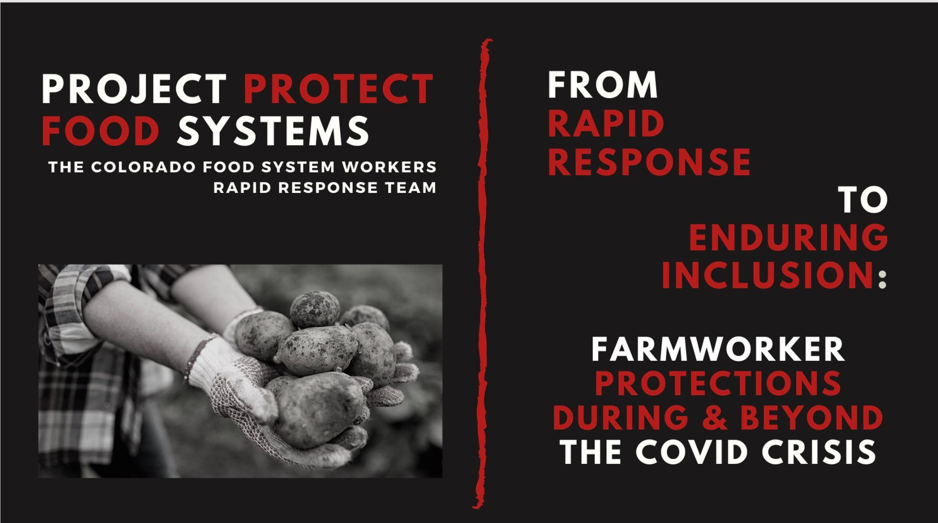
Image from an outreach presentation by Project Protect Food Systems Workers. Image courtesy of Project Protect Food Systems Workers.
The story of Project Protect Food Systems Workers is about how individuals, communities, and eventually coalitions reach for and achieve basic rights, support, and recognition for their participation in our systems, economies, and laws (Civita and Auerbach, 2023; Auerbach, 2021). Project Protect created a coalition of people who stood up to systems of oppression by prioritizing relationships and holding fast to the aim of redressing historical wrongs—along with virtual and physical spaces in which members of that coalition could act together. We focused on creating what the anarchist activist Hakim Bey called a Temporary Autonomous Zone, defined as a place where we can experience the world with the rules of capitalism and supremacy suspended (Bey, 2003). This work made substantive change to the laws, food system, and material well-being of agricultural workers in the state of Colorado.

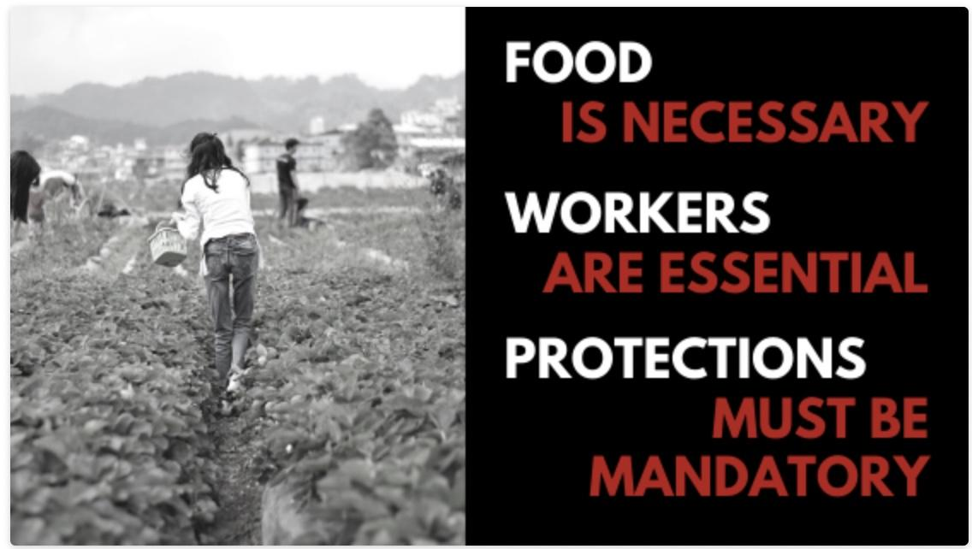
Image from an outreach presentation by Project Protect Food Systems Workers. Image courtesy of Project Protect Food Systems Workers.
A brief history of racist exploitation in agriculture in the United States (Allen, 2016)

To understand the moment into which we stepped, the racial context of agricultural workers as a group, and the long-standing characterization of that group as expendable is important. It is impossible to read the history of agricultural workers in the colonies and then the United States without recognizing that today’s exploitative practices were originally created, enforced, and eventually cemented through legislation to systematically and durably advantage one racial group (White Europeans) over other groups. The intergenerational economic advantages that racialized and exclusionary agricultural labor laws locked in are, in most states, a still-living and proudly displayed legacy of colonialism and slavery in this country. Thus, in 2020, when COVID-19 turned congregate living and working conditions into a deadly threat, the arguments against improving the housing of migrant workers to enable distancing or in favor of faster speed limits on meat processing lines did not seem particularly nefarious to many. Regarding these often invisible, absolutely essential workers as expendable was so much a part of the industry power brokers’ subconscious priming that the economic arguments made by owners, farmers, and producers felt persuasive because they were so familiar. It was only through the lens of historical racism and the context of how systems and structures are created to value financial gain over human life that these situations became clear.

Agricultural workers (alongside domestic laborers) were deliberately carved out of laws designed to protect all other workers, guarantee minimum wages and reasonable working hours, and enable collective action and power building. This “omission” is a visible impact of the long reach of slavery, colonialism, and White supremacy (DeWitt, 2010). Naming this fact, despite its historical accuracy, created defensive resistance and denial in just about everyone who opposes the simple notion of bringing the legal treatment of agricultural workers in line with those in all other sectors. Because reckoning with this often-obscured history can be challenging, we will quickly relay the relevant lowlights of United States history, which set the context for agricultural labor policy across the 50 states, including Colorado (Vaught, 1999; Sine, 2016; Weber, 1996; McWilliams, 2000).

Starting in the1600s, indentured servants were brought to the colonies in the mid-Atlantic and the south to provide agricultural labor which set the stage for a class-preoccupied society full of citizens motivated by the upward mobility myth. As the colonies grew, starting in about the 1650s, indentured servants were not enough of a labor force to keep up with agricultural production and land-owning settlers needed a more exploitable workforce. Chattel slavery addressed their labor problems, as enslaved people were brought from Africa to work the fields and act as domestic servants.

During the Reconstruction era, the United States government passed the 13th, 14th, and 15th Amendments to the Constitution which prohibited slavery and involuntary servitude, gave all men born in the United States (including formerly enslaved men) citizenship, and gave said men the right to vote. To consolidate power and prevent coalition building between White lower classes and enslaved Africans, starting in 1865 (just after the 13th Amendment was ratified), Black Codes, a collection of local and state laws, became ubiquitous in the South. These laws prescribed when, where, and how formerly enslaved people could work and set limits on their earnings (Mississippi Black Code, 1865). Though these laws were eventually repealed, due to the activism of Black workers, they remained in practice and embedded Whiteness as an ever more powerful construct in American society (Foner, 2014). They were effective in subdividing poor Whites and formerly enslaved people, setting these groups against each other instead of allowing natural solidarities to strengthen within the underclasses (Knapp, 2022).

Tenant farming, land rental arrangements, and sharecropping, a system that invited more worker exploitation, emerged in the South once enslaved labor was no longer possible. Under sharecropping arrangements, a landowner would allow a tenant use of (typically his) privately owned land in exchange for a substantial share of the crop. From the remaining proceeds, the sharecropper also had to pay the landowner for use of supplies and equipment that often had to be sourced from a “Plantation Store” at inflated prices and with high interest. This structure kept Black people tied to agriculture at low or no wages and with no opportunity to experience vaunted American upward mobility. Sharecroppers typically sunk into debt to the landowners and had little legal recourse or protections. On top of this, beginning in the Black urban migration period in the 1880s and extending through the Civil Rights era, Jim Crow laws picked up where Black Codes left off and re-inscribed inferior treatment of Black people and limited their opportunities for earning decent livelihoods (Woodward, 2001). Agricultural laborers did not submit quietly to these economic and legal oppressions. The sharecropping system gave rise to an early example of multi-racial and gender-inclusive organizing for farmworker rights in the form of the Southern Tenant Farmers Union, which mobilized and lobbied in the 1930s to improve the livelihoods and working conditions of those doing the actual farmwork, as well as to make sure that tenant farmers were also able to benefit from early agricultural subsidy and support policies (Paul, 2018). Only white supremacist violence, which manifested dangerously as lynching and massacres, and white conservative electoral fraud, managed to break these worker movements (Hild, 2007).

During the Great Depression, the United States Congress passed a series of laws to protect workers in various fields. The laws were designed to protect laborers by setting a minimum wage, limiting working time (via premium overtime pay), setting up compensation systems for injured workers, guaranteeing the right to act and bargain collectively and form unions, and regulating the use of child labor. Patterned by history, these laws specifically excluded farmworkers and domestic laborers, jobs that were among the few open to the overwhelming majority of Black and Brown people. The need for votes from Southern Democrats to pass these laws allowed formerly slaveholding states to further imbibe racism into the structures of agriculture and to codify it into law and public policy. A particularly overt and heinous example of the racism in this process came from the speech of Rep. J. Mark Wilcox of Florida opposing the Fair Labor Standards Act on the floor of the House. “Then there is another problem of great importance in the South,” he argued, “and that is the problem of our Negro labor. There has always been a difference in the wage scale of White and colored labor. . . .You cannot put the Negro and the White man on the same basis and get away with it.” Rep. Edward E. Cox of Georgia agreed, saying, “The organized Negroes of the country are supporting [the FLSA] because it will, in destroying state sovereignty and local self-determination, render easier the elimination of racial and social distinctions” (Perea, 2011).
In partial parallel, the history of migrant workers begins around 1848; at the end of the Mexican-American War, thousands of workers from Mexico moved across the border for temporary jobs. While they were neither enslaved nor indentured, these workers were not citizens, had no rights, and were uniquely under the control of their employers.

Second-class status for non-White people in agriculture was not limited to Black or Latinx people. During the post-Civil War era of agricultural expansion, the United States encouraged Asian migration to fill the need for agricultural workers. By 1886, the majority of farm laborers were Chinese, Japanese, or Filipino. Then, the Chinese Exclusion Act banned people from China from working in the United States. The passage of the Chinese Exclusion Act, which banned Chinese immigrants from working in the United States, marked the beginning of the fear that a flow of foreign workers posed a threat to “real Americans.” At least until a greater threat, such as multilateral armed conflict in the form of WWII, loomed.

The First World War caused a shortage of European and White American workers, so farmers again turned to nearby Mexican workers to keep agriculture going. The first guest worker initiative was initiated at the growers’ behest. From 1917-1921, this program facilitated U.S. agricultural employers’ access to more than 70,000 Mexican workers (Martin, 2022). But as soon as American unemployment became a concern during the Great Depression, the federal government deported or pressured about 500,000 Mexican-Americans to leave the country; the Mexican Repatriation was partially to free up agricultural jobs (ibid).

During World War II, the pendulum of the U.S, agricultural labor market swung back in the direction of need, prompting returned reliance on Mexican guest workers via the Bracero Program. This program was discontinued in 1964, when evidence came to light that Braceros were routinely abused and that the regulations and enforcement to protect them offered insufficient protection (America’s Heartland, 2006). In 1952, the Temporary Guest Worker Visa program was made law as part of the Immigration and Nationality Act. We still live with this program though today it is called the H2A Visa program.

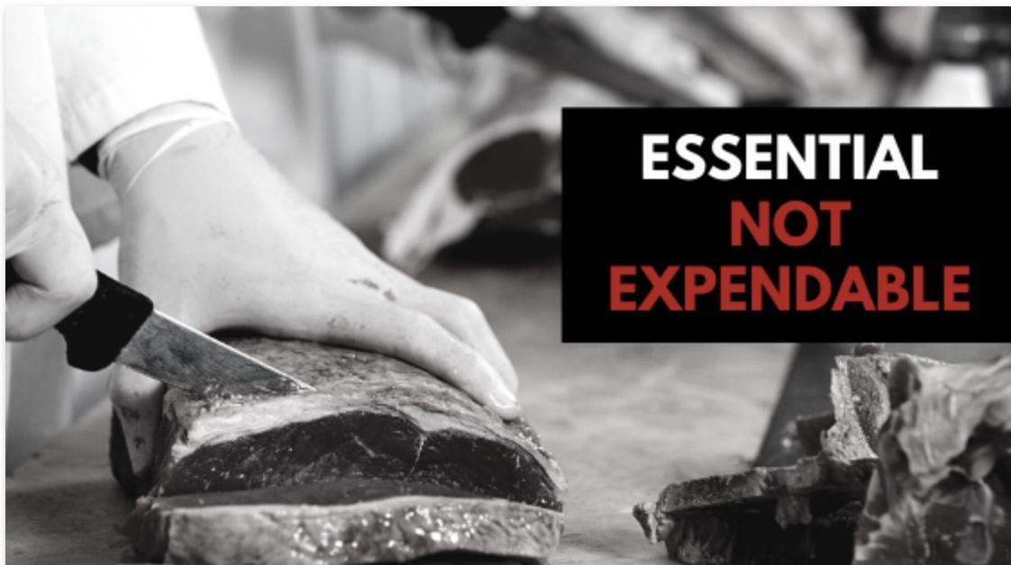
Image from an outreach presentation by Project Protect Food Systems Workers. Image courtesy of Project Protect Food Systems Workers.

In the middle of the 20th century, Filipino farmworkers in California began organizing for their rights and for better working conditions, demanding to be treated as human beings and not cogs in an economic profit machine (Morehouse, 2015). Their efforts were famously amplified and accelerated in 1962 when Delores Huerta and Cesar Chavez joined them, founding the National Farm Workers Association, which later became the United Farm Workers (UFW) (ibid.). Although this movement, which continues to inspire and challenge farmworker justice advocates today, made major strides (especially in California), agricultural exceptionalism remained pervasive under federal law and across most of the United States. Throughout the 1980s, 90s, and early 2000s, farmworker advocacy groups form and press for justice in various agricultural regions of the United States, (e.g., the Farm Labor Organizing Committee in the Midwest; Pineros Y Campesinos Unidos del Noroeste in the Northwest; the Farmworker Association and Coalition of Immokalee Workers in Florida), with some notable successes. Nevertheless, because labor exploitation is an original and continuous feature of American agricapitalism and because farmworkers face significant structural vulnerabilities that limit their ability to exercise political voice, (Coles, 2016; Guthman, 2016) efforts to uproot exploitation and center farmworkers have typically been slow, scattered, and spotty (Civita, 2021).

Project Protect Food Systems Workers Rejects Crisis Capitalism in Favor of Community Care

In the fear-filled and chaotic first weeks of the pandemic, when the country, and most of the economy, were “shut down,” millions of workers categorized as essential saw no decrease in the pace of their work—and substantial increases in its peril. The designation of agriculture and food production workers as essential “expose[d] a cruel paradox: everyone relies on food system workers to meet their basic needs for sustenance in times of calm and crisis, but many food system workers do not have secure livelihoods and exist on the margins of society” (Civita, 2022).
Further, each worker’s ability to safely manage COVID-related risks varied based on:

- their particular job duties;
- employers’ policies, ethics, and accountability;
- their ability to organize with labor unions and have a collective voice;
- the level of social inclusion and the quality of their connections to the communities where they live and work;
- their legal status, work authorization, ability to secure alternate employment; and
- the status of their financial security and that of the people relying on them for financial support (ibid.).

The panoply of intersecting vulnerabilities that food system workers faced prior to the pandemic changed the nature of and risks associated with their work amplifying their risks of contracting and spreading the virus long before testing, treatments, and vaccines were widely available, experiencing destabilizing financial hardship, and impairing their ability to support themselves and their families, and being pushed further to the margins of society.

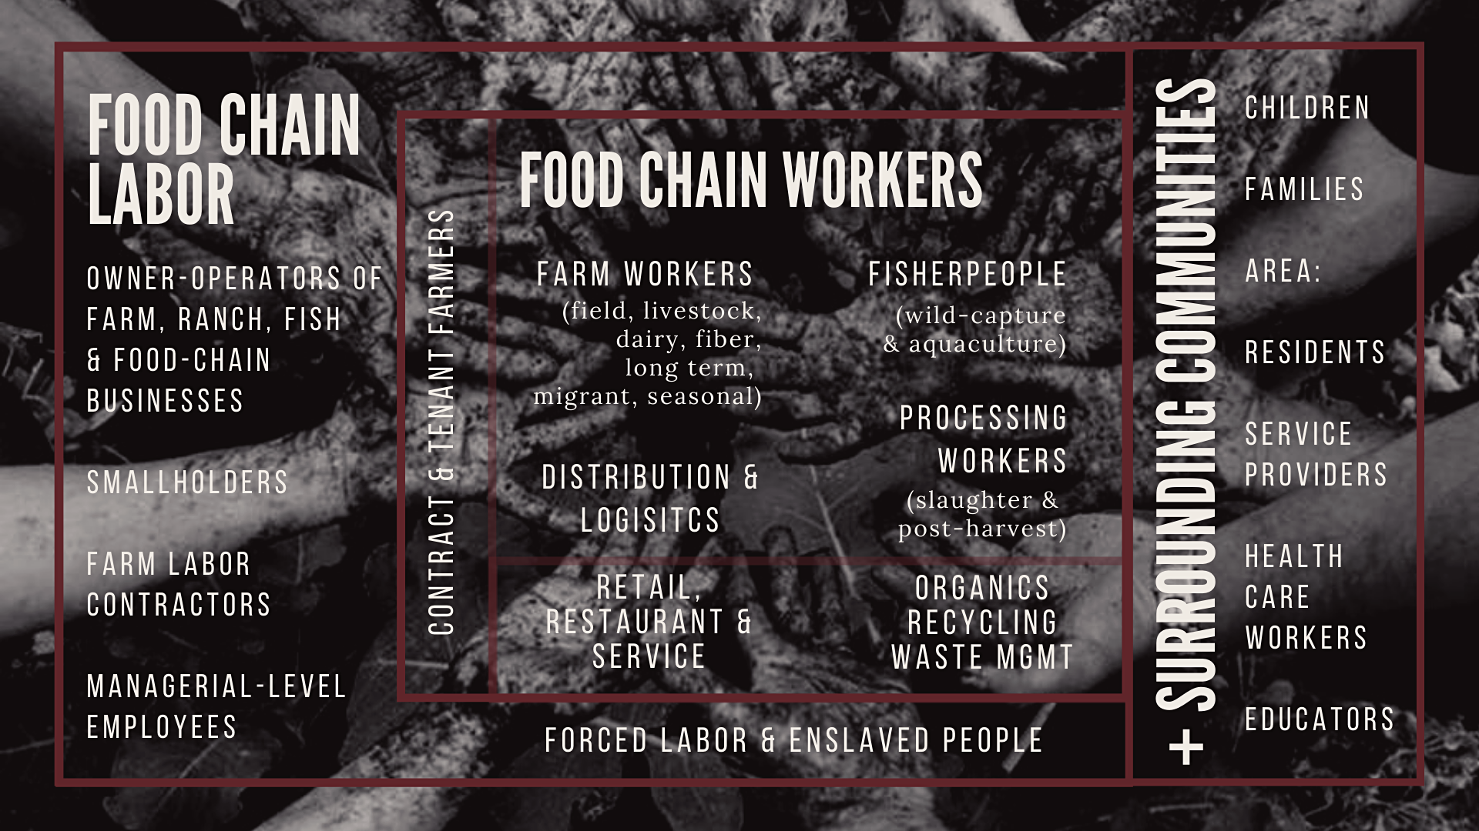
Image from an outreach presentation by Project Protect Food Systems Workers. Image courtesy of Project Protect Food Systems Workers.
Recognizing these particular vulnerabilities—and noticing that other groups that existed or mobilized to address pandemic disruptions to Colorado’s food system seemed insufficiently attentive to the needs of workers—a loosely organized Colorado Food System Workers Rapid Response Team spun out of other efforts and into its own Zoom meetings. Early meetings drew dozens of people from across the state, each of whom logged on to share community needs or offer expertise and resources. The organizers and attendees of these meetings were troubled by their shared recognition that “[f]ederal relief directed toward the agriculture sector prioritized the needs of business owners, but largely ignored the specific vulnerabilities and needs of Food System Workers” (ibid.).

Before long, this group of “immigrants, farmers, scholars, activists, unions, and workers across Colorado working to identify, elevate and address the needs of the people who contribute their labor to all parts of the food system” (Marks et. al., 2020), gave itself a more compelling name: Project Protect Food Systems Workers (PPFSW). It was our belief that food systems workers are always essential but that their rights, health, needs, and interests had been systematically ignored for far too long because their vulnerability and structurally racist marginalization was a boon to extractive agricapitalism. Inattention to the plight and the health of food system workers is unsurprising but deeply problematic. We ignore their well-being at our collective peril. We began by getting PPE and COVID information into agricultural worker communities, and when workers and their families shared that without wages, they were experiencing food insecurity, we began delivering food.
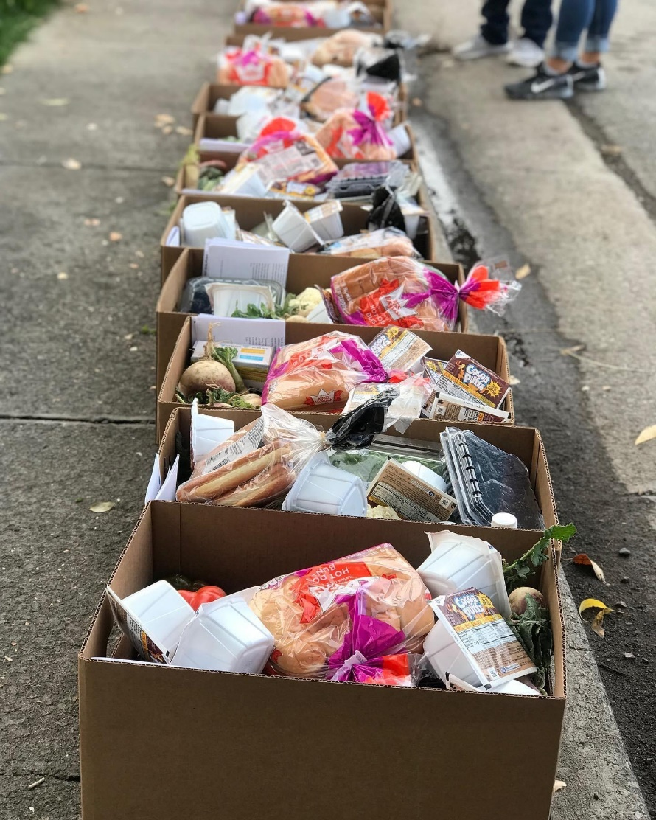
Food collection for distributing to food systems workers in Colorado during COVID. Image courtesy of Project Protect Food Systems Workers.

The group was convened by Fatuma Emmad, Nicole Civita, and Damien Thompson. It soon grew to include Devon Pena, Founder and President at The Acequia Institute and anthropology professor, Caitlin Matthews the Food Systems Coordinator for the Tri-County Health Department, Jenifer Rodriguez, the Managing Attorney of the Migrant Farm Worker Division (MFWD) of Colorado Legal Services, and Alexia Brunet Marks a Professor of Law at the University of Colorado Law School who brought along Hunter Knapp, then in his final weeks of law school, Michelle Auerbach, an activist and communications consultant, Margaret Brugger of Commún, plus JaSon Auguste and Kassandra Neiss from Frontline Farming. The group was joined by many other people who represented aligned organizations and the meetings were open to anyone who wanted to join and help.

As early outbreaks raged in our state’s meat packing facilities and among agricultural workers, we recognized that essential food system workers needed protections at and outside of the workplace. We articulated an immediate policy response agenda (Marks et al., 2021):
A. Protect Workers in the Workplace | B. Protect Workers and Families Outside the Workplace
1. Require posting of COVID19 safety protections & related guidelines. | 1. Empower community healthcare networks.
2. Provide temporary shelter and sanctuary for workers with COVID-19 symptoms. | 2. Expand Medicaid access and coverage.
3. Ensure employer-provided housing meets the requirements of the COVID-19 pandemic. | 3. Support undocumented people.
4. Implement additional safety inspections and enforcement in essential workplaces. | 4. Support children of essential Food System Workers.
5. Ensure Food System Workers can participate fully in forums designed to monitor working conditions in Colorado and recommend policies to protect workers. | 5. Support federal legislation to protect families of Food System Workers who make the ultimate sacrifice.

We also quickly noticed that there was a dearth of data on the food system workers in our state—and this lack of data both reinforced the invisibility of these workers and was often used to justify their exclusion from responsive policies and/or resource allocations. To begin advancing this agenda, PPFSW members self-organized into teams focused on Social Movements, Policy, Fundraising, Data, and Communications. We were committed to practicing what we stated in our principles and so we ran our meetings with care—beginning each one with a grounding and ending with a blessing to create a container that honored our bodies, soothed our nervous systems, connected our spirits, and elevated our work. These space-making practices helped to distinguish PPFSW gatherings and the energy exchanged within them from the overwhelming number of back-to-back Zoom meetings that characterized early pandemic work and organizing.

Emergent, Agrelational, and Responsive: Project Protect Food Systems Workers’ Principles (Frontline Farming, 2021)

As we dug in more deeply, PPFSW created a set of Guiding Principles to inform the work of our open coalition. It was crucial that these principles be emergent—defined as strategy that is responsive to patterns as they change and follows the signals we receive, shaping change as we go (Civita and Auerbach, 2023, p. 144). Emergent strategies are by definition responsive—they function from groundtruthing—the practice of using lived experience and data together to read the signals in a situation of potential change and deep listening. These principles also needed to be agrelational—a term we coined for food systems that place people, land, and climate above profit (ibid., p. 66). As change theorist Margaret Wheatley describes—relational change happens when “networks of relationships form among people who discover they have a common cause and vision of what’s possible… Through these relationships, we will develop the new knowledge, practices, courage, and commitment that leads to broad-based change” (ibid., p. 145).
The only requirement of any individual or organization wishing to attend our meetings, align with, or contribute to our work has been a willingness to uphold and be guided by these principles. As such, this foundational document has influenced all aspects of our advocacy, actions, structure, relationships, and coalition building.

- Essential, not Expendable
A contradiction of capitalism is the existence of people whose marginalization both economically and socially is essential to the proper functioning of the economy. To recognize another's humanity is to treat that person with dignity, regardless of legal status in a particular location. Access to jobs, education, housing and a healthy environment in which to live are foundational supports for essential workers in any economic system.
- No Justice, No Security
We know the security of any system only exists insofar as the individuals and communities supporting that system are themselves secure. As long as workers are vulnerable to coercive threats from employers and the state, the food system will not be secured.
- Protection of Workers & Environment is Good Business
The food system will be secure when workers are owners, when they are well-paid and their families are well-fed and housed decently. The food system will be secure when farmworkers are known and respected as land stewards. The food system will be secure when animals meet their end in culturally appropriate ways that honor the relationship between humans and our animal relations.
- Equity in Risk and Opportunity
The essential but expendable paradigm reveals that some are called upon to potentially sacrifice their lives for the wellbeing of the economy. Essential workers should have access to greater opportunities in housing, education and healthcare equal to the proportion of risk (e.g., measured by death, dismemberment, chronic disease, shortened lifespan, etc.) that they endure for the sake of “our” economic system.
- Nurture Economies of Solidarity and Resilience
Vulnerable communities have long created economies that leverage local assets in historically rooted, culturally appropriate and mutually supportive ways. It is critical that these supportive networks are nurtured as they provide critical structures of resilience and resistance to communities that are marginalized in the current food system.
- Land based, People based
Our resilience is rooted in land and the capacities of people in our communities.
- We Elevate and Amplify (Essential) Worker Voices

None are liberated until all are liberated. We recognize every human being has the ability to work towards liberation and become self-sufficient by creating necessary systems. In a liberated society, every voice is lifted and every one of us is visible and our contributions are recognized.

Visibilizing Food Systems Workers through Data Collection and Communication

In Colorado at the beginning of COVID, agricultural workers fell into three categories – though in reality these categories functioned together in overlapping economies: (1) agricultural workers in the Colorado workforce as documented in state data; (2) H2A visa workers, and (3) workers who are undocumented. State data covers the first two categories but often not the third and so the economies of the food systems workers in Colorado went unaddressed and ignored.

Agricultural Workers
Farmworkers and Laborers, Crop Nursery, and Greenhouse | Agricultural Equipment Operators
Farmworkers and Laborers, Farm, Ranch, And Aquacultural Animals | First Line Supervisors of Farming, Fishing, and Forestry Workers
Agricultural workers, All Other | Graders and Sorters, Agricultural Products
Source: Project Protect Food Systems Workers (Neiss, 2021).

In the category of documented workers in Colorado, the demographics look very different than the reality we know is happening in the fields, the processing and packaging plants, and in the food system as a whole.

According to PPFSW’s 2020 Food Worker and COVID-19 Report, “In Colorado we estimate migrant and seasonal farm workers to number between 20,000 and 25,000 annually, with between 40,000 and 55,000 total workers employed in agriculture (United States Department of Agriculture, 2017). The quarterly wage census data for 2020 estimates farmworkers in Colorado have an average annual income of $29,970, which is above the national average income for farmworkers of $26,185, but leaves any family of 5 or more below the Federal Poverty Level (EMSI, 2020). The majority of these jobs are in crop production (32%) or animal production (25.2%) (ibid.). Additionally, warehousing work, especially in potato production, provides late and early-season jobs” (ibid.)

Race/Ethnicity | Agricultural Workers
White | 54.2%
HIspanic or Latinx | 39.1%
Black or African American | 3.0%
Asian | 1.7%
Two or More Races | 1.1%
American Indian or Alaska Native | 0.7%
Native Hawaiian or Other Pacific Islander | 0.1%
Source: Project Protect Food Systems Workers (Neiss, 2021).

H2A visa workers, or guest workers, make up a good number of the agricultural workers in Colorado. In fact, “Colorado has also benefited from an average of 3,000 temporary agricultural workers from foreign countries, most commonly Mexico, on certified H2A Visas per year over the last four years” (Marks et al., 2021). Employers of those workers are ostensibly held to a higher standard in wages, housing, safety regulation, and transportation, but enforcement is scarce. As we saw on the ground, those standards were barely met and often felt more like control and restriction of movement than secure housing, public health, or safety precautions.

Specific demographic information about Colorado agricultural and food system workers is especially difficult to come by because there have been too few state-specific studies. Accordingly, PPFSW looked to some national averages and statistics to shed some light. Nationally, up to 74% of agricultural workers in the US are immigrants, most of whom are from Mexico (Farmworker Justice, 2019). More specifically, in the U.S. foreign-born workers account for 73% of hand packers and packagers, 62% of agricultural graders and sorters, and 32% of supervisors. (Gelatt, 2020). Additionally, 49% of farmworkers are immigrants who lack work authorization. The percentage roughly equates to 1.1 million to 1.7 million undocumented farmworkers, nationwide (Farmworker Justice, 2019).

Thus, we estimate that undocumented workers make up a roughly estimated 50% of Colorado’s agricultural workforce. (A more precise count or percentage is to pin down because neither workers nor employers benefit from disclosing legal status.) Though undocumented persons are not authorized to work in the United States, they perform essential labor, pay taxes, enable farmers to profit from their land, allow food prices to remain low (relative to other countries) and contribute to the economic vitality of the state. In return, they are vulnerable to exploitation, wage theft, unfair labor practices, dangerous working conditions, discrimination, trafficking, and other forms of dehumanizing treatment.

Currently, based on Quarterly Workforce Indicators data, H-2A data, NAWS data and known under reporting estimates, it can be stated that between 65% to 74% of Colorado agricultural workers are BIPOC, with 85% to 97% of those identifying as Hispanic, Laitnx or of Spanish origin (Project Protect Food Systems Workers, 2021).

Farmworkers, in Colorado and more broadly, are skilled laborers who have developed specialized skill sets to succeed in agricultural employment. The majority (55%) of farmworkers in the U.S. have spent 11 years or more in agriculture (Farmworker Justice, 2019). We have no reason to believe that Colorado farmworkers are any less experienced on the whole.

Furthermore, seasonal farm labor supports multiple family members, some of whom live in agricultural housing with the employed farmworker. Most live below the poverty line, which has dire effects on food access, healthcare, and housing. Some farmworkers and their families access public assistance programming including Medicaid (44%), Supplemental Nutrition Assistance Program (SNAP, 18%), Special Supplemental Nutrition Program for Women, Infants, and Children (WIC, 17%), and public health clinics (10%). However, farmworker use of public assistance has historically been low and many eligible families may not be participating (ibid.).

In the face of overwhelming lack of rights and protections and the unknowns of the pandemic, Project Protect Food Systems Workers insisted upon regarding food systems workers in a holistic and agrelational way—as economic and social citizens of our state, or put another way, as both part of the food ecology of the state and as part of its care economy also (International Labor Organization, 2020). More than that, these people who have kept us fed are human beings doing skilled labor for the benefit of the entire population of Colorado and deserve at least the most basic rights.

PPFSW Expands on Emergency Response to Shape Enduring Change

Once PPFSW was in full swing, we channeled much of our collective energy into two streams of work: supporting the physical and emotional needs of worker communities through the formation of a statewide network of promotoras (lay community health workers) and addressing the structurally racist exclusions of agricultural workers by advancing ambitious legislation, SB-21-087, which became colloquially known as The Farmworkers’ Bill of Rights.

The notion that a loosely affiliated group of people could form a strong and wide enough network through which the needs of workers were surfaced and rapidly addressed—materially, socially, and legally—was, perhaps, naively optimistic. But, it was also inspiring and galvanizing. The boldness and necessity of our ambitions propelled us to meet seemingly endless needs and face down fierce opposition. As we felt our way through the Summer of 2020, its nation-wide reckoning with the violent and deadly consequences of structural racism, racial disparities in COVID infections, deaths, and other harms, and continued instrumentalization of “essential workers,” early brainstorms of a promotora network that could span the state turned into meetings with CDPHE and proposals for funds. Likewise, aspirational musings about legislation that would make legendary farmworker rights’ advocates Cesar Chavez and Dolores Huerta proud turned into conversations with potential legislative sponsors. Progress was possible not because we were the most experienced political operatives or organizers but because we held fast to a relational approach that emerged from and responded to the needs of the moment. Understanding both historical drivers and present harms, we knew that we had to undertake both projects—and that, while separate, each would energize and inform the other.

Creating the Promotora Network

Models for a promotora network already existed and seemed like an obvious and culturally appropriate response (Promotora de Salud, 2022). The CDC defines a Promotora as: “Promotores de salud, also known as promotoras, is the Spanish term for “community health workers.” The Hispanic community recognizes promotores de salud as lay health workers who work in Spanish-speaking communities (Community Health Workers (Promotores), 2019). In looking to such models and practices, we recognized that “in order to meaningfully increase health equity in our communities, community leaders of color must be at the table and involved in identifying the barriers and creating the solutions as well as being involved in decisions about activities that may affect their communities’ environment and/or health” (ibid.). Further, seeing that, when COVID response in frontline communities isn’t done in a culturally responsive way, it has immediate negative impacts and can contribute to future outbreaks and overall local community insecurity (Promotora Network, 2022), we sought to support a network of promotoras—skilled and respected Latinx community members who work within their community to bring resources, advocacy and needed services. There is much written about this model elsewhere so we will write about the successes of this network both during the height of the COVID pandemic and elsewhere. (Ayala et al., 2010; Eng et al., 1997; Liebman et al., 2007).

The network was created to train and provide resources for a group of promotoras across the state who are knowledgeable in legal, health and food-based issues that confront food systems workers in response to COVID-19 (Promotora Network, 2022). PPFSW determined that our promotoras would:

- support and work in tandem with Regional Labor and Employment Specialists;
- live in the geographic region where they work and have connections to the farm/food worker communities therein;
- work in collaboration with agencies and members of the community to bring community voice to inform and influence decisions that impact their lives;
- provide community education around health, legal guidance, and available resources including personal protective equipment (PPE) supplies;
- provide support for community members who are experiencing additional vulnerabilities related to COVID-19; and
- provide support for community members who are Colorado residents as well as community members who are not residents but who are employed in the state or are required by public health officials to remain in Colorado as a result of COVID-19 exposure.

Our process began with the data that our data team collected. We wanted our actions grounded in the realities of farmworker lives and not on the perceptions or assumptions that usually drive toxic philanthropy. Then, as the pandemic hit its height in Colorado, Fatuma Emmad and Jenifer Rodriguez began the work of weaving together a coalition of Promotoras across the state. Jenifer’s legal and relational experience connected us to many organizations and individual actors across the state, ag workers, and those already providing services. She also knew how their lack of access to even basic resources had long been invisibilized and ignored. Fatuma’s own personal history as a child of immigrants and a farmer positioned her to recognize the needs of immigrant families and also gave her a firsthand experience of the value of existing community assets. Through interviews with outreach workers and trusted community members, Jenifer and Fatuma began to identify leaders across regions who had already been doing the work of outreach in different capacities, often unpaid. While launching the network, they were constantly warned about the impossibility of creating community in certain regions of the state, and perceived attitudes about engaging farmworker communities at all, as well as how difficult it would be to establish teams working together across the entire state.

They approached these communities from an asset-based perspective and with humility. This approach allowed an understanding, mutual recognition, and base building. This original approach led to each region of the state lifting up its own regional directors and then forming a unified statewide team who understood the value in working together across space and for a shared mission. As a result, these communities now recognize that there is much more that connects them and their cultures than the segregated geographical communities they live in (Emmad, 2021). There were 34 promotoras across four regions in Colorado who held 186,808 individual interactions with farm workers during 2020-2022 (The Data, 2023). The majority of those interactions were with male or male-identified farm workers with the majority falling in the 26-55 age range. As of December 28, 2022, the promotoras found that their work included 21,487 individual outreach events (ibid.) addressing issues ranging from information about COVID, general information requests, legal issues, education about workplace regulations, questions about the Department of Motor Vehicles and drivers licensure, childcare, internet access, and domestic violence (ibid.). The network distributed 45,492 food boxes, 909,840 pounds of food, and 35,814 food assistance referrals (ibid.). The network also distributed 16,540 articles of clothing, 8,554 hygiene kits, 10,544 articles of outerwear, 5,510 pairs of work gloves, 2,694 duffel bags, 2,490 containers of sunscreen, and 891 sleeping bags (ibid.).

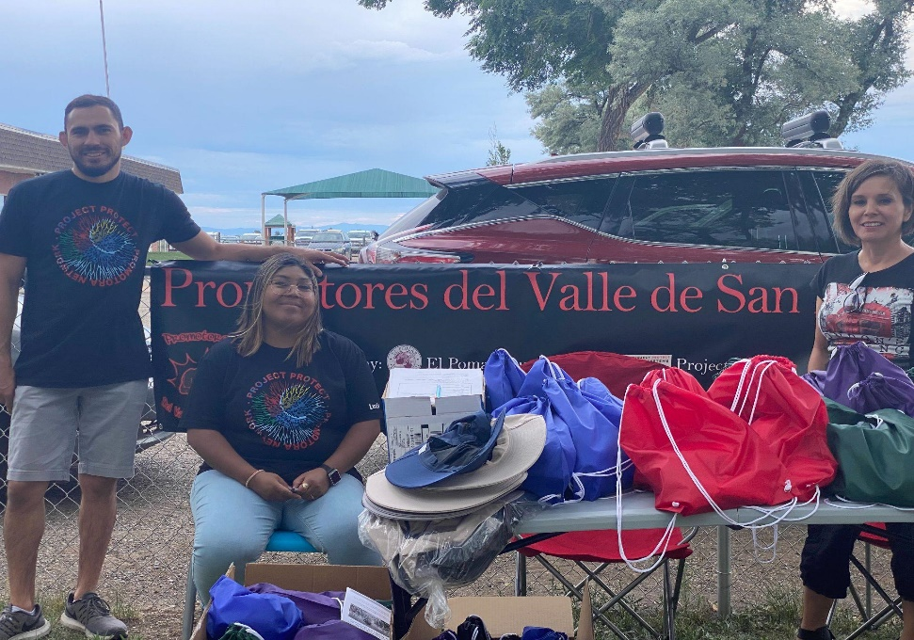
Finally, the promotoras don’t just help agricultural workers deal with challenges, access resources, and redress wrongs. They also draw their communities together in ways that honor and celebrate culture in new contexts. For example, we held a Día de Muertos vigil and celebration to honor agricultural workers who died doing their work. The promotoras are not all accustomed to the same celebrations, so it was also a learning experience planning the event—with each person asking for the food, music, alters, and ways of doing the event that they were used to. By the time the event began, there were many cultures coming together to dance, sing, mourn, laugh, teach, and learn. The dancing, music, and sharing went on for hours in the cold November dusk outside a state office building, creating warmth that kept us all there for hours. By building cultures that create joy and meaning even amidst mundane tasks or grinding challenges, the promotoras open up the possibility for thriving in systems that do not have their communities’ best interests at heart (Civita and Auerbach, 2023).

Project Protect Promotora Network meeting with workers to distribute the hot weather gear necessary for outdoor worker safety. Image courtesy of Project Protect Food Systems Workers.

Creating SB 21-O87 Concerning Agricultural Workers Rights

The long history of labor exploitation in U.S. agriculture meant that many contemporary farmers and their well-resourced and organized industry associations saw little wrong with labor dynamics that keep a largely BIPOC and migrant workforce at the margins of society and the economy while demanding the performance of hard physical and manual labor in the unsheltered outdoors often in excess of 60 hours per week. Such had been the norm for so long that the business models of individual farms and agribusiness sub-sectors had become reliant on exploitative and artificially low labor costs with lax safety standards. Indeed, in some ways, this arrangement is what made it possible for an American agricapitalism to extract maximum value from stolen indigenous lands while rewarding homesteaders (and later ever larger farm operators) who spread across the continent and reinforced tenuous claims to large swaths of land by rendering it “productive.” As a result, it is not surprising that (mostly White and landowning) farmers across Colorado clamored that they would “not be able to make any money” when they heard that PPFSW and its allies were working to rewrite the state's agricultural labor laws.

Having immersed ourselves in legal and movement history, we knew that the only way to rectify legislative exclusions and agricultural exceptionalism was to create legislation. For Cesar Chavez, Dolores Huerta and the UFW, their movement brought California to the Agricultural Labor Relations Act of 1975, which provided California agricultural workers with collective-bargaining rights and protection from unfair labor practices guaranteed by the Agricultural Labor Relations Board (Leroy, 1999). Washington state also passed a bill that guaranteed overtime pay. New York passed the Farm Laborer Fair Labor Practices Act in 2019 (Farm Laborers Fair Labor Practices Act, 2021).

So, in Colorado, we needed to propose a bill and pass it—even if doing so would be akin to ascending the tallest peaks in the Rocky Mountain state. But if we didn’t climb, the centuries-long legacy of racialized labor exploitation in agriculture would survive the pandemic (Agricultural Workers’ Rights Bill Explainer, 2021).

In February of 2021, Senator Jessie Danielson introduced Senate Bill 21-087, the Agricultural Workers’ Rights’ Bill, into the Colorado Senate. The Bill was co-sponsored by Representatives Karen McCormick and Yadira Carveo in the House.

The bill passed out of the Business, Labor, and Technology Committee with a 4-3 vote. The process of getting to a committee vote was grueling and the response from the farmers was an education in White Supremacy and its symbiotic relationship with extractive capitalism. Stripped bare, the owners fought for their right to deny the basic rights of workers in order to maximize their own profit. The workers, including community advocates and promotoras, were prepared for the committee hearing through a bilingual process of story harvest and testimony preparation assuming the usual three minutes allotted to speakers in hearings discussed later. The story team worked together to cover all aspects of the workers' lives, from health and safety, living conditions, pay issues, and access to services. The promotoras and workers were told they could present in Spanish and so testimony was prepared in their language of choice. In reality, when the hearing opened, there was no translator and Project Protect needed to provide translation and worker advocates and farmers of color supporting them were strictly limited to two minutes of testimony each, cut off when allotted time ran out, and asked no questions. White farm owners in the very same hearing were granted unlimited time to speak, were asked numerous substantive questions even when the question was outside of their area of expertise and responded with vague open-ended queries to indefinitely enlarge their time to testify. They were offered, quite literally, a chair at the table and opportunities to expound, while our testimony was done from a distance and tightly timed. On top of this, after the hearing, opponents were heard by farmworkers, ironically, telling the press that not a single farmer testified in support of SB-87. This was patently false: the inconvenient and revealing truth was that no individual White farmers or multi-generational White Colorado ranchers expressed their support. Farmers of color, first generation farmers, urban farmers and even the National Young Farmers Coalition (both officially as an organization and in the testimony of individual members) had all raised their voices in support of farmworker justice (Emmad, 2022).

Summative testimony came from Nicole Civita, who reflected on what had happened in the hearing, drawing attention to the problematic dynamics of power and participation, as well as to rhetorical devices being used to undercut the need for the legislation:

“You first heard from proponents, including some farmers who want to see this bill pass. You didn’t hear directly from workers BECAUSE they are unprotected. Because they need the bill to pass to even be able to show up here and participate without retribution. And I will tell you the retribution is real — because our Promotoras and partners have been facing it since this bill was introduced. Our organizational partners had to deal with farmers calling and making up lies about her work to get her contracts for serving ag workers canceled by a food bank in this state.

Then you heard from producers — and you asked them lots of questions — a level of inquisitiveness not expressed to the witnesses who spoke about impacts on workers.

Hours of long, deeply engaged testimony about how good some farmers are — and I genuinely believe that some of them are. But I also know that there is a substantial record of legal claims against some of the farms that were represented by folks who testified here today, some of which is public and some of which would be available via a CORA or FOIA request. So I’d urge some caution about discounting the stories of workers because the very people who have power over them say “it’s all good.” Also, social pressure among farmers is not a substitute for legal protections. We see support for the spirit of the bill, but not for the actual provisions that are needed to make life better, make work fairer for ag workers.

But again this is not an argument about the values or individual actions of agricultural employers. There are some excellent employers out there — and they are not the point. This is not a debate about good or bad actors. The reality is that these exclusions are representative of an entire system that supersedes the desires of individuals and it is those systems which must be changed or regardless of who the individual employers are, the impacts on workers will be the same” (Civita, 2020).

As the bill continued to move through the legislature, we continued to look for safe ways to balance the incorporation of second and firsthand farmworker stories into the proceedings. For, example, we marshalled powerful testimony from a Regional Organizer of our Promotora Network whose family had labored in the fields and who was contemporaneously serving farmworkers:

“I live in Delta County.... I am a regional organizer for Food Project Protect Systems in the Western Slope. I am in support of Bill SB21-087 Concerning Agricultural Worker Rights.

July, 2020, a 30-year old male a migrant worker H2A Visa Holder, comes here every year during corn harvest. He happened to get sick few days after arriving, unfortunately our local clinic they could not do much for him, since he had lots of visible blood in his urine and problems walking due to his pain…. [The U]rologist stated he needed to have surgery as the stone is way too big to pass on his own … I ask the community members for donations since he didn’t have access to insurance or healthcare anywhere close. These situations are caused due to lack of breaks, water supply, or the education on the importance of hydration and the fact that women and men must hold their pee for longer hours. Yet, employers refuse to let their workers attend to free health fairs or medical appointments because they have a quota to meet.

My family and I have worked in the very same fields many H2A visa workers work now, I have seen the hard labor and the abuse many of them are still experiencing today. This bill will force employers to give local ag workers a better job opportunity to ensure their health care and the availability to support their families, the money they make will stay within our communities that are in desperate need of attention and jobs. Thank you for your time and I urge all of you to support Senator Danielson and Bill SB21-087” (Regional Organizer Testimony SB 21-087, 2020).

We were also fortunate to be introduced to a former farmworker who was eager to advocate for those still suffering as she had. Her testimony directly contradicted the assertions of employers who claimed to have never seen or heard of any worker mistreatment, unsafe practices, or wage theft:

“I worked for 5 to 6 years as a farm worker in Colorado and Arizona. I have worked with all kinds of vegetables and greenhouses with roses and in all places. The conditions are horrible and they took hours away from us. Saturday and Sunday there is no rest. I experienced exploitation in each of the places - wage theft, sexual harassment, they fired me from work when I asked permission to go to the clinic, they didn't give us water, there were no bathrooms, we had to go to the river and the cornfields, and there was no water to wash or remove the insecticide from the hands before eating. One time, one of my employers showed us a video telling us the consequences of pesticides - we could get cancer- and we had to sign a piece of paper saying that we understood and accepted the consequences and that the operation was not responsible for anything that may have happened to us. They didn't give us gloves or masks to protect us. We packed corn in Brighton starting at 7 in the morning until 11 at night, people were fainting, people falling on the side of knives. When it was time to cut the lettuce we started at 2 in the morning in the dark and when the sun came up we started packing the lettuce in bags and we worked until 10 at night…

I once had to take an employer to court for my wages…. In the heat one day, I almost fainted. We worked from sunrise to sunset. Saturday and Sunday, without resting for two weeks. Carrying my own water. Using my own gasoline. And they didn't pay in the end. This was in 2010 in Thornton. With the help of Colorado Legal Services I was finally able to sue him for my wages. 2-3 years later! AFTER!. They also paid my colleagues with bad checks. And they too had to go to the services of C.L.S.

When you are forced into these situations out of necessity, you can only obey. I am embarrassed of the experiences I have had but understand that I have a responsibility to tell these stories. I was fired from my job for speaking up and complaining and I learned that it was best to keep quiet. It is clear that other farm workers cannot tell their stories and that the threats are real and that you will lose everything.

Farm workers need protection like every other worker. I can tell you that I experienced exploitation everywhere I worked in agriculture. We need laws that ensure that people receive basic protections. Not just anyone can do this job and we do it from sunrise to sunset and before the sun rises. I urge you to support this bill and use your voice to support the many workers like me who are willing to work but have been rendered voiceless by these outdated and racist laws.

Let's pass this bill SB87 and end the exclusions for our brothers and sisters in the camp” (Former Farmworker Testimony SB 21-087, 2020).

Multistakeholder meetings with legislators and public hearings were far more contentious than one might have expected considering that SB 21-087 was just a basic rights bill. Its provisions aimed only to bring agricultural workers up to the lowest standard of rights other workers in the state enjoyed such as:

- Providing basic health and safety protections during the pandemic;
- Extending the right to organize to farmworkers;
- Ensuring that service providers like doctors have access to farmworkers on employer provided housing;
- Ensuring fair pay of at least the minimum wage and overtime based on rules enacted by the Colorado Department of Labor and Employment;
- Mandating rest breaks and other protections against overwork, especially in extreme heat; and

- Providing protections against retaliation for farmworkers who speak out about mistreatment.

But, as the bill worked through the legislature, we collaborated with allied organizations, especially Towards Justice and the Hispanic Affairs Project, to clear each hurdle and widen our coalition of advocates and activists. Each group within PPFSW and our larger coalition of SB-87 proponents played a part tailored to the goals of their community and the resources they had at their disposal. As the bill went to a vote in the legislature, each of the organizations testified in concert to cover all the issues included in the bill. Many compromises were hashed out to clear various political blockades thrown up by legislative opponents and the Governor’s office. While several of these were hard to swallow—especially those made late at night to overcome Republican blustering and endless cowboy fantasizing—when all was said and done, we won far more rights and protections than we had imagined possible in our first legislative effort (Civita and Auerbach, 2023).
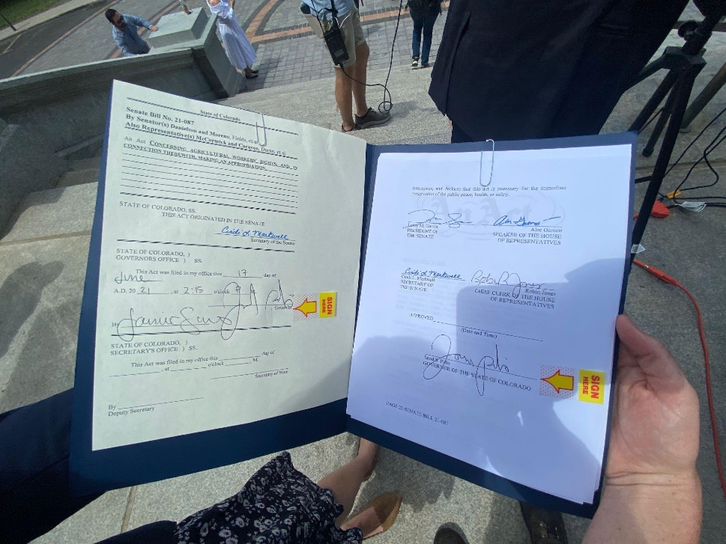
Image of the bill, SB21-087, signed by Governor Polis held by a PPFSW member. Image courtesy of Project Protect Food Systems Workers.

Two moments of the process stand out as both unusual and representative of PPFSW and our principles and beliefs. The first was in supporting workers, worker advocates, and community members in testifying in front of the legislature. After participating in grueling and dehumanizing early hearings, we knew this was going to be a very emotionally challenging process for people who already have little formal power and are infrequently represented in the halls of state power. Moreover, we were rapidly amassing evidence that workers and their local community advocates were experiencing retaliation for and being warned against speaking their truths. Nevertheless, it was essential that worker voices were heard and read into the legislative record. To build capacity and courage for this, Michelle Auerbach created a bilingual process for gathering and refining testimonies from the workers who were the experts in how the bill would impact their lives and communities, to subject matter experts in public health, law, immigration, and farming. Distilling their knowledge down to three minutes and preparing for the racism they would encounter in the process took time, careful strategy, group processing, and post-testimony reflection. We stressed the liberatory aspects of sharing our stories, the internal success of speaking our truth to the very systems that exclude and oppress us, and the vitality of bringing the people most impacted by a bill to the legislature. We knew the experience would be hostile and demeaning but in framing it as a liberatory practice and preparing together with a chance to share stories, we created a container that enabled individuals to show up and speak despite the horrendous circumstances we outlined earlier.

The immoral and racist process of the hearings was summed up by a local member of the clergy. It was important to the community that a clergy member speak—for many community members, a moral and spiritual context imbued the work PPFS was doing:

“We do not all live in the same Colorado. Due to the legacies of white supremacy and legal racism, our farm and agriculture workers continue to be left out in the cold specifically because they are Brown, Black, and oftentimes vulnerable immigrants and guest workers. COVID has shown us how essential these workers are — and how exploited they are.

Every person of faith, whatever your tradition, knows the commands to love our neighbors, to care for the stranger, and to protect the vulnerable among us. As people of faith, we are morally obligated by our sacred texts to create a just and equitable community - here in Colorado - where there is only one state, and where all of us, as citizens, care for the flourishing of all the people who share this land.
And, yet, are hearing the voices of lobbyists and employers saying they feel this bill is unfair. They are not bad people, but those claims are disingenuous. What ethical employer of any workers can say that it is unfair to give another human being basic rights and necessities?

In our world, we have grown too accustomed to abusing the workers on whom we depend for our own food, and we lean on a legacy of exploitation to say it is acceptable to do so. We continue to argue that it is too costly to treat some people as fully and equally human.

There are opposing sides to this debate, but they are not equal. There can be no middle ground between human dignity and human exploitation. These workers are human beings. And, yet, we are allowing powerful business interests to claim that they have the right to harm, to exploit, and to abuse them without constraint.

Senators, we will not, with any one bill, fix 400 years of racial wrongs. But, with this bill, we can start here, today, to create in Colorado the foundations of a just and beloved community. One where all people are treated with the dignity they deserve by being born into God’s world, and by living in a free society. We can begin to make this state a place where exploitation and harm are not the law of the land. It’s not just good for our state, but it is necessary for our souls to live in peace.

Our work is to pass this bill and begin to make life in Colorado equitable for all. In words that come out of the Jewish tradition, “We are not obligated to complete this work, but neither are we free to abandon it.”

As we take up this bill, may we act as God would have us to act, and as our faith traditions require. God bless Colorado for all of us. And God bless you in your work” (Cole, 2020).

The other moment that stands out is being united on the steps of the Colorado Capital as Governor Jared Polis made a signing speech largely composed of the talking points in our victorious post-passage press release (Auerbach, 2021). We were able to see ourselves as a group of people who had created change by representing the state's agricultural labor force, diversifying farming communities, unions, and immigrant rights advocates. After almost a year and a half of pandemic alienation and distancing, some of us jubilantly met in person for the first time ever at the signing. We were able to bear witness to each other’s efforts and to change happening—as well as to clasp hands and wrap each other in long embraces of mutual respect, admiration and support. Dolores Huerta personally sent us a message of congratulations and support, which brought tears to our eyes. Seeing ourselves and seeing each other as part of that history of progress and not just the history of oppression was a shift in understanding and identity for us all.
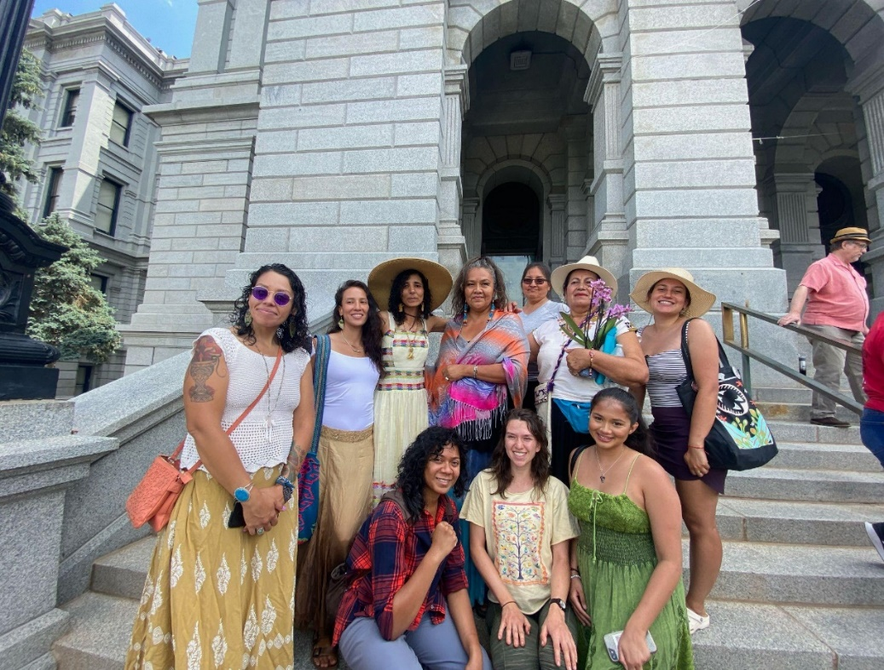

Image of Project Protect supporters at the bill signing. Image courtesy of Project Protect Food Systems Workers.

Contrasting Responses that Were or That Weren’t Supportive

During this same period, Nicole Civita held a Governor-appointed seat on the Colorado Food Systems Advisory Council (COFSAC). From that position, she attempted to direct the attention of COFSAC and, in turn, Governor Polis’ Administration to the plight of agricultural and food system workers. COFSAC was established and funded by the Colorado Legislature to recommend ways to strengthen the food system in Colorado and to increase access to local food systems and economies. However, throughout her tenure, the council reinforced old paradigms. Its multi-stakeholder composition had designated seats for growers, agricultural industry interest groups, food security charities, academics and researchers and even recipients of federal nutrition assistance, but no seats for food system workers or their advocates. There was no focus on the people, animals, land and climate that are the foundation of the food system. Only the people who profit from the work economically, intellectually, or through access and power. When resigning from COFSAC because of the body’s politicization of a research brief on agricultural workers, Civita quipped, “This body might more properly be named The Colorado Agribusiness Welfare, Food Market Channel, and Charity Council.” The other fact that kept COFSAC in a place of supremacy was “at least 65% of people who labor in Colorado’s food system are Black, Indigenous, or People of Color (with at least 82% of this group identifying as Latinx). These workers earn an average income of less than $30,000 per year in a state with an above average cost of living. COFSAC, by contrast, is composed almost entirely of White people” (Civita resignation, 2021).

Additionally, as PPFSW was formed, the Rocky Mountain Farmers’ Union actively participated in meetings and were initially aligned with the supporting worker wellbeing through both provision of PPE and advocacy for short and long-term agricultural worker-protective policies, going so far as to review and contribute to outlines of a PPFSW-proposed farmworker rights bill. However, following a personnel shift and as PPFSW demonstrated that it was intent on ending agricultural exceptionalism in Colorado’s labor laws, RMFU’s support disintegrated. When the bill was introduced, they back-tracked, distanced themselves from PPFSW and, in a remarkable breach of trust, used their access to PPFSW meetings and files to share critical information with opponents of the bill.

Both organizations with their strong structure, large memberships, and resources could have made substantive change possible more quickly and easily. However, they had too much to lose in the form of power to openly and meaningfully support workers.
Relational Economies and Ecologies

PPFSW was a coalitional in its earliest structure—a loose, open, self-organizing, responsive multi-racial, multi-lingual, multi-stakeholder, multi-professional group that took shape within a space defined by guiding principles. But it is important to note that it achieved its successes by directing the energy of its coalition outward to foster connections with and mobilize engagement by allied organizations. Legislative wins were secured by steering a wider coalition; a press release written during the 2021 legislative session proudly and accurately proclaimed that SB-87 enjoyed “wide support among a range of labor unions, advocacy groups, and farmers committed to ensuring basic human dignity in the industry and dismantling structural racism in Colorado” (Press Release SB 21- 087, 2022). Supporters included, among others: Colorado AFL-CIO, the National Young Farmers Coalition, Project Protect Food Systems Workers, Frontline Farming, Towards Justice, COLOR (Colorado Organization for Latina Opportunity and Reproductive Rights), the Hispanic Affairs Project, the Colorado Immigrants Rights Coalition, Colorado Jobs with Justice, Colorado People’s Alliance, and Conservation Colorado” (Press Release SB 21- 087, 2022). Other groups also joined and their representatives brought wisdom and sometimes even levity to the process including Colorado Blueprint to End Hunger, Commún, and farmers from around the state who spoke up and supported the bill or the network.
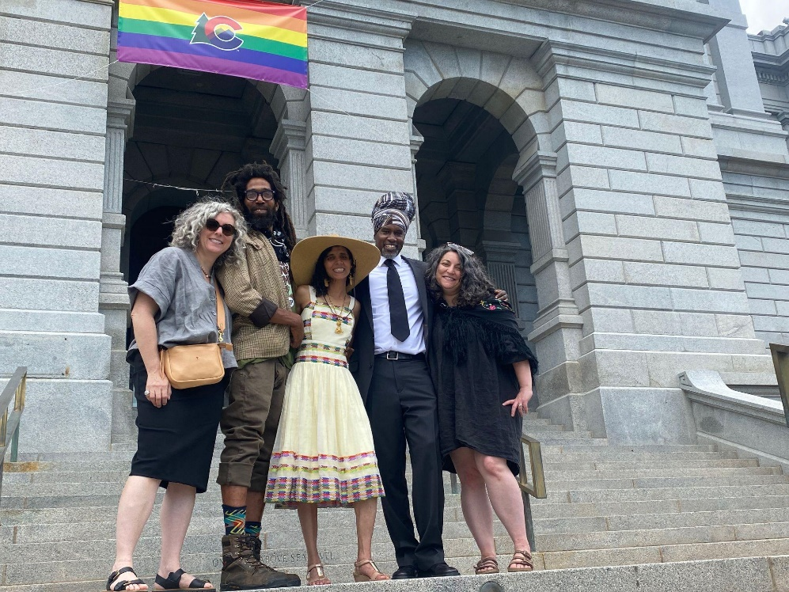
Image of Project Protect Steering Committee Members at the Bill Signing. Image courtesy of Project Protect Food Systems Workers.

Similarly, the Promotora Network was formed by individuals and groups who had expertise across the state in dealing with labor law, immigrants rights issues, health promotion, the specific needs of certain groups like sheep herders, and farmers who knew the lived experience of the people in farmworker communities. Specifically, Jenifer Rodriguez from the Migrant Farm Worker Division of Colorado Legal Services had a wealth of pre-existing knowledge and relationships that helped to connect already existing promotoras, farm workers to whom only she had access, and to other service providers for immigrants and farm workers. Thus, PPFSW’s successes are, in part, traceable to respecting, elevating, and amplifying the work of those who had already spent years serving and advocating on behalf of farmworkers—unsung heroes who had devoted themselves and made substantial personal sacrifices to the cause long before it found a spotlight.

There are messages for future liberation movements in the successes of humanizing and centering the needs and truths of food systems workers and strategically allowing different coalition members to lead from their places of strength. These messages focus on the importance of constructing an ecology and a system of resistance through community. We founded our principles on relationship first, on the emergent strategies of listening and serving our community. We set out clearly to contextualize the work we did in history, law, and economics so that we were able to draw clear lines from each step we took to the necessity of creating alternatives not modeled on the logics of extractive capitalism and White supremacist systems. We nurtured economies of solidarity and resistance and showed up for the communities who made up our coalition. Our bill was not the only one passed in 2021 that positively impacted the lives of farm workers and as other organizations had their agendas, we supported them. And finally, we elevated the voices and stories of the workers, making it a priority to capture not just data, which was crucial to our success, but also to insist upon space for their stories. We elevated the voices for change but also for healing, calling on the food system workers, their advocates, and communities to tell the stories of their lives, loves, successes, needs, and realities.

The process we engaged in was not a trajectory—because we embraced emergence. It was not a march because we found times when we needed to move back or sideways to get needs met. The best metaphor for Project Protect Food Systems Workers making change in Colorado is a dance. The dance is not just a metaphor, but was an actual strategy we used on Día de Muertos in the plaza outside the Colorado Department of Labor and Employment, as overtime rulemaking hearings after SB-87 became law. While two of our steering committee members testified inside the halls of power, a huge crowd gathered outside to hold a vigil and celebration. We danced, sang, lit candles, scattered marigolds, and shared stories about farm workers who died because of unfair and unsafe labor practices. We honored the life and death of Juan Panzo Temoxtle, who asphyxiated and drowned in a manure pit while working at an industrial confined feeding operation as SB-87 was hotly debated. Workers, activists, promotoras, and supporters from religious institutions and from Standing Up for Racial Justice all held hands in the plaza and created a sacred space.

The dance is also an apt metaphor, though, for a process in which we listened to the music, celebrated together, followed the rules we needed to follow (and freestyled around the ones that didn’t bring justice), improvised, and had to change partners often. It was possible for a group of people to have the skills, determination, and fortitude to stay in the dance till the set ended. We created a Temporary Autonomous Zone (Bey, 2003) of attentive care and relational power that gave us all insight into what is possible in the face of the gruesome realities of our history and economy.

References

Agricultural workers’ rights bill explainer (for distribution). (2021). Google Docs. Project Protect Food Systems Workers. https://drive.google.com/file/d/1B_RSoFfiuodtk8D6_-5nbQ8xnkwSOaJf/view?usp=sharing&usp=embed_facebook.
Allen, P. (2016). Labor in the food system, from farm to table. Journal of Agriculture, Food Systems, and Community Development, 6(2), 1–4. https://doi.org/10.5304/jafscd.2016.062.022
America’s Heartland. (2006). Season 2, Episode 7. https://www.pbs.org/video/americas-heartland-207/.
Auerbach, M. (2021). Project protect case study [course material]. EcoGather. Sterling College, VT. https://www.ce.sterlingcollege.edu/ecogather.
Auerbach, M. (2021). Press release: Colorado’s historic agricultural workers rights bill 21-087 is law. Project Protect Food Systems Workers. https://www.projectprotectfoodsystems.org/post/press-release-colorado-s-historic-agricultural-workers-rights-bill-21-087-is-law.
Ayala, G.X., Vaz, L., Earp, J.A., Elder, J.P., & Cherrington, A. (2010). Outcome effectiveness of the lay health advisor model among Latinos in the United States: an examination by role. Health Education Research. Oct; 25(5): 815–840. https://www.ncbi.nlm.nih.gov/pmc/articles/PMC2948840/.
Bey, H. (2003). TAZ: The temporary autonomous zone, ontological anarchy, poetic terrorism. (Second edition). Autonomedia.
Civita, N. (2020). Testimony before the committee and submitted thereafter to members. Nicole Civita private records.
Civita, N. (2021). Colorado’s agricultural workers [Brief]. Colorado Food Systems Advisory Council. https://cofoodsystemscouncil.org/wp-content/uploads/2021/04/AgWorkers_Brief.pdf.
Civita, N. (2021). Passage from resignation letter. Nicole Civita private records.
Civita, N. & Auerbach, M. (2023). Feeding each other: Shaping change in food systems through relationship. Changemakers Books.
Civita, N. (2022). Essential food system workers [Brief]. Johns Hopkins Berman Institute of Bioethics. https://bioethics.jhu.edu/research-and-outreach/covid-19-bioethics-expert-insights/essential-workers-project/essential-food-system-workers/.
Cole, A. (2020). Testimony for SB21-087. Project Protect Food System Workers archive.
Coles, B. (2016). The shocking materialities and temporalities of agri-capitalism. Gastronomica, 16(3), 5–12.
Colorado agricultural workers & COVID-19 2020 food worker and COVID-19 report. (2021). Project Protect Food Systems Workers. https://docs.google.com/document/d/1DVkZQGkpjZtIqjOefL2kQA_K-XKunA-Xz_aUQruj6xY/edit?usp=embed_facebook.
Community health workers (promotores). (2019). Centers for Disease Control and Prevention. https://www.cdc.gov/minorityhealth/promotores/index.html.
The data. (2023). Project Protect Food Systems Workers. https://www.projectprotectfoodsystems.org/thedata.
DeWitt, L. (2010). The decision to exclude agricultural and domestic workers from the 1935 Social Security Act. Social Security Bulletin, 70(4). https://www.ssa.gov/policy/docs/ssb/v70n4/v70n4p49.html.
Elder, J.P., Ayala, G.X., Parra-Medina, D., & Talavera, G.A. (2009). Health communication in the Latino community: Issues and approaches. Annual Review of Public Health, 30(1), 227–51, https://doi.org/10.1146/annurev.publhealth.031308.100300.
Emmad, F. (2021). Interview with Fatuma Emmad of Project Protect Food Systems Workers and Frontline Farming for EcoGather.
Emmad, F. (2022). Project Protect Food Systems Workers. Zoom.
EMSI. (2020). Q4 data set for Colorado for the following standard occupational classification codes: 45-2092, 45-2093, 45-2099, 45-2091, 45-1011, and 45-2041.
Eng, E.; Parker, E.; Harlan, C. (1997). Lay Health Advisor Intervention Strategies: A Continuum from Natural Helping to Paraprofessional Helping. Health Education & Behavior, 24(4), 413–417.
Farm Laborers Fair Labor Practices Act. (2021). Department of Labor, https://dol.ny.gov/farm-laborers-fair-labor-practices-act.
Farmworker Justice. (2019). Selected statistics on farmworkers (2015-16 Data). http://www.farmworkerjustice.org/wp-content/uploads/2019/05/NAWS-Data-FactSheet-05-13-2019-final.pdf.
Foner, E. (2014). Reconstruction: America’s unfinished revolution. Harper Perennial Modern Classics.
Former farmworker testimony. (2020). SB 21-087. Denver, CO.
Frontline Farming. (2021). Guiding principles. Project Protect Food Systems Workers. https://www.projectprotectfoodsystems.org/guiding-princples.
Gelatt, J. (2020). Immigrant workers: Vital to the U.S. COVID-19 response, disproportionately vulnerable. Migration Policy Institute. https://www.migrationpolicy.org/sites/default/files/publications/COVID-19-EssentialWorkers-FS_Final.pdf
Guthman, J. (2015). Binging and purging: Agrofood capitalism and the body as socioecological fix. Environment and Planning A: Economy and Space, 47(12), 2522–36.
Hild, M. (2007). Greenbackers, Knights of Labor, and Populists: Farmer-labor insurgency in the late-nineteenth-century south. University of Georgia Press.
International Labor Organization. (2020). The care economy. https://www.ilo.org/global/topics/care-economy/lang--en/index.htm.
Kelley, R. (1990). Hammer and hoe: Alabama communists during the Great Depression. University of North Carolina Press.
Knapp, H. (2022). Essential, not expendable: Protecting the economic citizenship of agricultural workers. University of Colorado Law Review, 93(2). https://lawreview.colorado.edu/printed/essential-not-expendable-protecting-the-economic-citizenship-of-agricultural-workers/.
LeRoy, M.H. & Hendricks, W. (1999). Should “agricultural laborers” continue to be excluded from the national labor relations act?. Emory Law Journal, 48(3). https://papers.ssrn.com/sol3/papers.cfm?abstract_id=992923.
Liebman, A.K., Juarez, P.M., Leyva, C., & Corona, A. (2007). A pilot program using promotoras de salud to educate farmworker families about the risks from pesticide exposure. Journal of Agromedicine, 12(2), 33-43. DOI: 10.1300/J096v12n02_04.
Marks, A.B., Civita, N., & Knapp, H. (2020). Project Protect Food Systems: The Colorado food systems workers rapid response team policy response agenda. University of Colorado Law Review. https://lawreview.colorado.edu/wp-content/uploads/2020/08/Marks-et-al-Colorado-Coronavirus-CPRA.pdf.
Marks, A.B. & Civita, N. (2021). Colorado’s agriculture worker [brief]. Colorado Food Systems. https://cofoodsystemscouncil.org/wp-content/uploads/2021/04/AgWorkers_Brief.pdf.
Martin, P. (2020). Mexican braceros and US farm workers. Farm Labor & Rural Migration News Blogs. Wilson Center. https://www.wilsoncenter.org/article/mexican-braceros-and-us-farm-workers.
McWilliams, C. (2000). Factories in the field: The story of migratory farm labor in California. University of California Press.
Mississippi Black Code, 1865. In The American Yawp Reader. https://www.americanyawp.com/reader/reconstruction/mississippi-black-code-1865/.
Morehouse, L. (2015). Grapes Of wrath: The forgotten Filipinos who led a farmworker revolution. Weekend Edition. http://tinyurl.com/2mh9xpye.
Neiss, K. (2021). Activating the numbers: 2020 Colorado food system workers & COVID-19 report. Project Protect Food System Workers. www.projectprotectfoodsystems.org.
Paul, C. A. (2018). Southern Tenant Farmers’ Union. Social Welfare History Project. https://socialwelfare.library.vcu.edu/public-welfare/southern-tenant-farmers-union/.
Perea, J. (2011). The echoes of slavery: Recognizing the racist origins of the agricultural and domestic worker exclusion from the National Labor Relations Act. Ohio State Law Journal, 72(1), 97-138. https://lawecommons.luc.edu/cgi/viewcontent.cgi?article=1150&context=facpubs.
Press release SB 21- 087. (2022). Project Protect Food Systems Workers. https://www.projectprotectfoodsystems.org/sb-21-087.
Promotora de salud/lay health worker program model. (2022). Rural Health Information Hub. https://www.ruralhealthinfo.org/toolkits/community-health-workers/2/layhealth.
Promotora network. (2022). Project Protect Food Systems Workers. https://www.projectprotectfoodsystems.org/promotora-network.
Regional organizer testimony. SB 21-087. (2020). Denver, CO.
Sine, E. (2016). Grassroots multiracialism: Imperial valley farm labor and the making of Popular Front California from below. Pacific Historical Review, 85(2), 227-254. https://doi.org/10.1525/phr.2016.85.2.227.
United States Department of Agriculture. (2017). Agricultural census. https://www.nass.usda.gov/Publications/AgCensus/2017/Full_Report/Volume_1,_Chapter_1_State_Level/Colorado/.
Vaught, D. (1999). Cultivating California: Growers, specialty crops, and labor, 1875-1920. The Johns Hopkins University Press.
Weber, D. (1996). Dark sweat, white gold: California farm workers, cotton, and the New Deal. University of California Press.
Woodward, C.V. (2001). The Strange Career of Jim Crow (Commemorative Edition). Oxford University Press.
Volume 16, Issue 1, February 2024
________________________________________________________________________

The Animal Apparatus: Taxonomic Stratification as an Anglo-Imperial Technology

Author: Gray Black
Titles: Doctoral Student of International Relations
Affiliations: University of St. Andrews
Location: St. Andrews, Scotland, United Kingdom
Emails: b1chr0m3@gmail.com
Keywords: imperialism, taxonomic hierarchies, speciesism, late modernity, Great Exhibition, Industrialism, colonialism, critical animal studies
________________________________________________________________________

Abstract

This article seeks to understand the cyclical, socio-political schema of technology in the global, colonial implementation of taxonomic hierarchy, as well as speciesism’s role in the beatification of technology during the liberalisation of Victorian England. Beginning by a snapshot observation of what appears to be a benign panorama of present-day London’s Hyde Park, the substratum of technologically enforced ecological atomisation is incrementally revealed to expose its insidiousness in unexpected places. To address this scape’s illuminated speciesism necessitates a return to its source; this article specifically spotlights the Great Exhibition—centred between the first and second half of the Industrial Revolutions—as a paragon of the Late Modern Period and the multivalent oppression and alterity to which it is inextricably linked. It is within the Great Exhibition that animals were not just regarded as tools for human enjoyment but as a lesser being to the machines which would subjugate them over the next century and a half. Finally, this article inspects the extant legacy of Western industrialisation which has bequeathed its individualist ethos to the modern State through particular modes of thought, exteroceptive manipulations, and the capitalization on neurobiological mechanisms, and, in many ways, has “worlded” global speciesism through the fecundity of colonialism.

*****************

Across central London’s Hyde Park, painters daubed their canvasses with the tranquil scene of 2017’s budding Spring laid out in front of them. Picnickers lazily rolled their full bellies up towards the ether on the grass of Kensington Gardens after taking the final bite of their bacon butty. Envious businesspeople, relegated to the pavement where palatial horses trotted, loosened their leather belts trying to briefly simulate the lazy sunbathing that tempted them. Swans glided across the Park’s Serpentine, squawking at the young humans who excitedly tossed them bread from plastic bags. This multisensory melange was only amplified by the Gothic dome in the background, topped with the Christian cross, commemorating Queen Victoria’s husband, Prince Albert. It is no coincidence that the canopy where the cast bronze monarch lounged rests near the site of one of his biggest legacies. In 1851, what was known as The Great Exhibition, Albert’s brainchild, became the first of many World’s Fairs (Harner, 2019). Housed in the Crystal Palace, a mammoth conservatory erected in Hyde Park, The Great Exhibition celebrated technological advancement and the burgeoning industrialisation of the 19th century. Although acting as a platform for cross-cultural alliance with and freedom of mobility between industrializing countries across the globe, it also purposefully (and rather ostentatiously) conveyed that Britain would be principal in liberal “advancement” (ibid.).

This “exhibition of labour” reconsolidated Europe’s splintered geopolitical self-image while reducing the intrinsicality of their colonial subjects and depreciating their accomplishments (ibid.). Nonetheless, alongside the Royal Society’s panoply of technological inventions, Victorian journeymen had foregrounded the crown jewels of conquest within the exhibit: non-human animals (Would, 2018). Taxidermists stuffed wolves and lions alike, mounted them, and exhibited them as wild artifacts which had been subdued by the global elite (Would, 2018; Youdelman, 2017). Even fully-grown trees were engulfed by the hungry mouth of the cage, as if to placate these “once-animals” by showcasing their original habitats (Kishlansky, 2008). In this vein, the Crystal Palace served not only as a diorama of foreign biomes but as a representation of human sovereignty over and taming of the natural world, of which they deemed themselves no longer a part (ibid.). The symbolic dominion over nature was directly in line with the horticultural architecture of the Victorian era, which rejected the naturalism of the 18th-century, and where stylistic, geometric gardens framed lavish estates (Gaskell, 1980). Furthermore, the animals trapped behind the glass lips and iron teeth of the Crystal Palace occupied an uncanny liminal space in the natural world which emblematised their stratification in the eyes of their Homo sapiens counterparts. Once-living beings evolutionarily akin to humans, the stuffed leopards and dancing monkeys were categorised as having as much intrinsic worth as characterless plants, while also performing as the trinkets of civilization (Creaney, 2010). The freedom to be non-human meant the right to be subject to human’s enculturated violence.

With each passing year, the socio-political ramifications of European conquest and colonialism become clearer. The aftereffects are so diffusive that, to grasp their scope, we must be comprehensively study them through countless lenses. Important literature has been continually co-authored about the British Empire’s cultivation of white, masculine, cishet, neurotypical, non-disabled, and Christian hegemony, and these perspectives must not be understated. Largely due to the co-occurring ethnocide of more eco-conscious, non-European lifeworlds, specific analyses on European imperialism’s political debasement of non-human (but nonetheless sentient) beings have only recently entered mainstream discourse. Therefore, just as we have begun to explore the parallels between Hyde Park in the 21st Century and its Great Exhibition installation nearly two centuries prior, this paper dedicates itself to circumambulating a handful of the social, linguistic, and material ways that the British Empire abused cross-species relations and used non-human bodies to both engineer and maintain power.

*****************

As we meander through the memory of the postmortem rigidity of the elephants and the lions whose jaws are forcibly wired to emit perpetually silent cries, it is critical to evoke the etymological origins of the word “animal,” which the Victorian ruling class seemingly sought to neutralize as the lexical successor of the once-common “beast.” Through a morphological lens of the Proto-Indo-European (PIE) languages, we can discover that cross-linguistic origin dheusome equates to “a creature who breathes” (Ali Jassem, 2018). From Arabic thaur to German tier, animals are meant to be, at the very least, glottogonically synonymous with breath, the movement of life (ibid.). While Latin has a similar cognate, the parent language takes it a step further which can be found in French and English. Un animal, in French, or “an animal” descends from the Proto-Italic word anamos; a word not only meaning “breath,” but which also served as a metonym for “soul” or “spirit” (Cresswell, 2021). Therefore, once again, it is implied that an animal is a breathing, locomotive entity with the inclusion of a particular lifeforce which plants and rocks alike could never possess. Ironically, nowhere could you find this original lifeforce exemplified under the Crystal Palace’s translucent ceiling. These non-human beings were left as hollow shells of their unique personalities and kinetic actions, their once-emotive eyes marbled, and their souls stripped and reconfigured with the same automated mechanisms that were being highlighted around them. Paradoxically, horological instruments pulsed while the steam hammer wheezed, performing the various signs of life that the ossified creatures once possessed (Hoffenberg, 2001). In a sense, the roles had reversed. The animals were now the tools and trophies for consumption, while the machines—interactive marvels born from a human womb—had been given the right to become animated. In other words, soullessness befell non-human animals, whereas technology became soulful; “to become” implies not only a reception to change but a purposeful choice to do so.

While Homo sapiens noticeably share dermal coverings, a heart, and lungs with other beings and yet remain taxonomically singular, human technology is as much an extension of us—as Canadian philosopher Marshall McLuhan suggests—as it is a deviation from species classifications (1973). While the Cambridge Declaration of Consciousness (Low, 2012) publicized the academic consensus that human and non-human animals alike possess consciousness, I believe that the devolution from technology which once helped better the personal and collective consciousness to technocratic subjugation of flora and fauna was the extension of self-conscious “othering.” Amassed geospatial and anthropological knowledge, as well as the dissemination of Adam Smith’s seminal advocacy of self-interest, bore a new use of technology which surpassed the common phenomenon of tools-turned-armament. Military weapons were and have been made as joint physical extensions of alterity throughout history. Nevertheless, the technology exhibited in the Great Exhibition was indicative of the Enlightenment’s epistemology: more ideological, individualistic, sanctimonious, and especially complimentary of European ratiocination. In this way, technology not only virtue-signals a mere replacement of endemic, racialized slavery which Europeans enforced en masse and then hypocritically decried several hundred years later (thematic of other forms of enforced and reneged cultural paradigms, such as misogyny, homophobia, transphobia, and ethnocide). Technology machinated and subsequently justified a more abstract and “rational” form of enslavement. The savvy of and manipulation on behalf of the Early Modern European embedded itself within the machines they created, heralding their domination over the those perceived less than human and the profane. God may have died, but the foreordination of who was to play the role of exploiter and exploited was primed and firmly placed in the cogs of the mechanical master. The technology most commonplace today was both prearranged to be and exhibited as a reinforcement of the consciousness of “othering” whilst in concert with colonial conquest, solipsism, and objectification (in the material and metaphorical senses).

While much has changed within the United Kingdom since the Victorian Era, their industrial model has been transculturally exported. The progenitor of (neo)liberal rationale, the British Empire adaptively radiated a philosophical legacy of eco-social Darwinism throughout Indigenous clans, imagined communities, and nations. While the British and other proto-industrial powers disseminated the Westphalian state, institutionalized social phobias, and other harmful, propagandistic philosophies, the exploitative relationship with non-human animals via machinery has remained integral to the “One-World World” hegemony of the West (Escobar, 2016). This article seeks to discuss the ways in which Victorian technological expansionism and coloniality has eroded the non-human animal’s soul; while this paper recognizes that animal exploitation and malpractice has arguably existed across space and time, recognizing the Eurocentric methodologies which allow objectification of non-human animals to be pervasive is crucial. Therefore, six discrete albeit interconnected categories will illuminate the cyclical nature of the lingering anthropocentrism that the attendees of the Great Exhibition experienced. Beginning with semiotic objectification, the categories of consequent material exploitation, expendability, fetishization, disassociation, and normalization follow in succession.

Semiotic Objectification

One such way in which the Anglosphere has been able to homogenize the conceptualization of non-human animals is through language. While Modern English is remarkable in the sense that it possesses no default grammatical gender, instead of using the third person singular “they,” which has been employed since the 14th century, animals’ pronouns are conventionally “it” (Baron, 2020). Although a subject with the pronoun “it” connotes something lifeless, “it” has been applied persistently for animals, even in spite of the discernible sex of the being, such as a doe and a buck. In this way, it can be argued that the habitual usage of “it” has been a successful methodology to obfuscate the word’s indexicality and to regularize the hyper focus on animals’ instrumental significance. In turn, the objectification of animals morphs into the material and leads to their instrumentalization in the physical world. This is the beginning of the process that this paper denominates “deanimisation,” or the cleaving of the soul.

We turn to Alfred Sohn-Rethel’s book, Intellectual and Manual Labour (1978) for further consolidation of theory. Citing Parmenides’ “one,” Sohn-Rethel states that money is an abstraction of a metaphysical construct humans have created (ibid.). In the Platonic “Ideal of Forms,” through the value of a tool, an object is then given to anything that can serve the human (ibid.). When the word “it” is applied indiscriminately to a non-human “thing,” regardless of whether that object is a coin or a dachshund, “it” becomes a mechanism for alterity. “It” amalgamates all that is non-human, and subsequently, makes the “it” more easily proprietary. Cattle and coins, meat and money, dairy and dollars have been conflated since the beginning of the Holocene approximately 10,500 years ago (Lear, 2012). Solipsism in the Anthropocene is singular, however, due to the colonial conquest of the earth and its inhabitants, living or non-living, by the European colonial masters. Instead of existing alongside, we live over our furry, scaled, and winged counterparts, and mechanization of this ideological and material process has only exacerbated the removal of the nature’s intrinsic worth. Beneath a capitalist drop net, the totalizing process of reification, or the “making into a thing,” allows this atomization of the non-human to occur (Lukacs, 1923). The animal is cleaved from their being while, in this context, hypostatization demands the generalization of value of the non-human. The living universally becomes the commodity.

Exploitation and Expendability

In his academic article, “On the Need for Limits After the Time of the Coronavirus,” Gregory Lee challenges the Lockean notion of individual liberty (2020). Lee theorizes that Coronavirus has epitomized the problems with our “pseudo-freedoms of consumption” in the Western capitalist logos, as restraint for the good of the collective can only be decreed by the State (ibid.). Basically, our idea of freedom is hyper-individualistic self-determination. Lee also mentions that in the Eastern philosophy of Daoism power is not externalized, but rather internalized to radically accept the external while regulating one’s inner world (ibid.). In this way, once again, power relies on limits. Unfortunately, Western ideology is more or less oppositional to this pro-social existence (ibid.). Capitalist power is both anthro- and androcentric and thus creates excuses for the splintered inner world while lauding will and might. The reasons why men rarely seek help for physical (not to mention mental) ailments while also being granted the excuse “boys will be boys” after committing acts of sexual violence lies within the teleological narrative of wielded power. Carol Adams offers further insight into the phallocentric model of power in her book, The Sexual Politics of Meat (2015). Here, Adams posits that, while the phallus is seen as a sacred source of power amidst the profane, so too is the knife and the electric prod in slaughterhouses (ibid.). When boys are taught to viscerally react in their patriarchal cradle, and that they will have the societal backing to do so, their power in adulthood, especially when in a vulnerable position, manifests through the crossing of boundaries and the disregarding of limits. Congruently, in her essay, “Walled States, Waning Sovereignty,” Wendy Brown asserts that border walls are just performed displays of compensation for internal weakness (2017). Whether the bushing of a cat’s tail or the brandishing of peacock plumes, “erection” correlates to the “fight” defense mechanism.

Without restraint, one may be able to successfully develop the tools that are utilized to transform other species into tools themselves. Expanding upon the sexual representation of the penetrating knife into a pig’s jugular and the jolting force of an electric prod in the rump of a cow, riding crops which slap the haunches of the trotting horses outside of Kensington Palace serve the same purpose. These will likely be the same breed of draught horses that the English neo-aristocracy will use when hunting waterfowl in the West Country. The conquest of humans within bloodsports call, once again, for the use of a cylindrical weapon, a firearm, which will pierce the birds’ flesh. In an eight-kilometre (five-mile) radius from where our Spring scene occurred, between Imperial College London, University College London, and King’s College London alone, over 300,000 rodents were used for research and “humanely” killed with impunity that same year in 2017 (Imperial College London, 2017; University College London, 2017; King’s College London; 2017). This statistic does not consider the thousands of fish, primates, and other taxonomic orders that were inserted with needles and injected with chemicals for the sake of the same enthusiasm for science which Albert exhibited during his lifetime. Under the overlay of a male-dominated imperative, the same depreciation, manipulation and penetration of non-human animals has been outsourced. Animal flesh, once a privilege of the British ruling class, has grown in demand exponentially in the Global South, mimicking the colonial lifestyle (Nigatu & Seeley, 2015). In South Africa, a British postcolonial nation, hunting for sport remains endemic (Thompsell, 2015). When hunting is outsourced, and wealthy Westerners take a car to the airport, to take a plane to Cape Town, to take a gun into the reserve, this established exploitative relationship uses animals as an intermediary instrument of capitalist apparatuses.

After a tool with no refund policy breaks or wears out, the privileged, unskilled consumer has no alternative than to throw it away. The buyer is alienated from the process of labor, and regularly demands more and more. This instrumental disposability applies to anthrozoomorphic relations as well. Under capitalist, colonial rule, a system of quantification and standardization is built. The process of objectification becomes alphanumerical. The non-human animal is appraised as “it” and is deemed both a monetary value and one in a number to be used. Subsequently, whether in the slaughterhouse or in the natural world, the animal “its” are superfluous and disposable. For example, the swans who float across the placid waters of Hyde Park’s Serpentine are there as spectacles and can be removed when necessary. In 2012, the swans and their wee cygnets were provisionally relocated from their established territory along The Serpentine so that Olympians could practice their swimming (BBC, 2012). Although indoor pools were certainly an option for the professional athletes, these notoriously territorial creatures were considered as disposable as a branch along a bike path, and thus moved. Almost a decade after the swans’ forced removal, the UK parliament still condones the use of pesticides that are fatal for the bees who fly across Hyde Park, past London’s suburbs, and into the countryside (Busby, 2021). These bees will also no longer be able to pollinate the crops used to fatten the cows who are born and bred for meat and dairy. As a means of cost efficiency, any diseased bovine or pregnant heifer will be shot and ground up, fetus and all, as feed for one’s “pet,” the being that they own, who are used as tools for assuaging the many socially estranged in the wake of industrialization (Youdelman, 2017).

Fetishization

Back in Hyde Park, the businessman’s belt and the picnicker’s bacon butty have a popularised fantasy around them. Commodity fetishism—the intimate, often-mystical social relationship humans establish with insentient “things”—is used at the detriment of our non-human animal kin as a means to justify the exploitation and expendability of the living “it” (Marx, 1867). In the highly manicured setting of the Park, an entrepreneur—adorned with the perfect leather belt for his important consultation later in the afternoon—casts his embittered gaze towards park-goers. The picnicker he watches gains orgasmic pleasure from taste of the strips of flesh he fried up earlier. Both profit from the discrete, mysterious process of mechanically severing the animal from their soul and the illogical marketing spectacle of happy hens, prancing pigs, and other (often anthropomorphised) animals. In his book, Every Twelve Seconds, Timothy Pachirat discloses his findings after his year undercover in a slaughterhouse and succinctly deconstructs what he calls the “politics of sight” in an Orwellian hellscape (2014). Back of house workers, disproportionately people of colour, migrants, and the destitute, act as instruments in siloed areas of the slaughterhouse (e.g., kill floor, bleed pit, washroom, packaging, cooler), each performing a consistent, repetitive task each day they come in (e.g., cattle driver, knocker, shackler, tail ripper, trimmer) (ibid.). While the (dis)assembly line demands human cogs in an insatiable machine, the animals are bled, stripped and torn, losing all likeness to their original corporeal form (ibid.). Meanwhile, Pachirat recounts the constant surveillance from within and outside the building (ibid.). While the slaughterhouse has jurisprudential laws protecting its concealment, barbed wire fences and massive walls act as a fortress from the outside world (ibid.). Inside, the predominately white front of house and the slaughterhouse managers can either open a massive window overlooking the slaughterhouse floor or watch from suspended cameras (ibid.). The author evokes Foucault’s panopticon to solidify the enforcement of an omniscient, living machine that covets lifeless bodies (ibid.). Pachirat’s reconnaissance has helped us understand that, through fetishization, we can bypass self-imposed limits and dissociate ourselves from the conditions which made the product, and what, in fact, the product actually is.

Disassociation

Although the fragmentation of bodies can absolve us of guilt, disassociation from animals also serves the market prioritization. Both the cement encasing Hyde Park and the plastic bag holding bread for the swans are partially made with animal fat (Zagklis et al., 2020). The bristles of the artist’s paint brush—commemorating this tranquil Spring day—are actually plucked horse hairs. The artist’s animated depiction of Hyde Park helps to gloss over the fact that the canvas itself is coated with boiled tendons and hooves of pigs and is dotted with watercolor paint derived from bovine gall bladders (Scanes, 2018). When animals become completely indistinguishable from the tools we use, materially and not just ideologically, we have no need to challenge the commodification of beings. The integration of these tools into the routine begets apathy in the extreme. While the psycho-evolutionary survival mechanism of dissociation helps to combat overwhelming and longitudinal pain, machines do the work for us so that our minds do not have to attempt to process and internalize the unimaginable anguish of our earthling counterparts.

Normalisation

In each corner of Albert’s commemorative structure lies the allegorical statues depicting the continents on which the British monarchy once held tightly in grasp during the height of Queen Victoria’s reign. Beneath these ethnographic figures, one solitary animal is positioned. A tamed bull stands erect, ostensibly a tool to signifying the power, industry, and fortitude of Europe. Moving counterclockwise around the monument, continental Asia is depicted with whitewashed individuals resting atop a prostrated baby elephant. The marble creature is decorated with fabrics and jewels from the Orient, while Africa, directly behind, hosts a camel, also in use by the humans who have mounted. Lastly, in the rear left corner, the Americas are represented by a buffalo, their head hanging deferentially next to beings dressed in sheer robes and misrepresented Native American headdresses with startling Eurocentric facial depictions of indigenous peoples. Just as the British had commissioned the statues to depict their own glory through the claiming of the stately bull, they had also used the other non-human animals native to their allocated continent as figurative mechanisms. In this vein, we—as spectators—can garner that animals then can no longer simply exist as beings in their own right but as paraphernalia of humans, most especially those people with the power to transpose their own ways of existence onto the other cultural and spiritual interpretations of various species. Technoimperialism doesn’t just necessitate minoritized existential and cultural subservience or the inculcation of the colonial framework through language and semiotics. It universally demands the reconceptualisation of the categorical “tool” and its successive “product” to compulsorily include emotions, knowledge, and living beings. While animal psychologists and ethicists alike have all corroborated the fact that non-human animals are as dynamic and sentient as our own species, normalisation of non-human instrumentalisation once again returns us to the point of objectification where we willingly “deanimise” living beings. Just as an elephant is not a car, a bull is not a tractor; yet the extant regency of the proto-industrial nation-state has structuralised these symbols which, in turn, synonymise non-human living beings with tools.

*****************

The seductiveness of ecological stratification propagated by the ruling colonial class exists as abundantly today as the affiliated call for countless non-human animals to not exist—at least not in the form that these beings would choose for themselves. This prerogative to unalive trans-taxonomic life is embedded within a Facebook photo posing with a dead stag. It oozes with the oil from the halibut served at the London Ritz and is embedded in the colloquial nickname given to the Queen’s Yeoman Warders. The non-human animal’s subjection to an unfeeling, inanimate space remains enforced through these aestheticized ideological, linguistic, and material power structures. Luckily, the performance of non-human oppression through these tools is just a brittle veneer which can crack.

As problematic statues associated with racial persecution topple across the world and queer detournement makes headlines, a reclamation period of univocal emancipation and reassertion of social, political, and planetary boundaries is nigh. If the semiotic rejection of oppression and exploitation is transcending spatial boundaries, whether at the epicentre of postcolonial power or in Subaltern nations, why shouldn’t this include the victims of the most primary form of alterity we are conditioned to value when we lay our heads down on our downy pillows and wake to the smell of scrambled eggs?

In many ways, we need to share the identity of an oppressed group in order to advocate for said demographic. By including ourselves within the kingdom of animalia rather than raising (certain) animals to the estate of the elite, we can reconceptualise the colloquial meaning of “animal” as exclusively the non-human and may then speak alongside (not for) all those with an inherent lifeforce. While non-human animals have been ceaselessly rebelling through growls, cries, and kicks, their liberation requires our acknowledgement of our trans-taxonomic kinship that capitalism has terminologically and epistemically buried. More immediately, it necessitates deeper inspection of profoundly comfortable scenes and traditions constructed for us such as our afternoon in Hyde Park and the ways in which modern technology helps to subjugate and deceive us all. As long as modes of production are designed to include souls as commodities for our aesthetic, gustatory, and instrumental pleasure at the expense of their lives and livelihoods, eco-hierarchy will continue to imperil life on our planet.

References

Adams, C. J. (2019). The Sexual Politics of Meat: A Feminist-Vegetarian Critical Theory. Bloomsbury.
Ali Jassem, Z. (2018). The Arabic origins of English and European “place names”: A consonantal radical theory approach. Indian Journal of Arts, 7(8), 1-13.
Baron, D.E. (2020). What's your pronoun?: Beyond he and she. Liveright Publishing Corporation.
BBC (2012). Olympic swimming leads to swans moving from Serpentine. BBC News. Available at https://www.bbc.co.uk/news/uk-england-19192041.
Brown, W. (2017). Walled states, waning sovereignty. Zone Books.
Busby, M. (2021). Government breaks promise to maintain ban on bee-harming pesticide. The Guardian. Available at https://www.theguardian.com/environment/2021/jan/09/pesticide-believed-kill-bees-authorised-use-england-eu-farmers
Castoriadis, C. (1955). On the content of socialism: From the critique of bureaucracy to the idea of the proletariat’s autonomy. Socialisme ou Barbarie.
https://www.marxists.org/archive/castoriadis/1955/socialism-1.htm#h4.
Creaney, C. (2010). Paralytic animation: The anthropomorphic taxidermy of Walter Potter. Victorian Studies, 53(1), 7-35. doi:10.2979/victorianstudies.53.1.7
Cresswell, J. (2021). Oxford Dictionary of Word Origins 2nd ed., Oxford University Press.
Escobar, A. (2016). Thinking-feeling with the earth: Territorial struggles and the ontological dimension of the epistemologies of the south. Aibr-revista De Antropologia Iberoamericana, 11(1), 11-32.
Gaskell, S. M. (1980). Gardens for the working class: Victorian practical pleasure. Victorian Studies, 23(4), 479-501. http://www.jstor.org/stable/3826832.
Harner, C. H. (2019). Rebuilding the world at the Crystal Palace: Architectural discourse at the 1851 Great Exhibition. Victorians: A Journal of Culture and Literature, 136(4), 111-123. doi:10.1353/vct.2019.0015.
Hoffenberg, P. H. (2001). An empire on display: English, Indian, and Australian Exhibitions from the Crystal Palace to the Great War. University of California Press.
Imperial College London. (2017). Numbers and Types of Animals. Animal Research, London, UK: Imperial College London. https://www.imperial.ac.uk/research-and-innovation/about-imperial-research/research-integrity/animal-research/numbers/.
King’s College London. (2017). Our Animals. Biological Services, London, UK: King’s College London. https://www.kcl.ac.uk/innovation/research/corefacilities/bsu/animals/animals
Kishlansky, M., Geary, P. &amp; O'Brien, P. (2008). Civilization in the West. Pearson Longman.
Lear, J. (2012). Our Furry Friends: The history of animal domestication. Journal of Young Investigators. Available at https://www.jyi.org/2012-february/2017/9/17/our-furry-friends-the-history-of-animal-domestication.
Lee, G. (2020). On the need for limits after the time of the coronavirus. Club de MediaPart. Available at https://blogs.mediapart.fr/gblee/blog/270320/need-limits-after-time-coronavirus.
Low, P. (2012) The Cambridge declaration on consciousness. Proceedings of the Francis Crick Memorial Conference, Churchill College, Cambridge University, July 7 2012, pp 1-2. Available at https://fcmconference.org/img/CambridgeDeclarationOnConsciousness.pdf.
Lukacs, G. (1923). Reification and the consciousness of the proletariat. Merlin Press. Available at https://www.marxists.org/archive/lukacs/works/history/hcc05.htm.
Marx, K. (1867). Capital: A critique of political economy. Progress Publishers. Available at https://www.marxists.org/archive/marx/works/download/pdf/Capital-Volume-I.pdf.
McLuhan, M. (1973). Understanding media: The extensions of man. Sphere Books.
Pachirat, T. (2014). Every twelve seconds: Industrialized slaughter and the politics of sight. Yale University Press.
Scanes, C.G. (2018). Animal attributes exploited by humans (nonfood uses of animals). In Animals and Human Society (pp. 13-40). Academic Press.
Seeley, R. & Nigatu, G. (2015). Growth in meat consumption for developing and emerging economies surpasses that for the developed world. Economic Research Service. U.S. Department of Agriculture. Available at https://www.ers.usda.gov/amber-waves/2015/july/growth-in-meat-consumption-for-developing-and-emerging-economies-surpasses-that-for-the-developed-world/.
Sohn-Rethel, A. (1978). Intellectual and manual labour: A critique of epistemology. Haymarket Books.
Thompsell, A. (2015). Hunting Africa: British sport, African knowledge and the nature of empire. Palgrave Macmillan.
University College London. (2017). Facts & Figures. Animal Research, London, UK: University College London. https://www.ucl.ac.uk/animal-research/facts-figures
Youdelman, R. (2017). Iconic eccentricity: The meaning of Victorian novelty taxidermy. PsyArt 21, 38-68.
Would, A. (2018). The Curious Creatures of Victorian Taxidermy. History Today. Available at: https://www.historytoday.com/miscellanies/curious-creatures-victorian-taxidermy.
Zagklis, D., Konstantinidou, E., Zafiri, C., & Kornaros M. (2020). Assessing the economic viability of an animal byproduct rendering plant: Case study of a slaughterhouse in Greece. Sustainability, 12(14), 1-15. https://doi.org/10.3390/su12145870.

Volume 16, Issue 1, February 2024
________________________________________________________________________

Review: Vandenbosch, Michael, and Philip Lymberry (eds.). Cultivated Meat to Secure Our Future: Hope for Animals, Food Security, and the Environment. Brooklyn, NY: Lantern Publishing and Media.
Author: Nathan Poirier
Titles: Ph.D.
Affiliations: Aquinas College, Western Michigan University, Canisius College.
Location: East Lansing, Michigan
Emails: poirinat1@gmail.com
Keywords: veganism, In-Vitro Meat (IVM), vegan critique, ethical consumption
________________________________________________________________________

This book brings together a number of prominent people in the in vitro meat (IVM) space (or what the editors chose to call “cultivated meat”) to provide an overview on this technology. One could say that this book is a popularized version of an academic review paper. Although review papers oversaturate peer-reviewed scholarly articles on the topic, a popular book with this scope is yet to exist. Yet, while certain potential drawbacks of IVM are periodically highlighted, overall the editors and contributors are overwhelmingly for IVM. It is clear that when contributors discuss benefits of IVM, they always refer to potential benefits, not anything yet that is concrete. This must be so at this point as IVM is still only available in negligible amounts. But hyping up and promoting a technology solely on potential is a risky move. Contributors frequently stipulate what IVM can or will do, but tend to downplay potential roadblocks, of which there are many. Many prominent aspects of IVM development are discussed including the field’s history, consumer attitudes, ethics, environmental benefits, religious views, and key players in the space as a whole. However, IVM can only be the positive in(ter)vention the authors describe if it is handled correctly (read, “ethically”) by the sociopolitical actors involved. Yet it is precisely here where the weightiest critiques are levied, such as the interests of corporations, politicians, and regulators.
Many chapters have a similar general structure. Much of the support for IVM in this book comes from contrasting it with factory farming, as IVM production could (potentially) be much more friendly towards animals, the environment, and humans (again, if carried out ethically by all parties involved). In the abstract and in an ideal social landscape this is true. But the comparison to factory farming is not necessarily convincing; saying that IVM is better than intensive/industrial animal agriculture does not necessarily mean that it is particularly good. For instance, in Hannah Tuomisto’s chapter on IVM’s potential environmental benefits, she contrasts IVM’s improved environmental profile concerning several metrics to that of factory farmed animals and finds that IVM looks better in every case. Graphs are provided indicating the environmental impact of multiple food sources including vegan foods. But it is not mentioned that the vegan food items consistently rank better than IVM in every facet. So, the comparison to factory farming is accurate, but it obscures how much better than factory farming and IVM vegan food already is. This silencing of veganism is also prominent in academic papers also.

There are some other problems too. Probably the least well-done chapter is that of Julian Baggini who writes on “the ethics of cultivated meat.” One thing that is problematic is the title of his chapter. Titling it “the” ethics of IVM suggests that Baggini’s point of view is the point of view, or at least that it is sufficiently expansive as to encompass any and all ethical views on IVM, which of course, is not true. Additionally, more than once Baggini misrepresents veganism and dismisses it based solely on his misrepresentations. For instance, he presents veganism as an act of moral purity, stating adherents believe they can completely remove themselves from all nonhuman wrongdoing by eating vegan. First, this mischaracterizes veganism as a diet, of which it is necessarily so much more. Second, most vegans understand that they cannot completely remove themselves from harmful practices. Baggini also asserts that “the idea that the optimal human diet is entirely plant-based has no basis in mainstream nutritional science” (p. 101). Again there is more than one problem here. One is that Baggini seems to be oblivious as to who runs “mainstream nutritional science” which tends to be major corporations, financially-swayed politicians, and the food industry itself. This is the reason why vegan diets are not represented in mainstream nutritional science. In fact, Dr. Michael Greger’s work (who is also a contributor to this volume) demonstrates that a vegan diet is the optimal human diet based in all prevailing nutritional scientific evidence, its absence in the mainstream notwithstanding. Baggini also unfairly represents vegan diets as needing to be supplemented by certain vitamins or minerals. What he fails to mention is that vitamins and minerals are inserted into animals beforehand, so that animal products are also supplemented food. To make it seem like this is only true for veganism is likely an intentional misrepresentation.

This is a bit surprising given that this book comes from a vegan publisher, Lantern Publishing and Media. There is surprisingly little discussion of veganism present. There is also less discussion of animals than of the environment and humans. Human aspects are abundantly present throughout chapter topics and in chapter structure. For a vegan publisher to put out such a book is questionable as it is certainly debatable as to whether IVM can even be considered vegan (personally I don’t think there is any debate here; IVM seems abundantly clear to be not vegan at all since it is meat and other animal products—which is the entire point of IVM!). But there still is the hope that something like IVM will help to significantly reduce the problems of animal agriculture, something vegans definitely want. This is where the attractiveness lies, even if vegans themselves are not particularly interested in eating IVM, as Christopher Bryant informs us in his chapter.
It is unfortunate (yet not unexpected) that this book does not provide much room for critical thought on IVM. Readers not yet knowledgeable about it will largely be introduced to one side only, the positive side. Overall this is a disappointing volume because IVM provides so much opportunity about critical thought concerning solutions concerning animal liberation. Yet while many contributors discuss potential problems associated with IVM production and consumption, they do so with a clear slant towards IVM promotion and not skepticism, which should give readers pause. This book will help introduce IVM to a more general audience than academic papers, but readers should be critical of claims made by contributors, such as that of Ira van Eelen in the foreword, that IVM is “a solution for many of the world’s horrors.” I think a potential and partial solution, if enacted ethically, is more accurate. Readers must beware to think for themselves if they read this book.

